

Negotiations Manager



NEGOTIATIONS MANAGER is a resource which facilitates the negotiation of employee contracts. This module shares data from PERSONNEL MANAGER and PAYROLL MANAGER modules of the FINANCE MANAGER SERIES to create scattergrams and employee future benefit calculations. The module can quantify any number of variables related to the proposed employee contract settlements. Once proposed contracts are generated, a wide range of reports can be prepared. Multiple contract scenarios may be created for a single fiscal year period for easy comparison. Accepted salary schedules may be applied to the master employee payroll information for the up coming fiscal year.

Upon selecting the Negotiations button from the Finance Manager main window, the Negotiations Manager window displays.

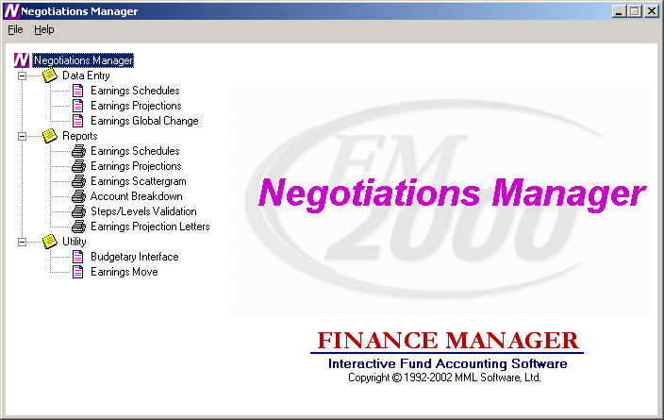

The Negotiations system is divided into three main areas: Data Entry, Reporting, and Utility. Use the tree on the left-hand side of the window to expand the Data Entry, Report, and Utility routines to display the options within each area.
Data Entry – Open the Data Entry tree to display the data entry routines. The Data Entry routines include Earnings Schedule Maintenance, Earnings Projections, and Earnings Global Change. The Schedules routine is used to create and maintain an unlimited number of salary matrices that store contractual, supplemental (i.e., Longevity, Credit Hours, etc.), hourly, and per diem salary information associated with specific bargaining units and employee types. The Earnings Projections routine is used to project salary and benefit costs for those employees who are in an employee type that is associated with a salary schedule. The Earnings Global Change routine is used to increase/decrease salaries by a percentage, flat amount or both for those employees who are in an employee type that is NOT associated with a salary schedule.
Reports – Open the Reports tree to display the reporting routines. The Report routines include Earnings Schedule Report, Earnings Projections Report, Earnings Scattergram Report, Account Breakdown Report, Steps/Levels Validation, and Earnings Projection Letters.
Utility – Open the Utility tree to display the Budgetary Interface routine that is used to export generated salary projections to Budget Manager. The Earnings Move routine is used to move the Earnings Projections or Global Earnings increase/decrease to Payroll.

Negotiation Schedules
To access the Schedules routine, select the Earnings Schedule option from the Negotiations Manager Data Entry tree menu.

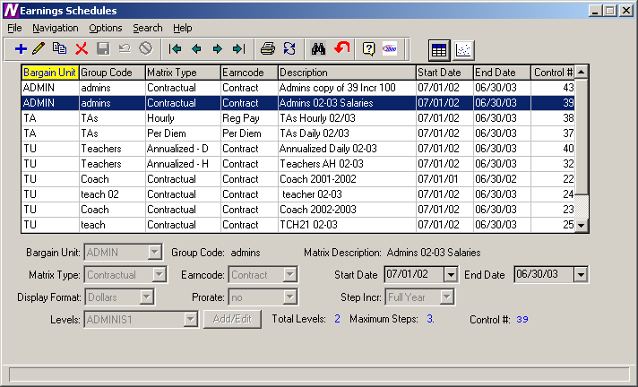

The Schedules routine is used to create and maintain an unlimited number of salary matrices that store contractual, supplemental (i.e., Longevity, Credit Hours, etc.), hourly, and per diem salary information associated with specific bargaining units and employee types. The current and future salary matrix assigned to the bargaining unit and employee type are used in making future salary projections. The future salary projections may then be used to produce reports, generate retroactive payments, and make salary increases for the upcoming fiscal year.

Schedules Browser
The Salary Schedule browser displays the following information: Bargain Unit, Group Code, Matrix Type, Earncode, Matrix Description, Start Date, End Date, and Control Number. To change the manner in which information is displayed in the browser, simply click once on the column title (Bargain Unit, Group Code, Matrix Type, etc.). The column title is highlighted in yellow to indicate the selected sort option.

Data in a browser is normally sorted in either numerical ascending order or in alphabetical order. To reverse the order, that is to sort in numerical descending order or in reverse alphabetical order, click on the column title a second time.

To change the starting point of the information in the browser, right-click on the column heading to display the Search menu window or use the Search button to begin the search process.

Drop-Down Menus
The following drop-down menus are displayed on the window:

File This menu provides access to options that allow you to add and maintain salary schedule information.

Navigation This menu provides access to the First, Previous, Next, and Last options that allow you to locate specific records in the browser.

The navigation options can be accessed through the buttons at the top of the window or through the Navigation drop-down menu.

Navigation Buttons | Function
First | This option is used to highlight the first record in the browser.
Previous | This option is used to highlight the previous record in the browser. For example, if there are five records in the browser and your cursor is highlighting the third record, select the Previous button to highlight the previous (second) record.
Next | This option is used to highlight the next record in the browser. For example, if there are five records in the browser and your cursor is highlighting the third record, select the Next button to highlight the next (fourth) record.
Last | This option is used to highlight the last record in the browser.
Print | This option is used to print a report of one or more earnings schedules. Pressing the Print button displays the Print Selection pop-up box.  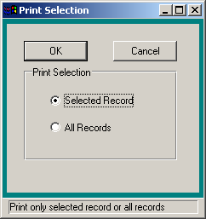  Use this window to select the schedule records that you wish to include in the report.  - Choose the Selected Record option if you want to report on only the earnings schedule that was highlighted in the browser. Choose the All Records option if you want the report to include all existing earnings schedules.  - Press the OK button to continue the Print process or press Cancel if you do not want to continue the Print process.  The Print Field Selection window displays.  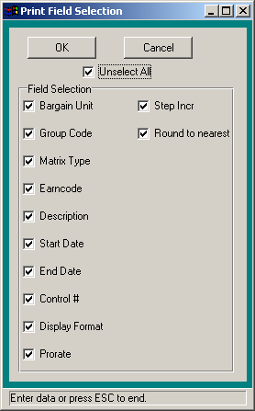  Use this window to select the information that you wish to include for each schedule record in the report.  - Flag each individual field that you wish to include on the report with a check. You must choose at least one field to print. To include all fields, check the Select All check box. (To remove the check flag from all fields, check the Unselect All check box.)  Press the OK button to continue the Print process. The Report Output window displays. This window provides the options of previewing the report, sending the report to the default printer, saving the report to a file, or exporting the report information to Excel.  Press Cancel if you do not want to continue the Print process.
Refresh | This option is used to refresh the window to reflect any recent changes that may have been made in any of the salary schedules.
Start Search | This option is used to search for a specific record in the browser.
Clear Search | This option is used to clear out any previously defined search criteria and restore the browser to its original values.

Action Buttons | Function
Add | This option is used to add a new salary schedule.
Update | This option is used to update an existing salary schedule.
Copy | This option is used to copy information from an existing salary schedule, increase or decrease salary information as needed, and save it to another newly created schedule.
Delete | This option is used to delete an entire salary schedule.
Save | This option is used to save information entered while adding, updating, or copying salary schedule information.
Reset | This option is used to reset the window back the last saved version.
Cancel | This option is used to cancel the Add, Update or Copy functions.
Exit | This option is used to exit the Schedules function.

Use the Schedules routine to add or maintain salary schedule information.

Field | Description
Bargaining Unit | Enter the code that uniquely identifies the bargaining unit. Bargain Unit Codes are defined in the Bargain Unit Maintenance File in Human Resources. Use the drop-down menu to select from a listing of valid Bargain Unit codes.
Group Code | Enter the free-form text (up to 10 characters) that identifies an employee type or group code associated with the specified bargaining unit. This code should allow you to recognize the employee group and bargaining unit associated with the schedule. Example: Clerk00/01 is the salary schedule for Clerks for the fiscal year 2000/2001.
Matrix Description | Enter the free-form text (up to 30 characters) that further identifies the salary schedule.
Matrix Type | Indicate the salary schedule type. Valid entries are: Contractual, Annualized Daily, Annualized Hourly, Supplemental, Hourly, and Per Diem. Use the drop-down menu to select from a listing of valid codes. You may also type in C, A, S, H, or P or use the up/down arrow keys to change the matrix type.
Earncode | Indicate the appropriate earnings code based on the previously selected matrix type.  If the Matrix Type is Contractual, Annualized Daily, or Annualized Hourly, the Earncode defaults to Contract and cannot be changed.  If the Matrix Type is Supplemental, the Earncode may be any one of the supplemental earnings codes (i.e., Longevity, Credit Hours, etc.) defined in the Earnings Code File. Use the drop-down menu to select from a listing of valid codes.  If the Matrix Type is Hourly, the Earncode defaults to Reg Pay and cannot be changed.  If the Matrix Type is Per Diem, the Earncode defaults to Per Diem and cannot be changed.
Start Date | Enter the effective starting date of the salary schedule. You may simply type the date (in MM/DD/YY format) or use the drop-down menu to select the date from the on-line calendar.
End Date | Enter the effective ending date of the salary schedule. You may simply type the date (in MM/DD/YY format) or use the drop-down menu to select the date from the on-line calendar.
Display Format | Indicate the display format for the salary schedule. Valid entries are Dollars or Cents. If the Matrix Type is Annualized Daily or Annualized Hourly, the Display Format defaults to Cents. If the Matrix Type is Contract, the Display Format defaults to Dollars. If the Matrix Type is Hourly or Per Diem, the Display Format may be a Dollars or Cents.  If the Display Format is Cents, the amount is extended to a decimal value. Example: 24.80.  If the Display Format is Dollar, the amount is a flat dollar amount with no decimal extension. Example: 46,029.
Prorate | NOTE: This field is only active if the Display Format is Dollars.  Enter Y if the salary is to be prorated based on the FTE percentage. Enter N if the salary is not to be prorated.  Example: Let’s say that an employee is a 50% FTE in an appointment and is starts out in step 1. Next year, instead of moving them up to the salary associated with step 2, the system will look at the salary schedule and apply the FTE% to the step 1 salary to determine the projected salary.
Step Incr | Indicate the step increment for the salary schedule. Valid entries are: Full Year or Half Year. Use the drop-down menu to select from a listing of valid increments. You may also type in F or H or use the up/down arrow keys to change the step increment. For example, if you indicate Half Year and 10 steps, the steps will be .5, 1.0, 1.5, 2.0, 2.5, 3.0, 3.5, 4.0, 4.5, and 5.0 (ten half steps).
Levels | Use the drop-down menu to view the existing levels associated with the schedule. Use the Add/Edit button to add and maintain the levels and steps associated with the schedule.  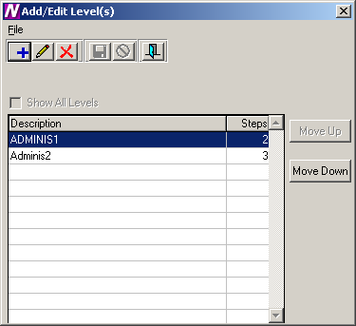  To Add a Step and Level for the Schedule:  - Select the Add button.  - Enter the level description (up to 8 characters). Example: Clerk 1, Nurse 1, Admin.  NOTE: It is recommended that you enter the Level Description using upper and lower case lettering.  - Enter the number of steps associated with the level. Each level may have a different number of steps.  - Press the Save button. NOTE: It is critical that you also press the Save button at the Matrix level (Earnings Schedule window) because you are updating the Matrix when you add or change step/level information.  To Update a Step and Level for the Schedule:  - Select the record that you wish to update.  - Press the Update button.  - Make changes as needed.  - Press the Save button. NOTE: It is critical that you also press the Save button at the Matrix level (Earnings Schedule window) because you are updating the Matrix when you add or change step/level information.  To Delete a Step and Level for the Schedule:  - Select the record that you wish to delete.  - Press the Delete button.  - Press the Exit button to return to the Earnings Schedule window. Press the Save button.  To Move a Step and Level within the Schedule:  - Select the Move Up or Move Down button.  The column(s) selected are shifted accordingly within the salary matrix.

Earnings Schedules
The Earnings Schedules window displays after selecting the Matrix radio button and pressing the Matrix button.

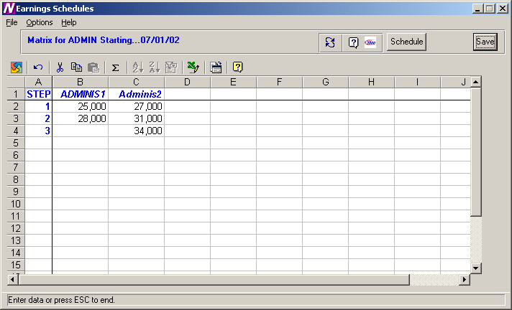

The Earnings Schedules window is used to indicate the appropriate salaries for each step and level created. The steps are displayed down the window and the levels are displayed across the window.

The system will only provide access to those cells in the spreadsheet where a step exists for the corresponding level. All other cells will be locked if you attempt to enter salary information where a step does not exist for a level. In the example above, level Supv1 only has 8 steps. Therefore, the cells for level Supv1, steps 9 and 10, are locked and cannot be accessed.

To Enter Salary Information:
- Use the up/down arrows to move to each level within the step. Use the Enter key or up/down arrows to move to each step within the level.
NOTE: After entering/modifying information in a cell, it is required that you move off that cell before pressing the Save key. If you type a salary in a cell and do not move your cursor off that cell before pressing Save, the information in that particular cell is not saved.
- When you have finished entering salary information, press the Save button.

NOTE: After you have completed entering the salary information for the schedule, go to Employee Type Maintenance and make sure that the correct Bargaining Unit is attached to the employee type. Then go to the Schedule folder in Employee Type Maintenance and link the appropriate schedules to the employee type. You should have one schedule with a status of “Current” and another with a status of “Next”. The system will use the schedule that has a status of “Next” to make the salary projection.

To Refresh the Salary Information on the Window:
This option is used to refresh the window to reflect any changes that another user may have made to the salary information.
- Press the Refresh button at the top of the window.

To Export the Salary Information to Excel:
- Press the Export to Excel button in the button bar at the top of the window.
NOTE: The information is displayed on your screen in an Excel spreadsheet. You may change any information in the spreadsheet as needed, but any changes saved while in Excel are NOT saved in Finance Manager.

To Return to the Schedules window:
- Press the Schedules button.

Copying a Schedule
The Copy Schedule routine is used to create a variation of a similar existing schedule and make any adjustments to that schedule. Replicated schedules may be modified by a percentage increase or decrease and rounded to the nearest specified dollar amount or may be simply increased or decreased by a flat dollar amount.

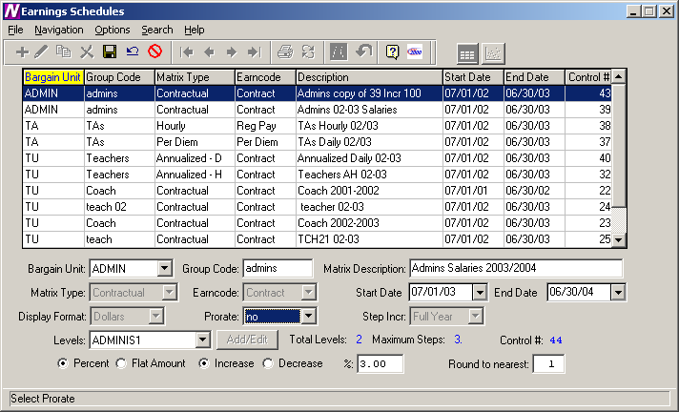

To Copy a Schedule:
- Highlight the desired schedule in the browser and select the Copy record button.
- Change the Bargain Unit, Group Code, Matrix Description, Start/End Dates, and Prorate flag as desired.
- Set the radio button to either increase or decrease the salaries by a specified Percentage or Flat Dollar Amount. Set the radio button to either Increase or Decrease the salaries by a specified amount. If you chose to increase/decrease by a percentage, indicate the percentage increase or decrease. If you chose to increase/decrease by a flat amount, indicate the dollar amount of the increase or decrease.
- If you chose to increase or decrease by a percentage, indicate the manner in which the system should round the salaries. Enter 1 to round to the nearest dollar. Enter 100 to round to the nearest hundred dollars. Otherwise, leave this field blank if you do not wish to round.
The system creates a new schedule that is a replica of the selected schedule. At this point, you may change the level names or any other information as necessary.
Scattergram
After a salary schedule is created, it may be used to generate and view a scattergram of the salary matrix for selected employee types. A scattergram displays the number of full-time equivalent employees at each step and level position in the salary matrix.

From the Earnings Schedules window, highlight the appropriate salary matrix in the browser. At the top right-hand side of the window, select the Scattergram radio button. Press the Scattergram button.

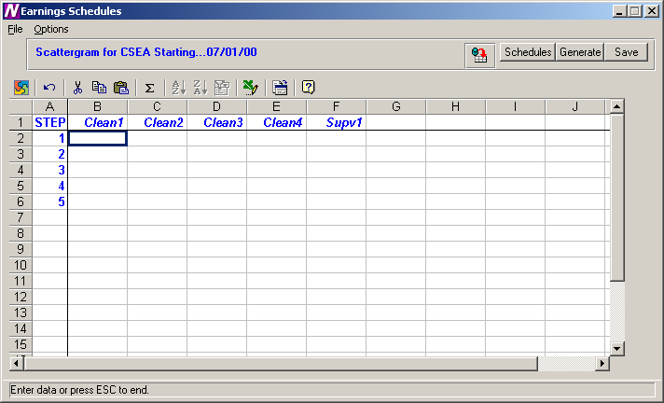

The above window displays the steps and levels associated with the selected salary matrix.

To Create a Scattergram:
- Select the Generate button.
- The Generate Scattergram window displays:
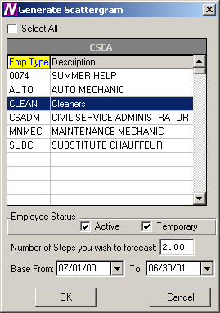
The Generate Scattergram window displays a listing of all employee types associated with the bargaining unit defined in the matrix.
- Use the browser to select the appropriate employee types for which you wish to create the scattergram. Press the Control key to select more than one employee type. Check the Select All check box if you wish to include employees in all employee types when creating the scattergram.
- Use the check boxes under Employee Status to indicate whether you wish to include those employees who are Active and/or those who are Temporary.
- Enter the number of step increases that you wish to forecast. For example, to project a scattergram for two years in the future when employees receive a step increase each year, enter 2.
- Enter the fiscal year base starting and ending date range.
- Press OK to generate the scattergram.

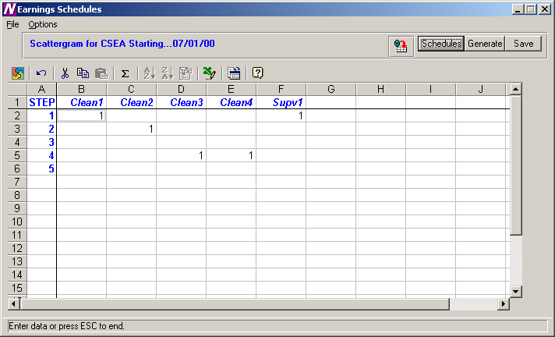

The scattergram shows the number of FTEs associated with each step and level in the salary matrix. Press the Save button to save the scattergram information.

Use the Refresh button to refresh the window to reflect any changes that another user may have made to the scattergram.

To return to the salary schedules window, press the Schedules button.

Earnings Projections
To access the Projections function, select the Earnings Projections option from the Negotiations Manager Data Entry tree menu.

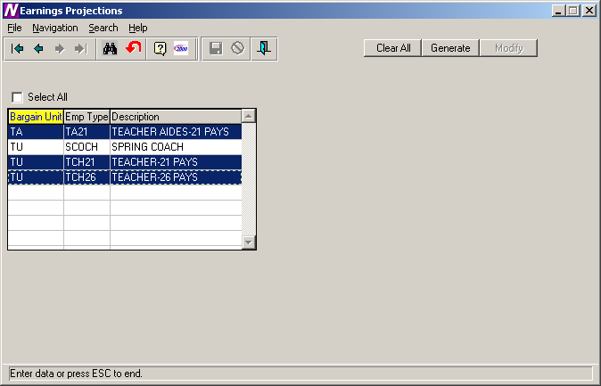

The Earnings Projections function is used to verify existing salary information and make salary projections with the existing salary schedules. The browser only contains employee types that have a Next schedule attached. The system looks in Employee Type Maintenance to find the schedule that has a status of “Next” to make the salary projection. The system only creates a projection if the Renewable flag is checked on the Earnings or Other Earnings window in Employee Maintenance.

To Begin the Earnings Projection Process:
- The browser displays a listing of those employee types for which a schedule exists. Use the browser to select the appropriate employee types for which you wish to project earnings. Press the Control key to select more than one employee type. Check the Select All check box if you wish to include employees in all employee types when projecting earnings.
- Press the Generate button.
Upon selecting the Generate option, the Matrix Type and Generate windows are displayed. The Matrix window contains the valid matrix types (Contract, Annualized, Supplemental, Hourly, and Per Diem) and those salary matrices that exist for the bargaining unit and employee type are preceded by a check mark.
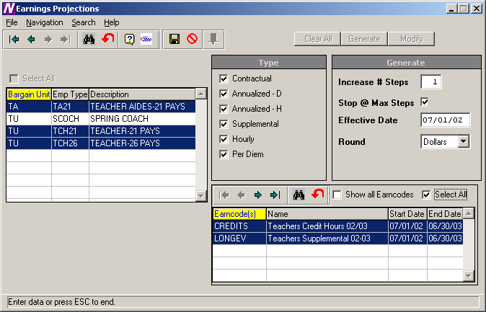

- Uncheck those matrix types that are not to be included in the earnings projection.
- Specify the number of steps to be increased.
- Indicate whether you wish the system to stop projecting to the next step if the employee has already reached the maximum step for the level.
- Enter the effective date of the earnings projection.
- Indicate whether you want the projected amount to be rounded to the nearest Dollars or Cents.
- If you chose Matrix Type “Supplemental”, select the earncodes that you wish to project. Those earncodes highlighted in green are those earning codes for which a salary schedule exists. To display all earncodes from the Earnings Code Maintenance File, check the Show all Earncodes check box.
- Press the Save button.
- If there are two schedules labeled as “Next” for any of the employee types selected, the Employee Salary Schedules selection window is displayed:
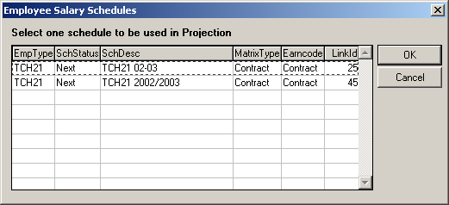
Highlight the appropriate “Next” schedule that you wish to use for this projection. Press the OK button.

To display the Earnings Information window for each employee, press the Modify button.

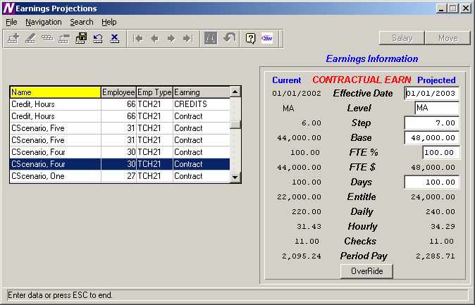

The above window displays the projected salary amounts based on the criteria selected. Use this window to update or delete the projected salary level, step, and earning amount if needed. NOTE: You may NOT add or copy a projection. The Add and Copy buttons are part of the standard Finance Manager toolbar. However, they are not ACTIVE on the MODIFY window.

Clearing Projections
If you wish to clear out the projections that were done using Salary Schedules, select the Salary button on the Earnings Information window. The Earnings Projection window is displayed. Select the appropriate employee type(s) in the browser and choose the Clear All button. This will clear out all projections for the selected employee types.

Sample Projections
Negotiations Manager will handle the projection of those employees who have a salary increment at the start of the fiscal year as well as those employees who have a salary increment in the middle of the fiscal year.

Below are examples of current salary information and how Negotiations Manager will project the new salaries.

Scenario One

 |  | Start | End | Base | Step | Level | Days | Checks | Entitle | Renew  Flag | Incr Date
Current | Contract | 7/1/01 | 6/30/02 | 42,000 | 5 | MA | 200 | 21 | 42,000 | YES | 07/01
Projected | Contract | 7/1/02 | 6/30/03 | 46,000 | 6 | MA | 200 | 21 | 46,000 | YES | 07/01

Scenario Two

 |  | Start | End | Base | Step | Level | Days | Checks | Entitle | Renew  Flag | Incr Date
Current | Contract | 11/1/01 | 6/30/02 | 42,000 | 5 | MA | 180 | 17 | 37,800 | YES | 07/01
Projected | Contract | 7/1/02 | 6/30/03 | 46,000 | 6 | MA | 200 | 21 | 46,000 | YES | 07/01

Scenario Three

 |  | Start | End | Base | Step | Level | Days | Checks | Entitle | Renew  Flag | Incr Date
Current | Contract | 7/1/01 | 12/31/01 | 42,000 | 5 | MA | 100 | 10 | 21,000 | NO | 07/01
 |  | 1/1/02 | 6/30/02 | 44,000 | 6 | MA | 100 | 11 | 22,000 | YES | 07/01
Projected | Contract | 7/1/02 | 6/30/03 | 48,000 | 7 | MA | 200 | 21 | 48,000 | YES | 07/01

Scenario Four

 |  | Start | End | Base | Step | Level | Days | Checks | Entitle | Renew  Flag | Incr Date
Current | Contract | 7/1/01 | 12/31/01 | 42,000 | 5 | MA | 100 | 10 | 21,000 | YES | 01/01
 |  | 1/1/02 | 6/30/02 | 44,000 | 6 | MA | 100 | 11 | 22,000 | YES | 01/01
Projected | Contract | 7/1/02 | 12/31/02 | 46,000 | 6 | MA | 100 | 10 | 23,000 | YES | 01/01
 |  | 1/1/03 | 6/30/03 | 48,000 | 7 | MA | 100 | 11 | 24,000 | YES | 01/01

Scenario Five

 |  | Start | End | Base | Step | Level | Days | Checks | Entitle | Renew  Flag | Incr Date
Current | Contract | 11/1/01 | 12/31/01 | 42,000 | 5 | MA | 80 | 10 | 16,800 | YES | 01/01
 |  | 1/1/02 | 6/30/02 | 44,000 | 6 | MA | 100 | 11 | 22,000 | YES | 01/01
Projected | Contract | 7/1/02 | 12/31/02 | 46,000 | 6 | MA | 100 | 10 | 23,000 | YES | 01/01
 |  | 1/1/03 | 6/30/03 | 48,000 | 7 | MA | 100 | 11 | 24,000 | YES | 01/01

Scenario Six

 |  | Start | End | Base | Step | Level | Days | Checks | Entitle | Renew  Flag | Incr Date
Current | Contract | 10/1/01 | 6/30/02 | 42,000 | 5 | MA | 110 | 14 | 23,100 | YES | 10/01
Projected | Contract | 7/1/02 | 9/30/02 | 44,000 | 5 | MA | 90 | 7 | 19,800 | YES | 10/01
 |  | 10/1/02 | 6/30/03 | 46,000 | 6 | MA | 110 | 14 | 25,300 | YES | 10/01

Modifying Projection Information
The system allows you to update information and will automatically recalculate any earnings information as needed. If you update the FTE%, the system will recalculate the FTE$, Entitlement, and Period Pay amounts. The Override option allows you to change the FTE$, Entitlement, and Period Pay amounts for Contractual and Annualized employees and the system will not recalculate any of the values. The Override option is not applicable for Daily and Hourly employees. The Override option also allows you to update credit hours unit and rate amounts if necessary.

To Update Earnings Information with System Recalculation:
- Highlight the appropriate employee record in the browser on the left-hand side of the window.
- Press the Update button .

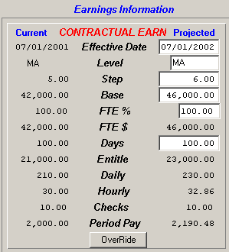

- Update any of the open fields as necessary. For Contractual earnings, you may update the Effective Date, Level, Step, Base, FTE%, and Days. For Annualized Daily, Annualized Hourly, Daily, Hourly, and Supplemental earnings, you may update the Effective Date, Level, Step, Base, FTE%, Days, and Daily and Hourly amounts.
- Press the Save button.

To Update Earnings Information without System Recalculation:
- Highlight the appropriate employee record in the browser on the left-hand side of the window.
- Press the Update button .
- Press the Override button.
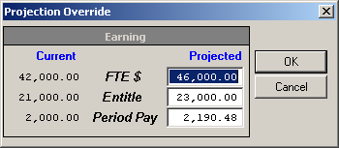
Update the FTE$, Entitlement, and/or Period Pay amount as needed.
- Press the OK button. The system will not recalculate any of the earnings information based on the changes you make.
To Update Credit Hours Information:
- Highlight the appropriate employee record in the browser on the left-hand side of the window.
- Press the Update button .
- Press the Override button.
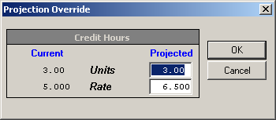
Update the credit hour units and/or rate as needed.
- Press the OK button. The system will recalculate the Base, FTE$, Entitlement, and Period Pay amounts accordingly.

Earnings Global Change
The Earnings Global Change routine is used to increase/decrease salaries by a percentage, flat amount or both for those employees who are in an employee type that is NOT associated with a salary schedule. So for example, if you had one particular employee type that does not use a salary schedule, you would use the Global Earnings Projection to increase/decrease the salaries of employees within that employee type by a percentage, flat amount, or both.

To access the Earnings Global Change function, select the Earnings Global Change option from the Negotiations Manager Data Entry tree menu. The Earnings Global Change (Non-Schedule) window is displayed.

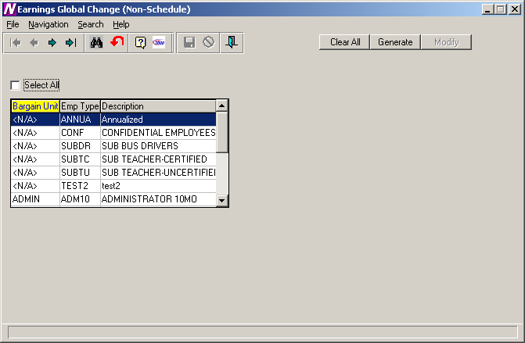

The Earnings Global Change (Non-Schedule) routine is used to search the Payroll files for employees within a specified employee type who are not on Salary Schedules. The system calculates and updates across-the-board increases or decreases in pay rates based on the criteria selected. The browser only shows those employee types that are NOT attached to any schedule labeled as Next. The system only creates a projection if the Renewable flag is checked on the Earnings or Other Earnings window in Employee Maintenance.

To Begin the Earnings Global Change Process:
- The browser displays a listing of those employee types for which NO schedules exist. Use the browser to select the appropriate employee types for which you wish to change earnings. Press the Control key to select more than one employee type. Check the Select All check box if you wish to include employees in all employee types when changing earnings.
- Press the Generate button.
Upon selecting the Generate option, the Type and Generate windows are displayed. The Type window contains the valid pay method types (Contract, Annualized, Supplemental, Hourly, and Per Diem).
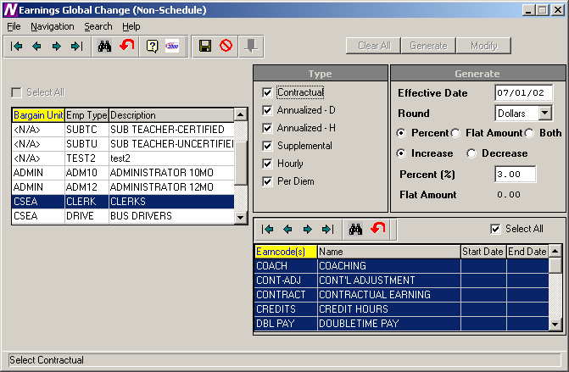
- Check those types (Contractual, Annualized – D, Annualized – H, etc.) that are to be included in the earnings change.
- Enter the effective date of the earnings change.
- Indicate whether you want the changed amount to be rounded to the nearest Dollars or Cents.
- Indicate the manner in which the salary is to be changed. Set the radio button to Percent if the salary is to be changed by a percentage. Set the radio button to Flat Amount if the salary is to be changed by a flat dollar amount. Set the radio button to Both if the salary is to be changed by a combination of a percentage and flat dollar amount (i.e., 3% plus $100.00).
- Set the radio button to either increase or decrease the salaries. Set the radio button to either Increase or Decrease the salaries by a specified amount, percentage, or percentage and amount. If you chose to increase/decrease by a percentage, indicate the percentage increase or decrease in the Percent (%) field. If you chose to increase/decrease by a flat amount, indicate the dollar amount of the increase or decrease in the Flat Amount field. If you chose to increase/decrease by a percentage and flat amount combination, indicate the percentage increase or decrease in the Percent (%) field and the dollar amount of the increase or decrease in the Flat Amount field.
- If you chose Type “Supplemental”, select the earncodes that you wish to change. To display all earncodes from the Earnings Code Maintenance File, check the Select All earncodes check box.
- Press the Save button.

To display the Earnings Information window for each employee, press the Modify button.

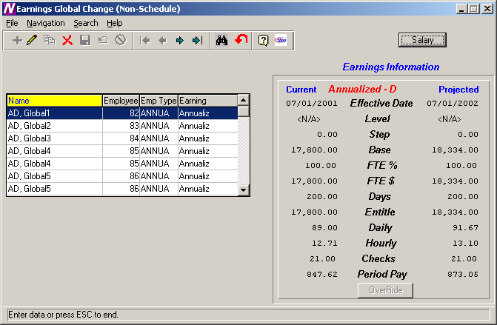

The above window displays the changed salary amounts based on the criteria selected. Use this window to update or delete the global salary change record as needed.
NOTE: You may NOT add or copy a earnings global change record. The Add and Copy buttons are part of the standard Finance Manager toolbar. However, they are not ACTIVE on the MODIFY window.

Clearing Projections
If you wish to clear out the projections that were done for those employees who are NOT using Salary Schedules, select the Salary button on the Earnings Information window. The Earnings Global Change (Non-Schedule) window is displayed. Select the appropriate employee type(s) in the browser and choose the Clear All button. This will clear out all global change records for the selected employee types.

Earnings Move
After the salary information have been projected and carefully reviewed, you may now move the projected salaries into Payroll. The move should only take place after the final fiscal year payroll has been printed and posted.

To move salary information to Payroll, select the Earnings Move option from the Utility menu tree. The Move Projections window displays.

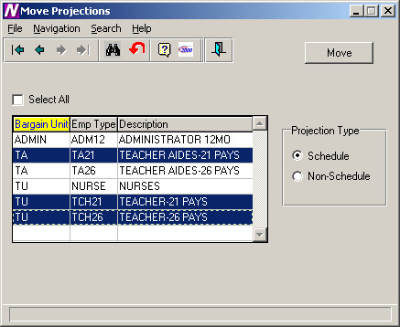

- Select the employee type(s) that you wish to move. You may select more than one employee type by holding the Ctrl key as you highlight the records in the browser.
- Select the Projection Type that you wish to move.
Set the radio button to Schedule if you want to move the salary information that was projected from the salary schedules using the Earnings Projections routine. Set the radio button to Non-Schedule if you want to move the salary information that was 2determined through the Earnings Global Change routine.
- Press the Move button.
- The system displays the question “Has the final Fiscal Year End Payroll been Completed and Posted?”.
If it has been completed and posted, choose Yes and continue the Move process.
If you have not yet printed and posted your final payroll, choose No. You should print and post the final payroll before the move can take place.
- Enter the effective date of the move. This date must be the same date as the Effective Date entered on the Earnings Projection window and is used for correct distribution of account information.
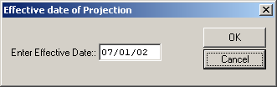
- Press the OK button.

The new salary information can be seen on the Earnings and Other Earnings windows in Payroll Manager. The effective dates of the earnings and the new step are updated accordingly.

IMPORTANT: After the move is completed, you must go to the Schedule folder for the employee type in Employee Type Maintenance and change the Next schedule status from “Next” to “Current” and the Current schedule status from “Current” to “Previous”.

NOTE: If you have already moved your salaries to Payroll and you inadvertently choose to move salaries again, the system will not re-move the salary information. There will be no adverse affects on the data at all.
Earnings Schedule Report
To access the Earnings Schedule Report, select the Earnings Schedule option from the Negotiations Manager Reports tree menu. The Earnings Schedule Report function is used to print the salary matrix information associated with a selected earnings schedule(s). Use this window to select the appropriate earnings schedule(s) that you wish to print.

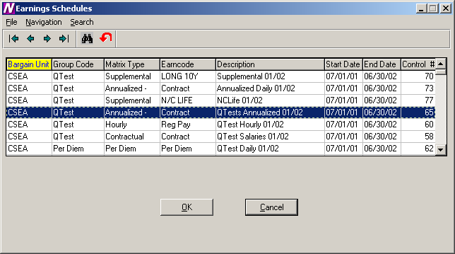

To Print the Earnings Schedule Report:
- Highlight the schedule that you wish to print. Use the Ctrl key to select more than one schedule.
- Select the OK button.
- From the Report Output window, select the desired reporting output destination.

The Earnings Schedule Report displays the bargain unit, group code, matrix type, status, date range, and control number. The salaries are then displayed for each step and level.

05/18/01 FINANCE MANAGER CSD PAGE 1
*****************************************************************************************************************************************************

CSEA CUSTODIANS 2000/2001 Contractual:Contract Status:Active Date Range 07/01/00 - 06/30/01 Control #:17

STEP Clean1 Clean2 Clean3 Clean4 Supv1

1 26,000 27,500 28,500 29,800 32,333
2 26,200 27,800 28,900 29,900 32,575
3 26,400 28,000 29,450 30,000 32,829
4 26,600 28,200 29,700 30,800 33,119
5 26,800 28,400 29,850 31,100

Report Completed 11:07 AM

Earnings Projection Report
To access the Earnings Projection Report, select the Earnings Projection option from the Negotiations Manager Reports tree menu. The Earnings Projection Report function is used to print the projection information entered through the Earnings Projections or Earnings Global Change (Non-Schedule) routines. Use this window to select the reporting criteria that you wish to use.

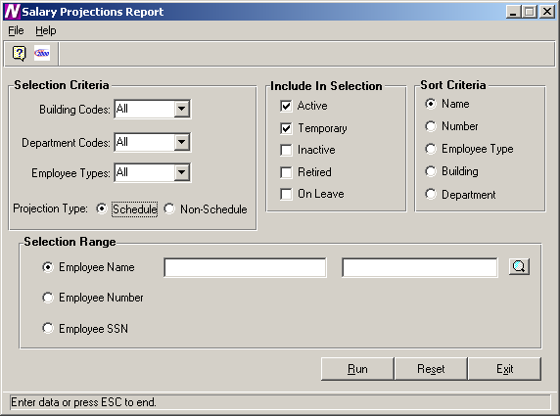

To Print the Earnings Projection Report:
- Define the Selection Criteria.
You may choose to print a report for employees in one or multiple buildings, departments, or employee types. The system defaults to All buildings, departments, and employee types. To print a report for employees in selected buildings, department, or employee types, use the drop-down menu to change the option to Selection. The system displays the lookup magnifying glass which allows you to select one or more buildings, departments, or employee types. In the lookup browser, highlight the appropriate codes that you wish to include in the report. Use the Ctrl key to select more than one code. Press the OK button when you have finished selecting all codes in the lookup browser. The system returns you to the criteria selection window where you can specify additional reporting criteria.
- Indicate the Projection Type as either Schedule or Non-Schedule. Choose Schedule if you wish to print a report containing those employees projected from a salary schedule through the Earnings Projection routine. Choose Non-Schedule if you wish to print a report containing those employees whose salaries are being changed through the Earnings Global Change routine.
- Use the Include in Selection portion of the window to flag the appropriate employee status to be included in the report. The system automatically defaults Active and Temporary employees as the selection. You may also choose to include employees that are Inactive, Retired, or On-Leave by inserting a check mark in the box preceding those employee statuses.
- Use the Sort Criteria portion of the window to select the manner in which information is to be sorted on the report. Information may be sorted in any one of the following ways:
alphabetical order by Employee Name
numerical ascending order by Employee Number
alphabetical order by Employee Type
numerical/alphabetical order by Building Code
numerical/alphabetical order by Department Code
- Use the Selection Range portion of the window to specify those employees who are to be included in the report. You may print a report for a specific range of employee names, employee numbers, or social security numbers.
Move the radio button to the desired selection range. Then use the starting and ending fields to type in the range of employee names, employee numbers, or social security numbers. If desired, use the lookup button to select one or a range of employees.
- After all reporting criteria has been specified, press the Run button. From the Report Output window, select the desired reporting output destination.

To Reset the Earnings Projection Reporting Criteria:
- Select the Reset button.
The system will reset the report criteria back to the original default values.

05/24/01 FINANCE MANAGER CSD PAGE 1
************************************************************************************************************************************************************************************

Contract Salary Projection Listing

Name Emp# Emp Earn Code Old Old Old Old New New New Eff Date New FTE Total Total Chks Total
Type Step Level FTE% Base Step Level FTE% Base Amount Base Actual Per Pay
------------------------------------------------------------------------------------------------------------------------------------------------------------------------------------
Cleaner, Claude 1561 CLEAN Contract 2.00 Clean2 50.00 27,800.00 3.00 Clean2 50.00 07/01/01 28,000.00 14,000.00 28,000.00 14,000.00 26.00 538.46

Cleaner, Robert 1562 CLEAN Contract 4.00 Clean3 100.00 29,700.00 5.00 Clean3 100.00 07/01/01 29,850.00 29,850.00 29,850.00 29,850.00 26.00 1,148.08

Cleaner, Samuel 1563 CLEAN Contract 4.00 Clean4 100.00 30,800.00 5.00 Clean4 100.00 07/01/01 31,100.00 31,100.00 31,100.00 31,100.00 26.00 1,196.15

Cleaner, Steve 1560 CLEAN Contract 1.00 Clean1 100.00 26,000.00 2.00 Clean1 100.00 07/01/01 26,200.00 26,200.00 26,200.00 26,200.00 26.00 1,007.69

Cleaner, Thomas 1564 CLEAN Contract 1.00 Supv1 100.00 32,333.00 2.00 Supv1 100.00 07/01/01 32,575.00 32,575.00 32,575.00 32,575.00 26.00 1,252.88

Earnings Scattergram
To access the Earnings Scattergram Report, select the Earnings Scattergram option from the Negotiations Manager Reports tree menu. The Earnings Scattergram Report function is used to print one or more scattergrams or to compare scattergrams created through the data entry function. NOTE: This report should be run only after you have generated the scattergram through the Scattergram Generation routine (Data Entry to Earnings Schedules to Generate Scattergram).

Use this window to select the appropriate schedule that you wish to use.

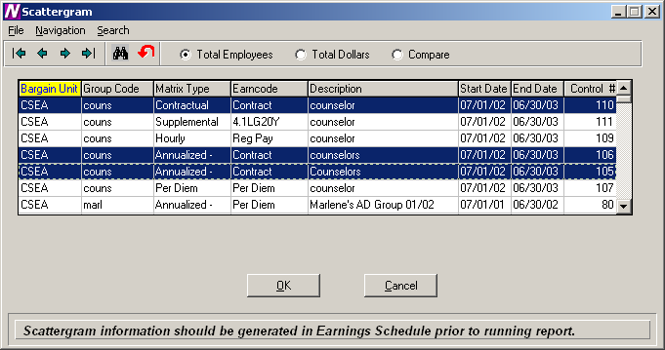

To Print the Scattergram Report:
- Highlight the schedule(s) that you wish to use. Use the Ctrl key to select more than one schedule.
- Choose one of the radio buttons at the top of the window.
Total Employees – Select this option to display the total number of FTEs for each step and level.
Total Dollars – Select this option to display the total number of dollars for the employees at each step and level.
Compare – Select this option to compare the total FTEs and total salary for each schedule chosen. The report will conclude with the differences in the number of employees and the salary amounts between the scattergrams.
- Select the OK button.
- From the Report Output window, select the desired reporting option.

05/23/01 FINANCE MANAGER CSD PAGE 1
*****************************************************************************************************************************************************

CSEA CUSTODIANS 2000/2001 Contractual:Contract Status:Active Date Range 07/01/00 - 06/30/01 Control #:17

STEP Clean1 Clean2 Clean3 Clean4 Supv1

1 1.00 1.00
2 .50
3
4 1.00 1.00
5

09/18/01 FINANCE MANAGER CSD PAGE 1

*****************************************************************************************************************************************************

CSEA COUNSELOR Contractual:Contract Status:Projection Date Range 07/01/02 - 06/30/03 Control #:110

STEP C30

1
2
3 63,860.00
4
5

Report Completed 10:44 AM

05/23/01 FINANCE MANAGER CSD PAGE 1
*****************************************************************************************************************************************************

CSEA CUSTODIANS 2000/2001 Date Range 07/01/00 - 06/30/01 Control #:17

Total Employees : 5 Total Amount : $132,733.00

CSEA CLEANERS SALARIES 2001/2002 Date Range 07/01/01 - 06/30/02 Control #:18

Total Employees : 5 Total Amount : $151,000.00

Differences Employees : 0 Amount : $18,267.00

Report Completed 4:17 PM

Account Code Breakdown
To access the Account Code Breakdown Report, select the Account Code Breakdown option from the Negotiations Manager Reports tree menu. The Account Code Breakdown Report routine provides a listing of budgetary account code information that may be printed after salary projections have been made but prior to moving the earnings to Payroll. Use this window to select the appropriate bargaining units and employee types that you wish to use.

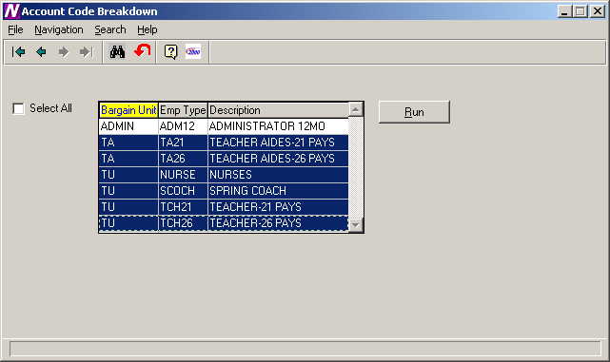

To Print the Account Code Breakdown Report:
- Select the bargaining units and employee types that you wish to use. Use the Ctrl key to select more than one employee type or check the Select All box to include all employee types.
- Press the Run button.
- From the Report Output window, select the desired reporting output destination.

The Account Code Breakdown Report prints the costs of the projected salary in account code order. Within each account code, the report includes the employee name, employee number, employee type, earning code, account percentage, and amount expensed to the account code.

The report provides totals for each account and fund. The report concludes with a grand total of earning amounts.

NOTE: Once the salary information has been moved to Payroll, you may run the Contract and Rate Report or the Account Code Breakdown Report from the Payroll Diagnostic Report Menu to see the employee’s earnings information.

05/29/01 FINANCE MANAGER CSD PAGE 1
**********************************************************************************************************************************

PROJECTED EARNING AMOUNTS BY ACCOUNT

Account Employee Name Emp# Emp Type Earning Account% Amount
==================================================================================================================================

A 1240.165-10 - OFFICE OF THE SUPERINTEN:NON-INST INCENTIVE SECRE
-----------------------------------------------------------------

Cleaner, Robert 1562 CLEAN Contract 75.00 22,387.50
------------
ACCOUNT TOTAL 22,387.50

A 1310.161-10 - NON INSTRUCTIONAL OT
------------------------------------

Cleaner, Steve 1560 CLEAN Contract 50.00 13,100.00
------------
ACCOUNT TOTAL 13,100.00

A 1430.150-10 - PERSONNEL:INSTRUCTIONAL SALARIES
------------------------------------------------

Cleaner, Samuel 1563 CLEAN Contract 100.00 31,100.00
------------
ACCOUNT TOTAL 31,100.00

A 1430.161-10 - NON INSTRUCTIIONAL OT
-------------------------------------

Cleaner, Claude 1561 CLEAN Contract 100.00 14,000.00
------------
ACCOUNT TOTAL 14,000.00

A 1620.162-10 - PLANT MAINTENANCE:NON-INSTRUCTIONAL SUMMER
----------------------------------------------------------

Cleaner, Steve 1560 CLEAN Contract 50.00 13,100.00
------------
ACCOUNT TOTAL 13,100.00

05/29/01 FINANCE MANAGER CSD PAGE 2
**********************************************************************************************************************************

PROJECTED EARNING AMOUNTS BY ACCOUNT

Account Employee Name Emp# Emp Type Earning Account% Amount
==================================================================================================================================

------------
ACCOUNT TOTAL 32,575.00

------------
FUND TOTAL 133,725.00

------------
GRAND TOTAL 133,725.00

Report Completed 4:38 PM

Steps/Levels Validation
To access the Steps/Levels Validation Report, select the Steps/Levels Validation option from the Negotiations Manager Reports tree menu. The Steps/Levels Validation Report function provides a utility which checks each employee record to ensure that the employee is assigned to a valid step and level within the current schedule linked to each employee type. If the system finds employees who are not assigned to a valid step and level within a selected salary matrix, a report is produced indicating the errors found. Use this window to select the appropriate salary matrix that you wish to use.

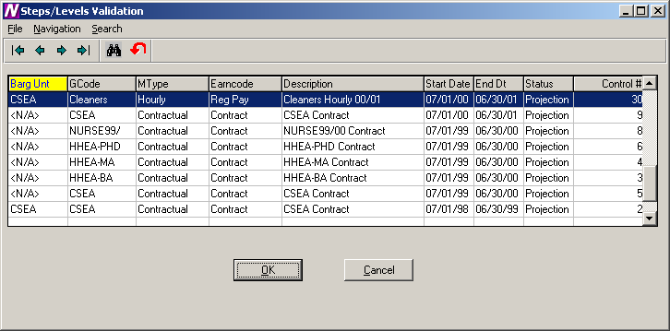

To Run the Step/Level Validation Process:
- Highlight the salary matrix that you wish to use.
- Select the OK button.
- From the Report Output window, select the desired reporting option.
If no errors are found, the system displays a message box indicating that all employees are at a valid step and level.
If errors are found, a report is generated which includes the following information: employee type, employee number, employee name, earning code, and invalid salary step and level.

05/29/01 FINANCE MANAGER CSD PAGE 1
********************************************************************************************************

Employee Earnings at an Invalid Salary Step and Level - By Employee Type By Employee Number

Emp Type Emp Num Emp Name Earning Step Level
--------------------------------------------------------------------------------------------------------
CLEAN 1571 Jackson, Mark Reg Pay 1 Hrly Cln

Report Completed 3:13 PM

Earnings Projection Letters
To access the Earnings Projection Letters, select the Earnings Projection Letters option from the Negotiations Manager Reports tree menu. The Earnings Projection Letters function provides the ability to print a salary letter after salaries are projected. Use the Selection window to select the reporting criteria that you wish to use.

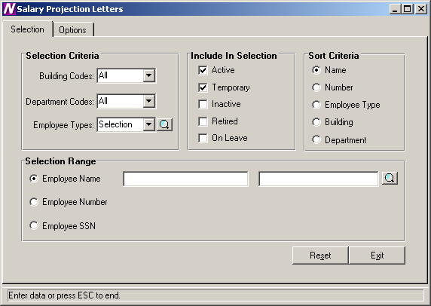

To Select Earnings Projection Letter Criteria:
- Define the Selection Criteria.
You may choose to print a report for employees in one or multiple buildings, departments, or employee types. The system defaults to All buildings, departments, and employee types. To print a report for employees in selected buildings, department, or employee types, use the drop-down menu to change the option to Selection. The system displays the lookup magnifying glass which allows you to select one or more buildings, departments, or employee types. In the lookup browser, highlight the appropriate codes that you wish to include in the report. Use the Ctrl key to select more than one code. Press the OK button when you have finished selecting all codes in the lookup browser. The system returns you to the criteria selection window where you can specify additional reporting criteria.
- Use the Include in Selection portion of the window to flag the appropriate employee status to be included in the report. The system automatically defaults Active and Temporary employees as the selection. You may also choose to include employees that are Inactive, Retired, or On-Leave by inserting a check mark in the box preceding those employee statuses.
- Use the Sort Criteria portion of the window to select the manner in which information is to be sorted on the report. Information may be sorted in any one of the following ways:
alphabetical order by Employee Name
numerical ascending order by Employee Number
alphabetical order by Employee Type
numerical/alphabetical order by Building Code
numerical/alphabetical order by Department Code
- Use the Selection Range portion of the window to specify those employees who are to be included in the report. You may print a report for a specific range of employee names, employee numbers, or social security numbers.
Move the radio button to the desired selection range. Then use the starting and ending fields to type in the range of employee names, employee numbers, or social security numbers. If desired, use the lookup button to select one or a range of employees.
- After all reporting criteria has been specified, use the Options window to indicate the additional text and information that is to be displayed on the letter.

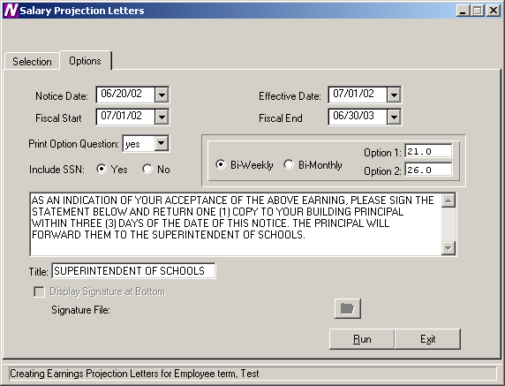

Use this window to indicate the additional text and information that is to be displayed on the letter.

To Enter Projection Letter Options:
- Enter the date (in MM/DD/YY format) that is to be displayed on the letter or notice. This date displays to the left of the school official’s signature line.
- Enter the effective date of the letter.
- Enter the fiscal start and end dates.
- Set the Print Option Question field to Yes if you want the letter to include the payment options section (for example, 26 equal payments or 21 equal payments). Then specify the check options.
Set the Print Option Question field to No if the payment options portion is to be excluded from the letter.
- Specify whether the projection letter should include the employee’s social security number. Set the radio button to YES to display the employee’s social security number. Set the radio button to NO if you do not want to display the employee’s social security number.
- Set the radio buttons to indicate whether the employees are paid on a bi-weekly or bi-monthly basis. Then indicate the minimum and maximum number of checks per year.
- Use the default letter text or change it as needed.
- Enter the title of the individual who is signing the Projection Letter.
- Press the Run button. From the Report Output window, select the desired reporting output destination.

DEMO SCHOOL DISTRICT
10 SCHOOL WAY
NEW YORK,NY 14444

Hours Credit SOC SEC NUMBER: 234-98-2034
PRIME LOCATION: <N/A>
, NY

YOU ARE HEREBY NOTIFIED THAT YOUR COMPENSATION FOR THE 2002 - 2003 SCHOOL YEAR
AS TEACHER-21 PAYS IS:

START DATE END DATE EARNING STEP LEVEL AMOUNT
---------- -------- ------------------------------ ----- -------- ----------
07/01/02 06/30/03 CONTRACTUAL EARNING 5.00 MA 44,000.00
07/01/02 06/30/03 CREDIT HOURS 5.00 CR 19.50

TOTAL EARNINGS FOR 2002 - 2003 SCHOOL YEAR 44,019.50

AS AN INDICATION OF YOUR ACCEPTANCE OF THE ABOVE EARNING, PLEASE SIGN THE
STATEMENT BELOW AND RETURN ONE (1) COPY TO YOUR BUILDING PRINCIPAL WITHIN
THREE (3) DAYS OF THE DATE OF THIS NOTICE. THE PRINCIPAL WILL FORWARD THEM TO
THE SUPERINTENDENT OF SCHOOLS.

THANK YOU FOR YOUR COOPERATION IN THIS MATTER

DATE: 06/24/02 BY:_____________________________________
SUPERINTENDENT OF SCHOOLS

******************************************************************************

I ACCEPT THE ABOVE COMPENSATION AND FURTHER STATE THAT I AM PROPERLY QUALIFIED FOR
THE POSITION I HOLD.

I REQUEST THAT THE ABOVE EARNING BE PAID TO ME IN (CHECK ONE):
(NOTE: THIS OPTION MAY NOT BE CHANGED DURING THE SCHOOL YEAR)

( ) 21.0 PAYMENTS

( ) 26.0 PAYMENTS

DATE: ______________ EMPLOYEE'S SIGNATURE: _________________________
Budgetary Interface
To access the Budgetary Interface, select the Budgetary Interface option from the Utility Negotiations Manager Reports tree menu.

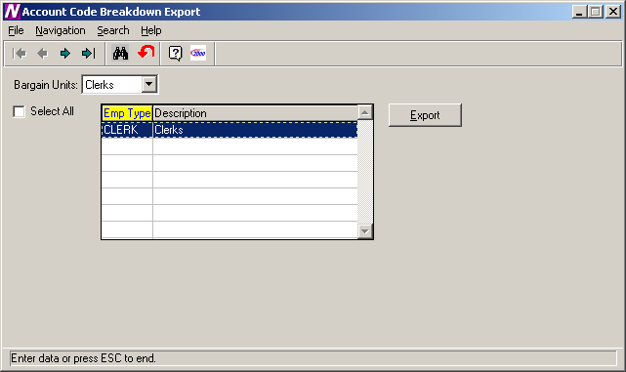

The Budgetary Interface function is used to export generated salary projections to Budget Manager.

To Begin the Budgetary Interface Process:

- Use the drop-down menu to select the bargaining unit for which salary information is to be exported.

The Budgetary Interface window displays a listing of all employee types associated with the selected bargaining unit.

- Use the browser to select the appropriate employee types for which you wish to export. Press the Control key to select more than one employee type. Check the Select All check box if you wish to include employees in all employee types when projecting earnings.

- Press the EXPORT button.

After the EXPORT button is clicked the Projected salary information will be exported and be ready for import into the Budget using the Load Salary Notes routine in Budget Manager.

