How can I encumber my salaries to be paid from Payroll?

- FM2000 has an automated routine which will allow a user (with the appropriate permissions) to establish an encumbrance for remaining payroll salary amounts (Contractual, Annualized and Supplemental). This is done by creating a PO that not only will be liquidated anytime an expenditure against one of these encumbrances is made and distributed to Accounting (via the Payroll to GL routine), but can also be updated to account for changes in salary.

Critical Note: Before proceeding with the payroll encumbrance procedure, ALL payrolls for the current fiscal year MUST be distributed to the Accounting module via the Payroll to General Ledger procedure in Accounting Manager. Failure to distribute all payrolls may cause appropriation accounts to show inflated unencumbered balance amounts. This is caused from the Payroll PO routine calculating remaining amounts in the Payroll module which have been decreased by payrolls that may not have already been expensed and/or liquidated through the Payroll to General Ledger routine.

Steps to Creating a Payroll Encumbrance:

To proceed with Establishing Payroll Encumbrance amounts and creating a Purchase Order, proceed to the Accounting Manager module. From the Data Entry drop-down, choose Purchase Orders and proceed to the Payroll Purchase Order routine.

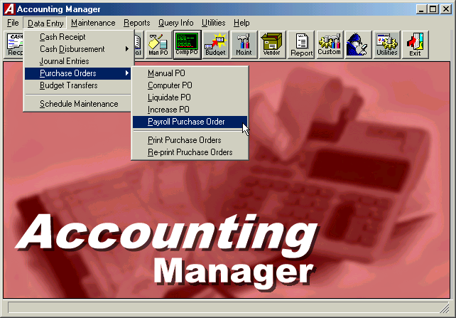

The following is a list of basic steps involved to Establish/Reestablish a Payroll Encumbrance:

- Reports - Print the Contractual Amounts by Account and/or Contractual Amounts by Employee (see attached samples) to verify remaining Contractual, Annualized and/or Supplemental amounts to be paid. This is done by choosing the Reports radio button on the lower left side of the Routine Selection box and then selecting the appropriate report you wish to print in the Report Selection box. Be sure to choose the criteria from the Remaining Balances Criteria box that you wish for the system to use in calculating the report. These include whether or not to include Supplemental Appointments (versus only Contractual and Annualized), Employees on Leave and Temporary Employees (versus only Active employees).

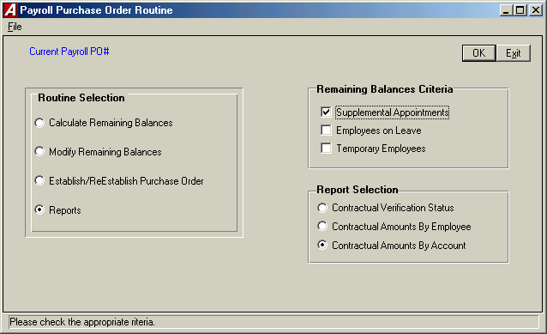

- Calculate Remaining Balances – This step will establish what the remaining amounts to be paid are (based on Criteria chosen in the Remaining Balances Criteria box) by calculating remaining salaries from Payroll Manager.

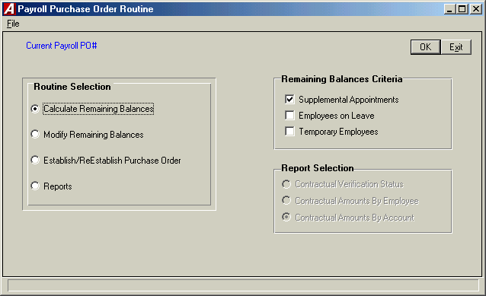
- Modify Remaining Balances – This area will allow you to view/change the remaining amounts that were created in Step 2, prior to establishing or reestablishing the PO.

Note: Changes made here may be deleted after reestablishing the payroll encumbrance since every time the Calculate Remaining Balances routine is run, the system is calculating remaining amounts based on ACTUAL payroll salaries and does not include these changes made.

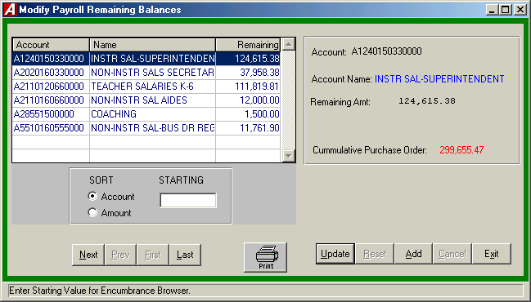

- Establish/Reestablish Purchase Order (You MUST calculate remaining balances prior to running this routine)

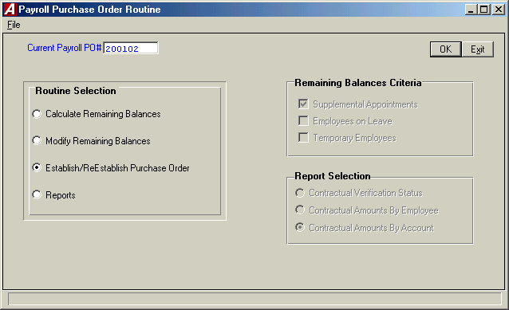

  - Establish Purchase Order - If there currently is not a Payroll Purchase Order being used, the Establish/Reestablish PO routine will ask for a PO#. Since this usually is not a physical PO, choose a number that is meaningful, but does not duplicate any other PO numbers entered on the system.
  - Reestablish Purchase Order - If there is currently a Payroll Purchase Order being used, the Establish/Reestablish PO routine will NOT prompt for a PO#, but will simply compare the current amounts established to the current PO balances by account and make any adjustments (Increases or Liquidations) to the Purchase Order that may be necessary.
    - When running this procedure, you will be asked to select a schedule for the encumbrances to be placed within and an effective date. The date should be any date on or after the last payroll distributed and an appropriate schedule should be chosen.

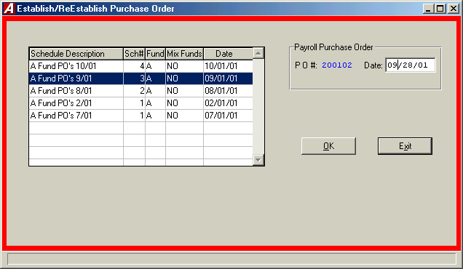

- Once a Purchase order has been established, the system will automatically fill the PO number into the Purchase Order# field on the Set Payroll Parameters screen

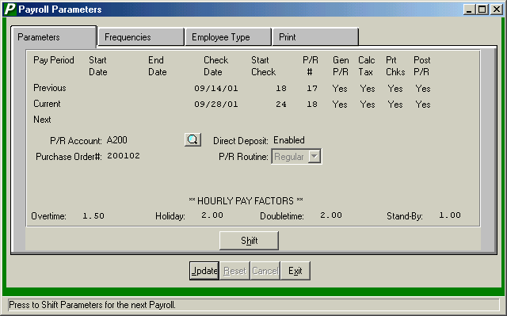

Other Notes:

- After encumbering payroll, when you distribute a payroll into accounting, the Payroll to GL routine will automatically liquidate the encumbrance by the amount of the expense distributed up to the amount currently encumbered

- The payroll PO is treated just like a normal purchase order which can be liquidated through the cancel/partial liquidation routine

- At fiscal year end, the payroll PO must be canceled (fully liquidated), and the number removed from the Set Payroll Parameters screen until a PO (with a different number) is established in the new fiscal year

Sample Reports
Contractual Amounts by Account:
10/28/01 DEMO SCHOOL DISTRICT PAGE 1
***********************************************************************************************************************
REMAINING CONTRACTUAL BALANCES BY ACCOUNT
ACCOUNT EMPLOYEE EMP # TYPE EARNING LIMIT PAID REMAINING
***********************************************************************************************************************
A 1240.150-33-0000 ADMINISTRATOR, JILL A 8 ADM12 Contract 135,000.00 10,384.62 124,615.38
--------------- --------------- ---------------
135,000.00 10,384.62 124,615.38

A 2020.160-33-0000 HUDSON, ROCK 5 FS Contract 41,954.00 3,995.62 37,958.38
--------------- --------------- ---------------
41,954.00 3,995.62 37,958.38

A 2110.120-66-0000 TEACHER, JOHN T 2 TCH26 Contract 52,785.00 2,030.19 50,754.81
TEACHER2, SAMANTHA 10 TCH21 Contract 61,065.00 0.00 61,065.00
--------------- --------------- ---------------
113,850.00 2,030.19 111,819.81

A 2110.160-66-0000 AIDE, TEACHER 11 TA26 Contract 12,000.00 0.00 12,000.00
--------------- --------------- ---------------
12,000.00 0.00 12,000.00

A 2855.150-00-00 TEACHER, JOHN T 2 SCOCH COACH 2,000.00 500.00 1,500.00
--------------- --------------- ---------------
2,000.00 500.00 1,500.00

A 5510.160-55-5000 ANNUALIZE, JOSEPH T 9 DRIVE Contract 13,000.00 1,238.10 11,761.90
--------------- --------------- ---------------
13,000.00 1,238.10 11,761.90
--------------- --------------- ---------------
317,804.00 18,148.53 299,655.47

Contractual Amounts by Employee:

10/28/01 DEMO SCHOOL DISTRICT PAGE 1
**********************************************************************************************************************
REMAINING CONTRACTUAL BALANCES BY EMPLOYEE
EMPLOYEE NAME EMP # TYPE EARNING ACCOUNT LIMIT PAID REMAINING
**********************************************************************************************************************
ADMINISTRATOR, JILL A 8 ADM12 Contract A1240150330000 135,000.00 10,384.62 124,615.38
--------------- --------------- ---------------
135,000.00 10,384.62 124,615.38

AIDE, TEACHER 11 TA26 Contract A2110160660000 12,000.00 0.00 12,000.00
--------------- --------------- ---------------
12,000.00 0.00 12,000.00

ANNUALIZE, JOSEPH T 9 DRIVE Contract A5510160555000 13,000.00 1,238.10 11,761.90
--------------- --------------- ---------------
13,000.00 1,238.10 11,761.90

HUDSON, ROCK 5 FS Contract A2020160330000 41,954.00 3,995.62 37,958.38
--------------- --------------- ---------------
41,954.00 3,995.62 37,958.38

TEACHER, JOHN T 2 SCOCH COACH A28551500000 2,000.00 500.00 1,500.00
TCH26 Contract A2110120660000 52,785.00 2,030.19 50,754.81

--------------- --------------- ---------------
54,785.00 2,530.19 52,254.81

TEACHER2, SAMANTHA 10 TCH21 Contract A2110120660000 61,065.00 0.00 61,065.00
--------------- --------------- ---------------
61,065.00 0.00 61,065.00
--------------- --------------- ---------------
317,804.00 18,148.53 299,655.47

