Transfer Earnings Between Accounts
The transfer earnings routine provides for the transfer of earnings from one account and/or earning code to another. A transfer is the process of changing the classification and/or account distribution for amounts of money that have already been paid.

To access the Transfer Earnings Between Accounts function, select the Transfer Earnings Between Accounts option from the Utilities drop-down menu or Utilities button OR simply select the Account Transfer button from the Account area of the Employee Earnings folder in Employee Maintenance.

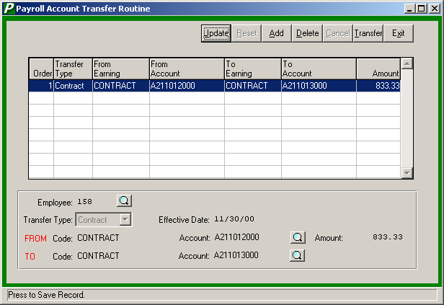

The following Maintenance buttons are accessible on this window:

Push Button | Action
Update | This option is used to update any transfer earnings record that are currently displayed in the transfer window browser.
Save | This option is used to save any new or updated transfer earnings record into the transfer window browser.
Reset | This option is used to clear any information that you have currently entered either through Update or Add and re-enter a transfer record.
Add | This option is used to add a transfer earnings record into the transer window browser for a specified employee. The system only permits you to enter transfer records for one employee at a time.
Delete | This option is used to delete a transfer earnings record from the current transfer window browser.
Cancel | This option is used to cancel out of Add or Update mode without saving changes.
Transfer | This option is used to transfer all earnings transfer records currently displayed in the transfer window browser. The system will not allow you to exit the transfer function if there are records in the current transfer window browser that have not been transferred.
Exit | This option returns you to the window from which the Transfer routine was accessed. The system returns you to either the Employee Earncodes window or the Payroll Manager Main Menu.

Field | Description
Employee | The number that uniquely identifies the employee. If necessary, use the Employee Lookup browser to select the appropriate employee. The lookup allows you to search for an employee by name, employee number, or social security number. The system defaults the employee name and social security number upon entry of the employee number.  NOTE: If you selected the Transfer Earnings function via the Employee Earncodes window, the employee number, name, and social security number defaults based on the employee record selected and the employee number cannot be modified.
Transfer Type | Indicate the type of transfer. Valid types are Contract or Earnings. The Contract Transfer Type should be used for contract only. The Earnings Transfer Type should be  used when transferring regular pay from one account to another.
Effective Date | Enter the effective date (in MM/DD/YY format) of the transfer. The date entered here is treated like a check date for Accounting purposes.  NOTE: The date of the transfer should be the next payroll date. This will cause the transfer to appear on the Payroll Transaction Journal for the next payroll. The effect of the transfer will be reflected in the budget accounts after the entry is posted. If dated accordingly, no additional accounting entry will be necessary to record the transfer.
FROM Code | This field identifies the earning code from which money is to be transferred. If the transfer type is Contract, the system defaults the Transfer From Code to CONTRACT and does not allow this default code to be changed. If the transfer type is Earnings, use the lookup browser to select from the employee’s existing earnings codes.
From Account | Enter the account code that identifies the account from which the specified earnings are to be transferred. By using the lookup feature, you will easily be able to choose the account code by employee type and differentiate appointments.  NOTE: The From Account must be an existing code defined for the employee in the Employee Maintenance File.
Amount | Enter the amount of the earnings to be transferred.
TO Code | This field identifies the earning code to which money is to be transferred. If the transfer type is Contract, the system defaults the Transfer To Code to CONTRACT and does not allow this default code to be changed. If the transfer type is Earnings, use the lookup browser to select from a listing of all valid earnings codes.
To Account | Enter the account code that identifies the account to which the specified earnings are to be transferred. By using the lookup feature, you will easily be able to choose the account code by employee type and differentiate appointments. If the transfer type is Contract, the To Account must be an existing code defined for the employee in Employee Maintenance. If the transfer type is Earnings, use the lookup browser to select from the employee’s existing earnings codes or use the Add button to select from a listing of all valid earnings codes.  NOTE: The Add button is not active if the Transfer Type is Contract OR when transferring earnings to a Contract, Docked, or Contract Adjustment code.

Adding an Earnings Transfer Record
- Select the Add button.
- Enter the employee number, transfer type, effective date, from/to earnings and account codes, and the transfer amount. Press the Save button. The saved record is displayed in the browser. Enter as many transfer records as needed for the specified employee. NOTE: The system only allows you to enter earnings transfer records for one employee at a time.
- Select the Transfer button to transfer the earnings. The system will not permit you to exit the Transfer routine if records exist that have not been transferred.
- Once the transfer process is complete, it may be necessary to return to the Employee Earncodes window and fix the earn limit and anything else related to the account distribution.

Updating an Earnings Transfer Record
- Highlight the appropriate record in the browser.
- Select the Update button.
- Make change(s) by typing over the existing information.
- Press the Save button. The saved record is displayed in the browser.
- Select the Transfer button to transfer the earnings. The system will not permit you to exit the Transfer routine if records exist that have not been transferred.
- Once the transfer process is complete, it may be necessary to return to the Employee Earncodes window and fix the earn limit and anything else related to the account distribution.

Deleting an Earnings Transfer Record
- Highlight the appropriate record in the browser.
- Select the Delete button.
- The system prompts you to confirm that this is the correct action that you wish to take.
Enter YES to delete the transfer record.
Enter NO if you do not wish to delete the transfer record.

How to Use the Transfer Function
Let’s say that a Contractual employee has already received one paycheck but the salary is being distributed to the incorrect budget code. The Analysis folder in Employee Maintenance shows the following information:

To properly correct the salary expense distribution from this point forward, the correct budget code should be added to the Employee Earncodes window with zero as the Percent, zero as the Earn Limit, and zero as the Amt/Chk as shown in the illustration below:

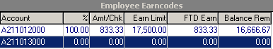

Now that the correct budget code exists in the employee’s appointment record, the transfer process can be performed. Using the Transfer Earnings Between Accounts function, transfer the money from the incorrect account code to the correct account code.

After the Transfer is completed, go back to the Employee Earncodes window and zero out the Percent, Amt/Chk, and Earn Limit for the incorrect account code. Then make any necessary adjustment to the Percent on the correct budget code record.

