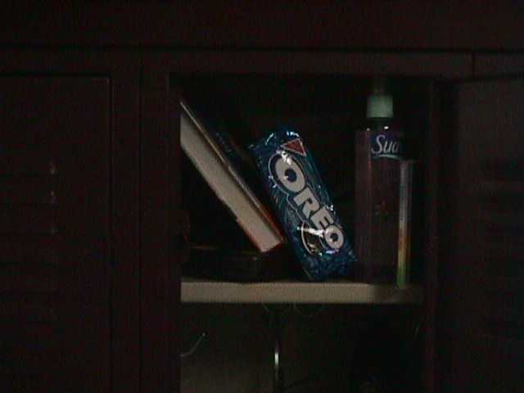
Can you find….

Eastbay catalog
Headphones
Messy papers

Binders
Clothes
Food
Sneaker
Pop Can
Koosh ball
Lunch bag
Hair spray
Books
CD/CD player
Top section, other sections on next page
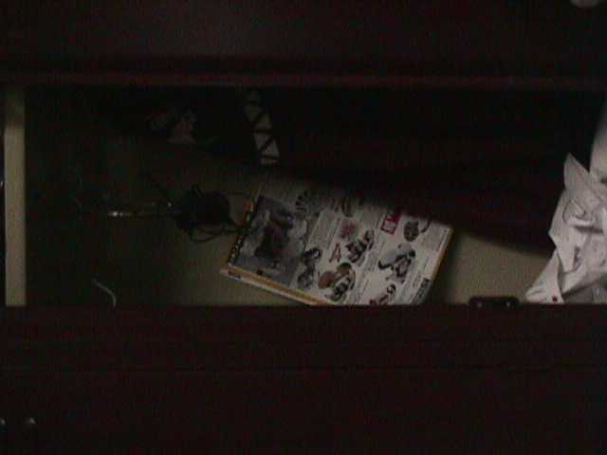
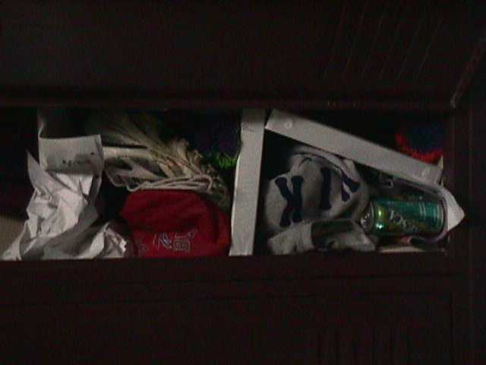

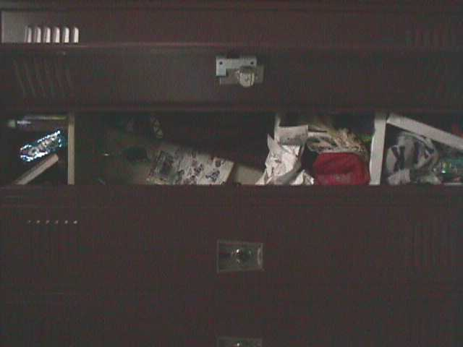
What’s wrong with this locker?

