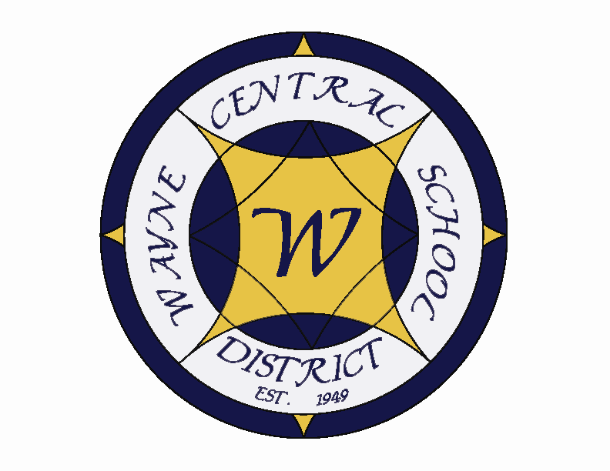
Letter to the Board

Michael Havens
Superintendent of Schools
Phone: 315-524-1001 Fax: 315-524-1049 mhavens@wayne.k12.ny.us

July 7, 2006

“It is hard to fail, but it is worse never to have tried to succeed."
--Theodore Roosevelt, 26th president of the U.S.

Greetings from Wayne Central. Below are a few items of interest.

Board Agenda:

- Reorganizational Meeting: This follows the same procedure as past years. The changes are as follows;
  - Mileage reimbursement increases from 40.5 to 44.5 cents/mile as per federal guidelines.
  - Custodial rates for building use went from $22.50 to $23.50 due to contract increases.
  - Food Services rates for building use went from $20.85 to $21.85 due to contract increases.
  - Equipment is designated as those items having a value in excess of $1,000 up from $500 to comply with Federal guidelines.
  - The Board will need to appoint
    - representative to safety committee
    - representative and alternate to BOCES
    - Four County Board of Directors (president, vice president)
    - legislative committee (Mrs. Lyke and Mr. Schultz last year)
    - Program committee (Mr. Wyse and Mr. Johnson last year)
    - Liaison to energy performance project (Mr. Griswold last year)
    - Policy committee and Chairman
    - audit committee (committee of the whole last year)
    - Increase Voter Turnout (Mr. Griswold, Mrs. Lyke, Mr. Schultz, Mr. Davis)
- Regular Meeting
  - Annual Report: Enclosed is the annual report reflecting how our students did academically this year. I will be reviewing the report with the Board.
  - Vacancy Committee: The Board vacancy committee will review its plans with the public for replacing Mr. Davis.
  - Auditing Committee: The auditing committee needs to have its first meeting. I suggest it be the same date as the financial workshop discussed below.
  - Financial Workshop: The Board has requested that Mr. Atseff repeat the financial workshop he gave a couple years ago to refresh our memories about the critical items the Board should be watching for in the monthly financial reports. This will be especially good for new Board members.
  - Financial Report: Greg has been away for awhile. It will be good for him to give us his monthly report again. You should also ask him questions about the end of the year fund balance.
  - Consensus Agenda: There are a number of consensus agenda items including approving the agreement with district office non-represented salaried employees which Mark presented to you at the last meeting, and the amended AIS plan as presented to you by Mr. Spring in June.

