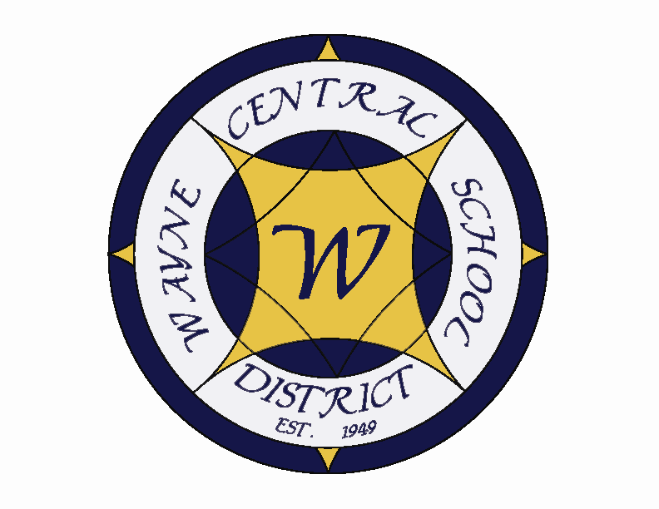
Letter to the Board

Michael Havens
Superintendent of Schools
Phone: 315-524-1001 Fax: 315-524-1049 mhavens@wayne.k12.ny.us

June 23, 2006

“We should all be concerned about the future because we will have to spend the rest of our lives there."
--Charles F. Kettering, Inventor, Philosopher

Greetings from Wayne Central. Below are a few items of interest.

Board Letter:

- Monroe County Sales Tax Issue: Last night we discussed and you passed the resolution joining the Monroe County Sales Tax issue. Here are a few more details about it. The issue being litigated by 39 school districts versus Monroe County is the dispute over the distribution of sales tax collected by the county. The County wants to intercept the funds to pay Medicaid costs. The County is suing the municipalities and school districts to allow them to do it. Wayne Central receives a share from the sales tax from Monroe County and has, therefore, joined in the lawsuit. The costs associated with the lawsuit are divided among the schools and municipalities. We will pay only ½ a share because we do not receive as much money, however as pointed out last night, we receive even less proportionally than that.

- Middle School State Recognition: Attached is a letter and certification from the State Education Department recognizing TCA Middle School as one of New York State’s 795 “high performing/gap closing” schools. Of the specific criteria the state designates for this recognition, 2, 129 public schools met this criteria, and only 137 middle schools achieved this recognition. As noted in the letter, the middle school did so by meeting all applicable state standards for ELA and math in the 2004-05 school year and by making adequate yearly progress in 2003-04 and 2004-05. I would like to commend Mr. Armocida for all his efforts in making this happen, and all the middle school staff for all they have done to make these gains with their students at a time when middle schools across the state are struggling to make any gains. Significant improvement like this does not occur by accident. It is through the collaborative efforts of many, many members of our educational team from our administration, to our teachers, to our aides across the grades.

- Retirement Recognition: As you know, last night was Jackie’s last board meeting, thus ending a 12 year career as a vibrant, passionate, dedicated and knowledgeable member of the Board of Education. We will miss her and are sorry to let her go, but extend our best wishes for a wonderful retirement, and many pleasant, peaceful, quiet Thursday evenings doing whatever she wants to do!

- Train Station Move: On Thursday, June 28, the folks at Heritage Square will be moving the train station from its long standing location on Railroad Avenue to a new home at Heritage Square. This will occur between 8:00 a.m. and noon. This was accomplished through community fund raising and a grant from Senator Nozzolio. The Historical Society plans to use the building as meeting space, and a train museum. As those of you in Rotary know, it is in relatively good shape and has been kept in its original form with many original features of a train depot. I am very pleased to see another piece of history preserved by the efforts of the historical society and local residents. (by the way, the Board of Education endorsed this project to the state to help with the grant award).

- Fence: The fence along the north side of the high school is finished. We did have one problem which Mr. Miller had to fix. In one place the fence jagged upward from the creek leaving a 1 foot square space at the bottom of one part.......You guessed it. Some of our boys found it was just the right size for them to crawl under. Bob has remedied that situation. We will have to watch to see if there are other “holes” in our fence. If there are I am sure our students will show them to us.

- Class of 2006 Donation: I am very pleased to announce that at their graduation rehearsal Thursday morning, by a unanimous vote, the Wayne Central Class of 2006 has donated $3000 of their class funds to the Wayne Education Foundation. This is a big step for the foundation, and one more way that it gains both recognition and standing in the community. I am very proud of our graduating seniors for making this donation, as it is both a civic minded and lasting thing to do with their remaining funds.

- The World is Flat: The district has acquired a number of copies of The World is Flat. I know some of you have read it and Scott currently has the book. If more of you would like to read it, let Lori know and she will get you a copy.

- Landry-Collins Letters: Enclosed are the letters that were sent to Mr. Landry and Mr. Collins. I have not heard any more from either of them. Coincidently, I hired Mr. Landry’s daughter on Tuesday of this week. Lisa is a Wayne graduate who was very active in our school. I have followed her progress through college and she often stops to visit. She worked for us at the district office one summer while she was in college, and recently married her high school sweetheart, Jay Marino. Jay teaches social studies for us while Lisa will be teaching special education. It really is a small world!

- Whistleblower Policy: Last night I was certain that we had the policy. I remember looking at it. But, it must have been in a different life because I do not find it. I ask our policy chairperson to see if I have overlooked it. If we don’t have one we need to create one for next year.

- Baseball Essay: Attached is the essay written by an OE student and sent in to a contest by the Red Wings about why education is important. He won the contest and a limosine ride to school with a Red Wing Player, who then spent time at school with him and his classmates.

- Upcoming Events:

June 23 – Class of 2006 Commencement Ceremonies @ FLCC PAC – 7:00 p.m.
June 26 – Board/Administration Workshop @ Constellation Training Center – 3:00 – 8:00 p.m.
July 3 & 4 – School offices closed for Independence Day holiday

- Attachments:
  - MS State Education Department Recognition
  - Collins Letter
  - Landry Letter
  - CDEP Letter
  - Safety Committee Meeting Minutes – 6/7
  - Cheerleader fundraiser
  - Baseball Essay
Wayne Central School District

Office of the Superintendent of Schools

PO Box 155
6076 Ontario Center Road
Ontario Center, NY 14520
315-524-1001

June 18, 2006

Mr. Ed Collins
6812 Lakeside Road
Ontario, New York 14519

Dear Mr. Collins,

This letter is in response to the questions you asked at a previous Board meeting. As Board member Mark Wyse explained to you personnel issues can not be discussed publicly by New York state labor law. Within those constraints we will answer as much of your questions as we can.

Regarding your questions about why the students were allowed to speak if the Board already had made up its mind. We would never prohibit a student from speaking so long as they obeyed the framework set out in Board policy. If you are suggesting that we should have told the students they shouldn’t speak because the Board would not listen to them we would disagree with that view. We feel it was important that those students be heard. Their comments and concerns needed to be stated for the record. That is the system of government we have in the United States. We may not always get what we want but at least here, we have a right to speak and be heard without fear of retaliation.

Your second question deals with whether or not the personnel action should be outlined in more detail so members of the audience could see what action is being taken. Our attorney, Mr. Wayne Vanderbyle has advised us that under New York State Open Meetings law not even an agenda is required ahead of time. What is required is that the meeting be conducted in public and that the minutes be available to the community. He further stated that making the personnel items public prior to the meeting was not prohibited. It is really up to the discretion of the Board of Education. Maintaining its current format is legal, as would be listing additional detail in the personnel action. We will bring this option to our July Reorganizational meeting to see if the Board wishes to make a change.

We hope this answers your questions regarding these issues.

Respectfully,

John Triou Michael Havens

Board President Superintendent of Schools

“Students First ~ Excellence For All”

Wayne Central School District

Office of the Superintendent of Schools

PO Box 155
6076 Ontario Center Road
Ontario Center, NY 14520
315-524-1001

June 18, 2006

Mr. Dennis Landry
365 Jacobs Road
Macedon, New York 14502

Dear Mr. Landry

This letter is in response to the questions you asked at a previous Board meeting. As Board member Mark Wyse explained to you, personnel issues can not be discussed publicly by New York state labor law. Within those constraints we will answer as much of your questions as we can.

Regarding your question about whether the Board of Education was aware of the alleged altering of regents exams. We can tell you that the Board was immediately made aware of the situation. Please also note that it was not determined that the exams were actually changed. There are obviously many more facts regarding this event which can not be shared. Rest assured however that the board was quickly made aware of the allegation.

Your second question dealt with a smoke detector that was tripped by dust in the technology room. The detector set off the fire alarm and all students, including those taking the AP exam, evacuated the building as required. Your concern about the incident appeared to revolve around whether the high school attempted to hide the incident from Educational Testing Service (ETS), who constructed the exam. Following the incident, high school counselor Richard Galvin sent a letter to ETS apprising them of the incident. That is the proper protocol to follow. Given the 1,000s of high schools across the country that give the test, an “unusual incident” as it is called is not uncommon for ETS. The student’s scores are not in danger, and teachers took every available precaution to make sure students did not talk with each other.

You can see that neither incident as portrayed in the letter was correct. It is easy to write an anonymous letter making unsubstantiated charges without proof. Each allegation contained enough facts to make it believable, however the charges in each were false. When you work for the public, as do both your wife and daughter, you are vulnerable to these kinds of allegations. It is an unfortunate aspect of the career.

We hope this answers your questions regarding these issues.

Respectfully,

John Triou Michael Havens
Board President Superintendent
Wayne Central School District
Office of Instruction

June 15, 2006

To the Board of Education,

The Comprehensive District Education Plan (CDEP) team met on 6/14/06 and reaffirmed the shared decision making structure and plan for the district. The team also approved minor adjustments to the Academic Intervention Services (AIS) plan and the Professional Development Plan (PDP).

These changes are minor and are outline in the table below:

 | Changes |  | Previously
AIS | Add new state assessments to the “Qualifying” data that determines which students need AIS |  | Only locally developed assessments (state tests from other years) at grades 3, 5, 6,& 7
 | Adjust length of time (service) in middle school to match new schedule structure |  | Service time matched one period (42 minutes, typically)
PDP | Make focus of 2006-2007 professional development days “Stage 3” of Understanding by Design for elementary level |  | These activities were to be accomplished through the curriculum writing process
 | Make focus of 2006-2007 professional development days “Reading in the Content Area” for secondary level |  | These activities were to be accomplished through the curriculum writing process
Shared Decision Making | No Changes |  | N/A

Sincerely,

Laurence T. Spring
Assistant Superintendent for Instruction
Enclosures
District Office, 62006 Ontario Center Road, Post Office Box 155, Ontario Center, NY 14520
Telephone: (315) 524-1004

TO: Safety Committee Members:
Chris Shaffer - Committee Co-Chairperson (MS Asst. Principal)
Fred Prince - Transportation
Maureen Doyle – MS PE
Tom Lucieer – OE Maintenance
Mark Callahan - DO Administration
Lori Sensenbach – OP SCRIP
Bob Magin – FE Instructional
Kim Smith – SRO
Chris Moore - HS Science Dept.
Don Davis - School Board Rep.
FROM: Bob Miller – Committee Co-Chairperson (Dir. of Facilities)
RE: Meeting Minutes
DATE: June 7, 2006

Old Business

I spoke with Michael about the Homeland Security booklet changes. The updated version will be ready for the 2006-2007 school year.

New Business

Student and staff accidents were discussed. I contacted the nurses and they weren’t aware of any accidents out of the ordinary.

A question was asked about the fence on the north property line at the high school. I explained the reasons for the fence and relayed the installation timeline.

I also talked about NIMS (National Incident Management System) training:

This integrated system establishes a uniform set of processes, protocols, and procedures that all emergency responders, at every level of government, will use to conduct response actions. These include:

- Standardized organizational structures, processes and procedures;
- Standards for planning, training and exercising, and personnel qualification standards;
- Equipment acquisition and certification standards;
- Interoperable communications processes, procedures and systems:
- Information management systems; and
- Supporting technologies - voice and data communications systems, information systems, data display systems and specialized technologies.

There are six components included in NIMS:

- Command and Management
- Preparedness
- Resource Management
- Communications and Information Management
- Support Technologies
- Ongoing Management and Maintenance

NIMS will require some of the school administration to be trained. I will be receiving more information in the near future.

Attached are the minutes of our last Safety Committee meeting of the 2005-2006 school year. I would like to thank you for this year’s attendance and will look forward to seeing you next year. Have a good summer…

Thanks Bob

School Resource Officer, Kim Smith, and I will be conducting safety inspections required by Project SAVE during the summer.

We also briefly discussed a card swipe security system for the high school. I will be contacting our lock vendor for preliminary pricing.

There was a concern about the playground at Freewill Elementary. I will be working on a budget figure for next year to install a woodchip surface similar to Ontario Primary.

This was our final Safety Committee meeting for the current school year. I am scheduling our first meeting of the 2006-2007 school year for Tuesday, September 19th at 8am and 2:30pm. I will look forward to seeing you then.

Robert Miller
Director of Facilities
Wayne Central School District
315-524-1045
Fax 315-524-1048

