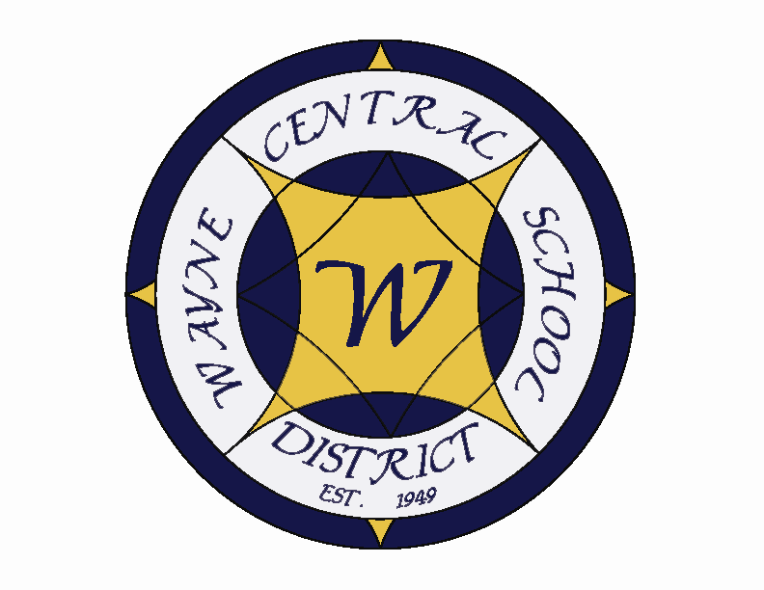
Letter to the Board

Michael Havens
Superintendent of Schools
Phone: 315-524-1001 Fax: 315-524-1049 mhavens@wayne.k12.ny.us

April 7, 2006

“There is nothing which can better deserve our patronage than the promotion of science and literature. Knowledge is in every country the surest basis of public happiness.
- - George Washington (address to Congress, January 8, 1790)

Board Letter:

- Requested Information: Attached is the information that John requested.

- Three Boards Meeting: The Town of Ontario has submitted the following items for discussion at the Three Boards Meeting: 1. Trailworks; 2. EPA Emissions Requirements; 3. Comprehensive Plan Update; 4. Community Center Project; The School Board has suggested so far: 1. A presentation made by the town supervisors to Wayne Students of Excellence.

- Senior Trip Update: I hear things are going well on the New York City Senior Trip. Unfortunately, it appears that a few have come down with a stomach bug which has hit several students and one of our chaperones. The weather has not cooperated as well as we hoped, but it has been a good trip so far. There was a brief glimpse of a few of them in the crowd of the TODAY show Thursday morning.

- Gullace Property: At Monday’s meeting the group discussed ways to approach the next three years in the settlement dispute (2003, 2004 and 2005). The assessment by the town for those three years is approximately 8.9 million. The counter offer from Gullace is approximately a 2.9 million dollar assessment. Of course the data we have, from both appraisals, does not support their number. Subsequently, we countered with a 8.5 million dollar assessment. This offer essentially puts both parties in a position of needing to present some data to substantiate their claims. Gullace has, to date, refused to supply to Harris Beach requested data and has instead taken a general settlement approach. The next step in the process will be an appraisal on these more recent years. Frank’s expertise in this field is an invaluable asset to the district, as well as the entire unit. I will keep you posted as things progress, however I do not expect any developments for a couple weeks.

- Track Ribbon Cutting Ceremony: The Ribbon cutting ceremony will be held on April 13 @ 4:00 at the new track. This will be a brief ceremony held before the track meet that evening. I hope you will be able to make it. The track is a beautiful facility that we have waited a long time for.

- Tot Spot Transportation Request: I had a visit from Wendy Mendola, owner of Tot Spot, asking for me to revisit the decision made by a previous superintendent regarding the possibility of an agreement between Wayne Central and the Tot Spot for the use of district buses over the summer to transport children from her business to the Ontario Country Club for swimming lessons. She stated that she believed it was occurring in other towns and wanted to know if this was a possibility. I reviewed district policy and state law, which prohibits the use for other than non-profit organizations. I sent her a letter explaining it was not possible.

- Board Question: Several Board members have asked about whether or not a current employee could run for the Board of Education. The law is clear that a current employee can not serve as a Board member but appears silent on whether they could run and subsequently resign (retire) from their district position. Our attorney is investigating it and will let me know.

- Rotary Mystery Dinner Theatre: NAC and Rotary club are jointly sponsoring a Dinner Mystery Theater, “Death by Chocolate.” It will be held at the Exempt Hall on May 19 and 20. Tickets are $35, or $30 if you buy a table. It sounds like a great evening out. If you would like tickets see any one of your Rotary Board members (Scott, Mark, Frank or myself).

- HS Talent Show: This Friday evening is the HS Talent Show hosted by the National Honor Society at 7:00 p.m. at the PAC. This is where students from the HS can take their own brand of talents to the stage and perform. Acts usually include music, comedy, dance in a variety of venues. It is generally a big hit - - feel free to stop in a see it for yourself.

- Board Petitions: I heard this week that Sharon Phillips has decided not to run, but that Marian Wulfert has taken out a petition. Also, Susan Newman has turned in her completed petition. To date, John and Susan’s are the only ones that have been turned in.

- HS Musical: If any of you did not see Cinderella this past weekend, you missed a great show. It was one of the most entertaining musicals I have ever seen and our students were absolutely wonderful. It was just pure entertainment. Our students were given the chance to really take on their characters and they were marvelous. Congratulations to all the cast, crew, Judy Porray, Marian Wulfert, Mike Lester, and all involved.

- Upcoming Events:
April 7 – HS Talent Show @ PAC – 7:00 p.m.
April 12 & 13 – Parent Teacher Conferences – Half days
April 13 – New Track Ribbon Cutting Ceremony @ HS Track – 4:00 p.m.
April 14 – 21 (inclusive – Spring Break – Schools Closed
April 17 – School Trustee Nominating Petitions Due
April 22 – Earth Day

Athletics (Home Events Only)
4/12 – Boys’ V Baseball vs. Newark – 4:15 p.m.
4/12 – Boys’ V Tennis vs. Bloomfield 2 – 4:15 p.m.
4/13 – Co-ed V Track vs. Penn Yan & HAC – 4:15 p.m. ** Opening Ceremony & 1st home meet in 7 yrs!**
4/13 – Boys’ V Baseball vs. Geneva – 4:15 p.m.
4/18 – Girls’ V Softball vs. Lyons – 4:15 p.m.

- Attachments:
  - Board Memo
  - Track Ribbon Cutting Ceremony Letter
  - Audit Committee Workshop MCSBI
  - BOCES Board Nominations
  - Lynn Gay Letter

Wayne Central School District
Office of the Superintendent of Schools

PO Box 155
6076 Ontario Center Road
Ontario Center, NY 14520
315-524-1001

April 5, 2006

Wayne Central Board of Education

Dear Board Members,

In the spring of 2004 the Wayne Central School District began the Capital Project renovation on the track at the James A. Beneway High School. At this time, I would like to cordially invite you to our “Ribbon Cutting Ceremony” officially opening our new eight lane all-weather track on Thursday, April 13, 2006 at 4:00 p.m.

There will be a brief ceremony immediately followed by our first home track meet of the season. As we open our new facility, we recognize the great tradition of our track program and its long standing at Wayne Central.

It would be our pleasure to have you join us for this occasion. Our students, staff and community can be very proud of this state of the art facility and we look forward to the honor of your presence. Please let me know if I can be of any assistance to you. Thank you.

Sincerely,

Michael Havens
Superintendent of Schools

/les
Xc: Board of Education
Athletic Director

“Students First ~ Excellence For All”

