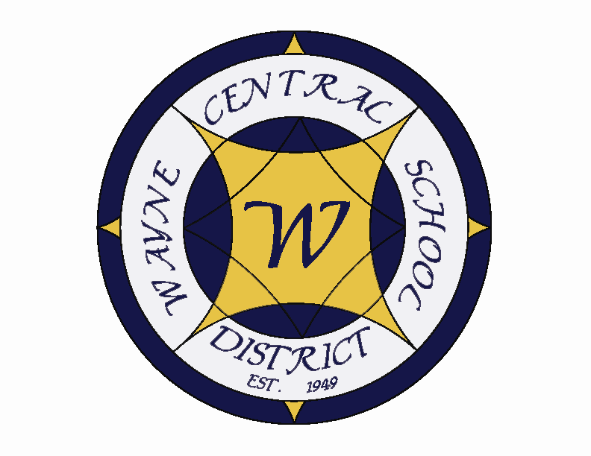
Letter to the Board

Michael Havens
Superintendent of Schools
Phone: 315-524-1001 Fax: 315-524-1049 mhavens@wayne.k12.ny.us

March 31, 2006

“What wisdom can you find that is greater than kindness?"
--Jean-Jacques Rousseau, Franco-Swiss philosopher, writer

Board Agenda:

1. Executive Session: There will be an executive session to meet Michael Pullen, the finalist for the Ontario Elementary School Principal position. Michael is currently elementary principal at Gorham. Enclosed is his resume.

2. International Baccalaureate Program: Joe Siracuse will present information on our plans to move forward with the International Baccalaureate Program. This is considered the premier national program for academic rigor. Some of you learned about this program at the Model Schools conference.

3. Budget: Enclosed is the final budget which we are requesting you approve. The tax rate will increase 1.89 with the average $100,000 homeowner seeing a tax increase of $28.72. My enclosed memo provides additional detail.

4. Financial Report: Greg will present his monthly financial report.

5. Business Items: Personnel action and CSE action are submitted for approval. You will notice several retirements on the personnel action. They represent many years of service to the district. The 2006-07 Proposed Budget is presented for adoption. The 2006-07 school calendar is presented for approval. This has been reviewed and approved by administrative council. It has also been reviewed by both unions. The new teacher contract allows us for the first time to begin the school year prior to September. The Orchard Grove litigation fees are for services rendered to date as well as going forward to 2006. Greg has enclosed an explanation. A Liability Reserve Account request allows us to pay the money approved last month. There is also a cash gift to the district from Constellation for our Eagle Ventures program.

Board Letter:

- Three Boards Meeting: We will be hosting the next Three Board’s Meeting on April 26. I will be sending out a letter to the Town Boards inviting them to the meeting and asking for discussion items. Please be thinking of items you would like to have placed on the agenda. Email Lori with your ideas.

- Staff Disability Offering: Recently staff requested that the district look into making disability insurance available to employees. Through the efforts of Mark Callahan, AFLAC has been contacted and an agreement has been made for Wayne Central and AFLAC to join forces and disability insurance is now being offered to all staff members, at a discounted rate, for employees to take advantage of if they so choose. This makes several types of disability insurance available to employees at an affordable cost, utilizing payroll deductions. As you may be aware, school districts, as a municipal employer is not required to deduct NYS disability insurance like non-municipal businesses. I feel this has been a very positive step for district-employee relations.

- Gullace Property: I will be meeting with the Town and county on Monday, as well as the attorneys to discuss future action. We are discussing what settlement offer we want to make on the remaining years of the dispute. A possible first course of action however, may be the consideration of a new appraisal. As you may recall, both Frank and Eileen Perkins were not overly pleased with the Midland appraisal method or findings (the firm hired by the town, to represent us). I will keep you informed of the outcome of Monday’s meeting.

- Track Ribbon Cutting Ceremony: The Ribbon cutting ceremony will be held on April 13 @ 4:00 at the new track. This will be a brief ceremony held before the track meet that evening. I hope you will be able to make it. The track is a beautiful facility that we have waited a long time for.

- Fiscal Responsibility Workshop: So far Joyce, Jackie, Greg and I have signed up for this workshop on Saturday, April 29. If anyone else is interested in attending, please let Lori know as soon as possible.

- Rotary Dictionaries At OE: The Ontario-Walworth Rotary will be distributing dictionaries to third graders at OE this Friday. As you may recall, they handed them out to FE third graders a few weeks ago. This is a very nice program Rotary initiated several years ago, and a valuable tool for our students. I appreciate their efforts.

- Scott Freischlag Update: I met with Scott on Tuesday. It was a beginning, but I feel we have much more work to do. I want a couple of weeks to pass and then I will meet with him again. I think Scott is at a crossroads in many ways. He and I need to work together to make sure the district and he take the path that is best for us. I think I alleviated some of his concern but he feels that the district administrators have placed a bull’s-eye on his back and are just waiting for him to make a mistake. I feel I can put things back on track. I just think it is going to take some time.

- Board Petitions: As of today, five petitions have been taken out for Board seats. John Triou and Scott Griswold, Larry Ruth, retired MS Art teacher from Walworth, Susan Newman as I stated before, and Sharon Phillips, whom I don’t know.

- HS Musical: Don’t Forget CINDERELLA this weekend!!! The HS musicals are always a great opportunity to see our students shine. This musical is an extremely entertaining one to see. There is excellent humor blended with all the talent, and of course, the classic story line of the age old tale – but with a “bit of a twist.” You are absolutely certain to be entertained. Don’t miss it!!!

- Upcoming Events:
March 31, April 1 – HS Musical, Cinderella; Friday - 7:00 p.m.; Saturday 2:00 and 7:00 p.m.
March 31 – Freewill 35th Birthday Party at Carey Lake
April 4-7 – HS Senior Trip to NYC
April 7 – HS Talent Show @ PAC – 7:00 p.m.
April 13 – New Track Ribbon Cutting Ceremony

- Attachments:
  - Michael Pullen Resume
Michael L. Pullen
22 Aldrich Drive
Palmyra, New York 14522

Mr. Mark Callahan
Director of Human Resources
Wayne Central School District
6200 Ontario Center Road
Ontario Center, New York 14520

February 2, 2006

Dear Mr. Callahan:

In connection with your search for an Elementary School Principal as listed in Sunday’s Democrat and Chronicle, I submit this letter and the attached resume.

In my role as an elementary principal, I have developed a firm understanding of the New York State Standards, the supporting curriculum, the State assessments and the importance of setting high standards. When I facilitated the Elementary Summer program at the East Rochester Elementary School, I developed a deeper understanding of Academic Intervention Services. My awareness of developmental levels supports these academic understandings. In addition to my leadership experiences, the various teaching positions I have held have afforded me the skills necessary to relate to students of all age levels, their parents and their instructors at all levels of the school continuum. I believe I possess those personal qualities that would be an asset to any school in which I might serve in an administrative role. I also possess the energy, drive, and personal attributes that I believe contribute to successful school leadership.

I would welcome the opportunity to assume a leadership role in the Wayne Central School District. I have a commitment to educational excellence and believe that it is our fundamental responsibility to present learning experiences that are engaging, rigorous, and geared to the achievement of high academic standards. I also believe that every child is capable of learning and has the right to be provided with exemplary instruction.

The opportunity to discuss the strengths that my background and the experiences could offer to the Wayne Central School District would be most appreciated. I may be contacted by telephoning either my residence at (315) 597-5005 or on my cell phone at (585) 746-1224. I look forward to hearing from you in the near future.

Sincerely,

Michael L. Pullen

Enc.

Michael L. Pullen
22 Aldrich Drive
Palmyra, New York 14522
315-597-5005

mpullen1@rochester.rr.com

EDUCATION: SUNY Oswego, Oswego, New York
Certificate of Advanced Studies in Educational Administration
August 2004

Nazareth College, Rochester, New York
Master of Science Degree in Reading Education
August 2000

St. John Fisher College, Rochester, New York
Bachelor of Arts Degree in Psychology
January 1997

CERTIFICATION: School District Administrator
School Administrator/Supervisor
Reading Teacher
Pre K – 6
EXPERIENCE:

2004 –Present Marcus Whitman School District, Rushville, New York
Gorham Elementary Principal
- Administered a K-5 building with a student population of 270 students
- Provided general curriculum and instructional leadership
- Implemented a new Science program
- Led the effort to develop and implement curriculum alignment maps
- Assessed student data to implement changes in reading instruction
- Worked with PTO to secure funds for a new playground
- Provided large and small group instruction in Character Education
- Worked with other district administrators to bring consistency to both
General and Special Education programs K-12
- Effectively communicated with school community through various channels

2001-2004 East Rochester UFSD, East Rochester, New York

Fourth Grade Classroom Teacher
- Worked with team to create integrated instruction
- Facilitated push-in instruction with Reading specialist and Consultant Teacher
- Supported the introduction of Reading and Writing Workshops

Summer Program Administrative Intern
- Organized and facilitated summer program
- Worked with staff to organize instruction
- Managed reporting to District and parents

1997-2001 Clyde-Savannah CSD, Clyde, New York

Sixth Grade Classroom Teacher
- Designed lesson plans integrating Social Studies and Language Arts
  - Provided large and small group instruction
  - Provided one-to-one tutoring
  - Organized field trip experiences

1/97-3/97 Rochester CSD, Rochester, New York

Long-term Substitute
- Team taught in 15:1:1 classroom

3/97-6/97 Rochester CSD, Rochester, New York

Newark CSD, Newark, New York
Clyde-Savannah CSD, Clyde, New York
Webster CSD, Webster, New York
- Completed per-diem assignments

RELATED
EXPERIENCE: Clyde-Savannah CSD, Clyde, New York
- Assistant Varsity Football Coach
- Boys 7th Grade Basketball Coach
- Girls 7th Grade Basketball Coach
- Assistant Varsity Track & Field Coach

St. John Fisher College, Rochester, New York
- Assistant Football Coach

East Rochester UFSD, East Rochester, New York
- Assistant Varsity Football Coach

COMMUNITY
SUPPORT: Volunteer at Camp Good Days and Special Times
Volunteer at the Ontario ARC
Multiple Sclerosis Bike and Walk-a-Thon

REFERENCES: Available Upon Request

