





Section I: Getting Started

IMPORTANT: Before you can start Negotiations, make sure that you have bargaining units defined and they are associated with the appropriate employee type.

The NEGOTIATIONS MANAGER system is divided into three main areas: Data Entry, Reporting, and Utilities. Use the tree on the left-hand side of the window to expand the Reports and Maintenance routines to display the options within each area. The routines within each main area are as follows:

Data Entry
Earnings Schedules
Projections
Scattergrams

Reports
Earnings Schedules
Earnings Projections
Earnings Scattergrams
Account Breakdown
Steps/Levels Validation
Earnings Projection Letters

Utility
Budgetary Interface

Section 2

Earnings Schedules
There are six different types of earnings schedules that can be set up:
Contractual
Annualized Daily
Annualized Hourly
Supplemental
Hourly
Per Diem

Exercise 1: Adding an Earnings Schedule
Follow the steps below to add an earnings schedule.

- Click the Add button .
- Select the “TU” bargaining unit from the drop-down menu.
- Enter the group code. For this exercise, enter Teachers.
- Enter the Matrix Description. For this exercise, enter “Teachers 2001-2002"
- Select the Contractual matrix type from the drop-down menu.
- Select the Contract earncode from the drop-down menu.
- Enter the starting date of the salary schedule as “07/01/01”. Enter the ending date of the salary schedule as “06/30/02”.
- Select “No” from the Prorate drop-down menu.
- Select “Full Year” from the Step Increase drop-down menu.

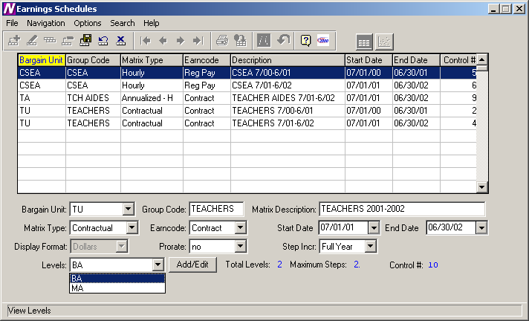

Exercise 2: Adding Steps and Levels to an Earnings Schedule
Now we are going to add the steps and levels for the schedule created in Exercise 1.
- Click the Add/Edit button to display the Add/Edit Levels window.
- Click the Add button from the tool bar.
- Enter the Level Description as “BA” and press Tab.
- Enter the number of steps as “2”.
- Press the Save button from the toolbar.

Repeat steps 1 through 5, but this time enter the Level as “MA” with 2 steps.

When finished, your screen should look like the one below.

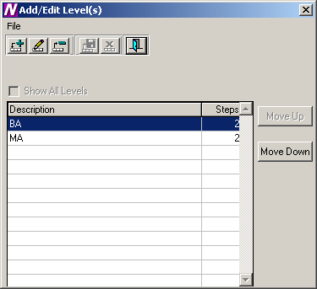

- When finished entering the steps and levels, click the Exit button to return to the Schedule screen.
- Click the Save record button from the toolbar to save the schedule.

Exercise 3: Setting Up a Salary Matrix

Once the schedule is entered, the next step is to set up the salary matrix for the schedule.

- From the Earnings Schedule, select the Go to Matrix icon .

The Earnings Schedule Matrix window displays.

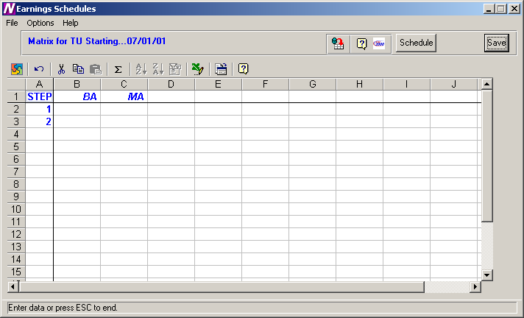

The Earnings Schedule window is used to indicate the appropriate salaries for each step and level created. The steps are displayed down the window and the levels are displayed across the window.

The system will only provide access to those cells in the spreadsheet where a step exists for the corresponding level. All other cells will be locked if you attempt to enter salary information where a step does not exist for a level. In the example, Level BA has two steps. Therefore, the cells after step 2 are locked and cannot be accessed.

To Enter Salary Information:
- Use the right/left arrows to move to each level within the step. Use the Enter key or up/down and right/left arrows to move to each step within the level.

NOTE: After entering/modifying information in a cell, it is required that you move off that cell before pressing the Save key. If you type a salary in a cell and do not move your cursor off that cell before pressing Save, the information in that particular cell is not saved.

- When you have finished entering salary information, press the Save button. Enter the following dollar amounts.

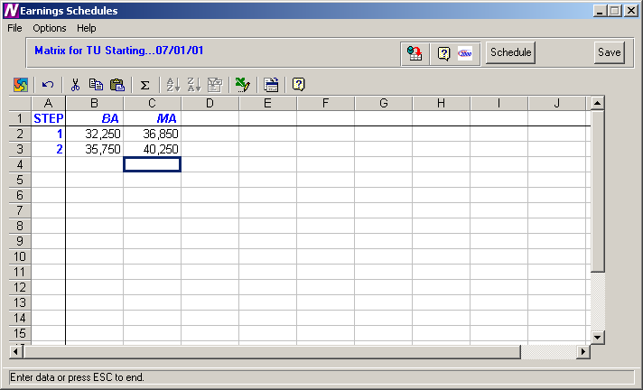
To Refresh the Salary Information on the Window:
This option is used to refresh the window to reflect any changes that another user may have made to the salary information.
- Press the Refresh button at the top of the window.

To Export the Salary Information to Excel:
- Press the Export to Excel button in the button bar at the top of the window.

NOTE: The information is displayed on your screen in an Excel spreadsheet. You may change any information in the spreadsheet as needed, but any changes saved while in Excel are NOT saved in Finance Manager.

To Return to the Schedules window:
- Press the Schedules button.

Exercise 4: Linking the Schedule to the Employee Type

Once the schedule setup is completed, you now need to associate that schedule with an employee type.

- Open up the Human Resources module and, from the Maintenance menu, select Employee Types. The Employee Types Maintenance window displays.

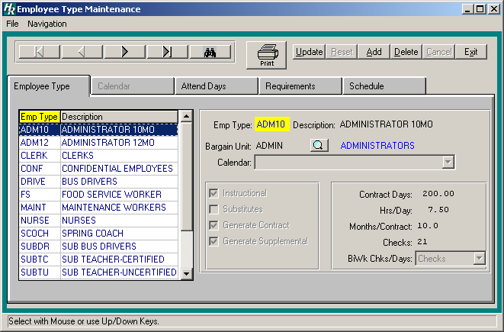

- Select the employee type that is to be associated with the schedule you just created. If the schedule is to be associated with more than one employee type, you must handle each type separately.
- On the right-hand side of the screen, make sure that the Bargain Unit field is filled in. If the field is empty or displays <N/A>, continue to step 4. If it is filled in, skip to step 8.
- Click the Update button from the Update panel.
- Click the lookup button next to the Bargain Unit field.
The Bargain Unit lookup window displays.

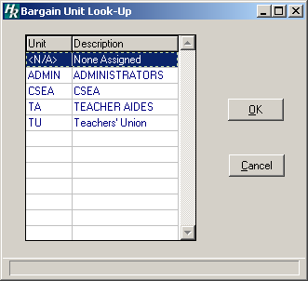

- Select the “TU” (Teachers Union) bargain unit and click OK to return to the Employee Type Maintenance screen.
- Click the Save button on the Update panel to update the record.
- Now click on the Schedule folder to display the Employee Type Schedule window.

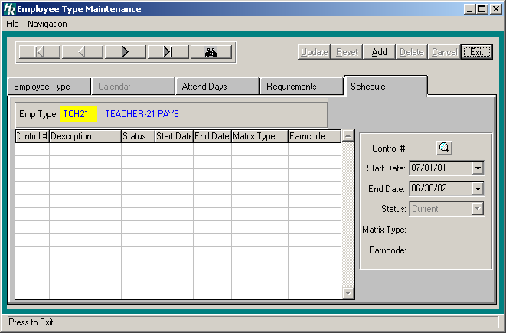

- Click the Add button from the Update panel.
- Enter the Control # of the Negotiations Schedule or click the lookup button to display the Earnings Schedule lookup window.

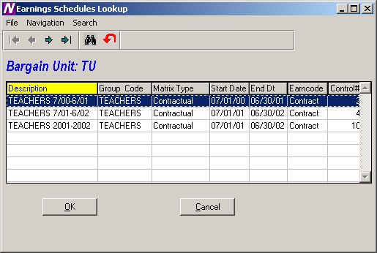

- Select the “Teachers 2001-2002" schedule and click OK to return to the Employee Type Schedule window.
- The Start and End Dates will be filled in automatically.
- From the Status drop-down menu, select Current and click Save from the Update panel.
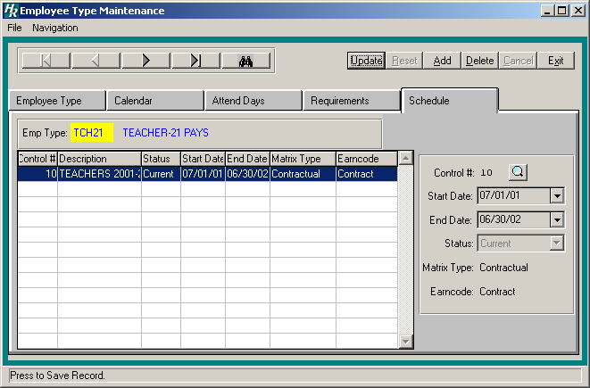

Exercise 5: Setting Up Next Years Schedule
The Copy Schedule function is used to create a variation of a similar existing schedule and make any adjustments to that schedule. Replicated schedules may be modified by a percentage increase or decrease and rounded to the nearest specified dollar amount.

Follow the steps below to add a schedule for the following year.
- From the Earnings Schedules window, select the schedule you just created “Teachers 2001-2002".
- Click the Copy record button from the toolbar.
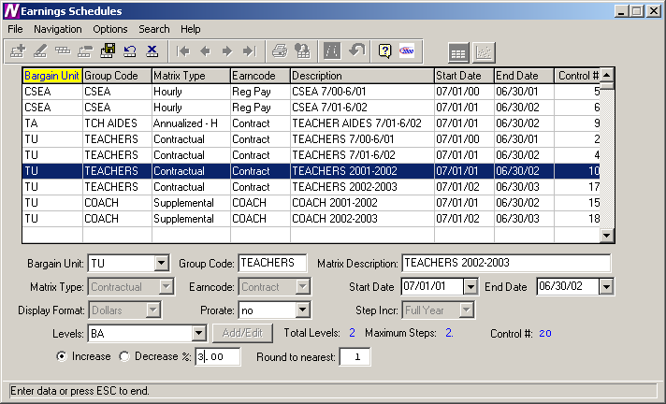
- The Bargain Unit, Matrix Type, Earncode, Start and End Date, Display Format, and Step Increment fields are all completed for you and some can be changed.
- Leave the Bargain Unit unchanged.
- Enter the Group Code as “Teachers” and press Tab.
- Enter the Matrix Description as “Teachers 2002-2003”.
- Change the Start Date to 07/01/02 and the End Date to 06/30/03.
- Leave the Prorate field unchanged.
- Select the Increase radio button to increase the salaries and press Tab.
- Enter 3 as the percentage to increase the salaries.
- Enter 1 in the Round to the Nearest field. The Round to the Nearest field is used to indicate the manner in which the system should round the salaries.
Example: Enter 1 to round to the nearest dollar. Enter 100 to round to the nearest hundred dollars. Or leave this field blank if you do not wish to round.
- Press the Save button to save the new schedule.
- Clicking on the GoTo Matrix icon will show the new salary matrix with the new dollar amounts increased by 3%.

After the schedule has been created, it must now be linked to its employee types.

Practice Exercise 1
Now that you have created two earnings schedules and attached one to its respective employee types, you must now link the salary schedule you just created to its respective employee types, but making sure that the Status field for this employee schedule is set to Next. Please try this exercise now. If you run into trouble, please refer to the section on Linking the Earnings Schedule to the Employee Type (Exercise 4). When finished your screens should look like the ones below.

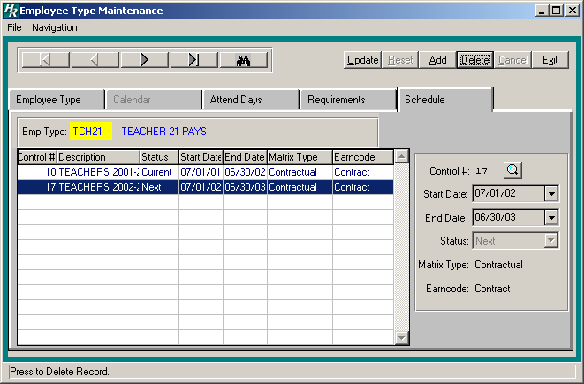

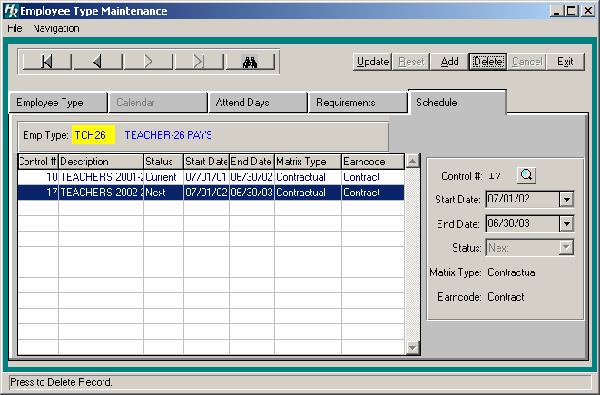

Practice Exercise 2
Now that you have created two Earnings schedules and attached both to employee types, you are ready to try one on your own.

Create 2 new earnings schedules based on the following criteria:

Schedule 1:
Bargain Unit = TU
Group Code = Coach
Matrix Description = Coach 2001-2002
Matrix Type = Supplemental
Earn Code = Coach
Start Date = 07/01/01
End Date = 06/30/02
Display Format = Dollars
Prorate = No
Step Increase = Full Year
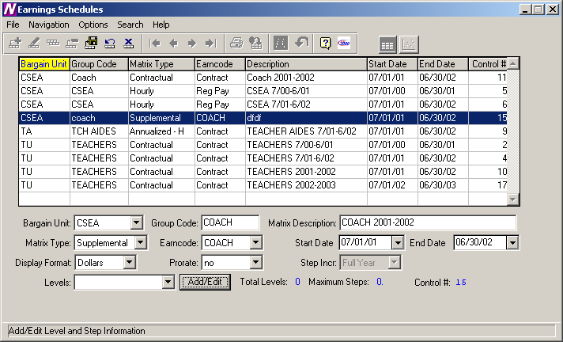

Add the following levels to this schedule:
Coach 1 with 2 steps. Step 1 = $500, Step 2 = $1000
Coach 2 with 1 step. Step 1 = $1500
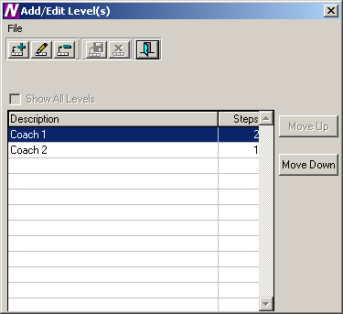

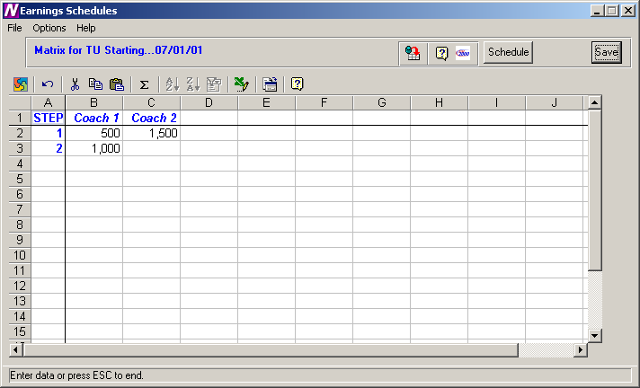
Schedule 2:
Bargain Unit = TU
Group Code = Coach
Matrix Description = Coach 2002-2003
Matrix Type = Supplemental
Earn Code = Coach
Start Date = 07/01/02
End Date = 06/30/03
Display Format = Dollars
Prorate = No
Step Increase = Full Year
Increase By = 3%
Round to Nearest = 1
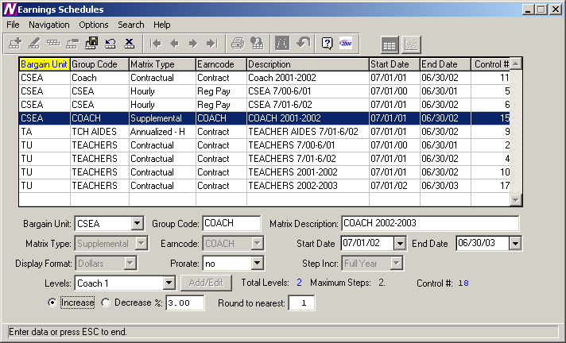
Now link the schedules you just created to the employee types with schedule 1 set to Current and schedule 2 set to Next. When finished your screens should look like the ones below.

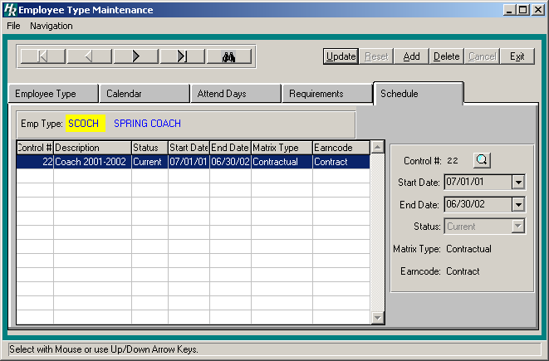

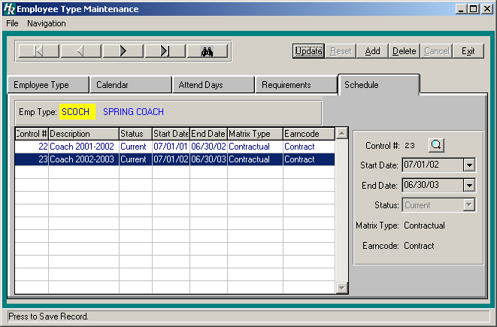

Exercise 6: Earnings Projections
Once all your schedules have been created and linked, you are now ready to project the earnings.

The Earnings Projections function uses current employee earnings information to make salary projections while considering any applicable salary schedules. The system looks in Employee Type Maintenance to find the schedule that has a status of “Next” to make the salary projection. The system only creates a projection if the Renewable flag is checked on the Earnings or Other Earnings window in Employee Earnings. In addition, a projection will not be created for those employees whose status is Inactive or Retired at the time the Projection is made.

- Click the Earnings Projections option from the Negotiations main menu. The Earnings Projections screen displays:
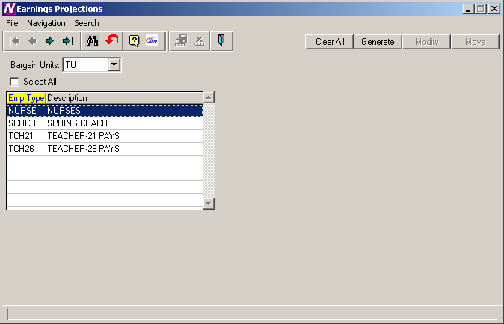
- Select the “TU” bargaining unit from the drop-down menu.
- A listing of all employee types associated with that bargain unit displays. Select “SCOCH”, “TCH21”, and “TCH26”.
- Click the Clear All button to clear old data associated with these employee types.
- Select the “SCOCH”, “TCH21”, and “TCH26” employee types again.
- Click the Generate button to display the Generate Projections option screen.
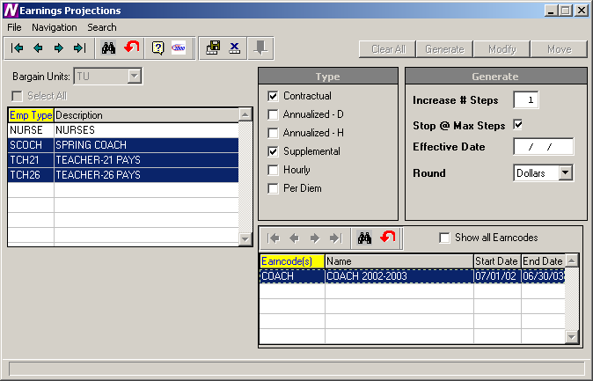

Upon selecting the Generate option, the Matrix Type and Generate windows are displayed. The Matrix window contains the valid matrix types (Contract, Annualized, Supplemental, Hourly, and Per Diem) and those salary matrices that exist for the bargaining unit are preceded by a check mark.

- Uncheck those matrix types that are not to be included in the earnings projection.
- Specify the number of steps to be increased as 1.
- In the Generate window, indicate whether you wish the system to stop projecting to the next step if the employee has already reached the maximum step for the level. For this exercise, leave the default check mark.
- Enter the effective date of the earnings projection as 07/01/02.
- Select the projected amount to be rounded to the nearest Dollars.
- For Matrix Type “Supplemental”, select the Coach earncode to project. Those earncodes highlighted in green are those earning codes for which a salary schedule exists. To display all earncodes from the Earnings Code Maintenance File, check the Show all Earncodes check box.
- Click the Save button to generate the information. Once the Generate routine is completed, the Modify and Move buttons become enabled.
- To display the Earnings Information window for each employee, click the Modify button.

Exercise 7: Verifying the Earnings Projection
Once the projections have been generated, they need to be verified. The verification can be performed by running the Earnings Projection Report.

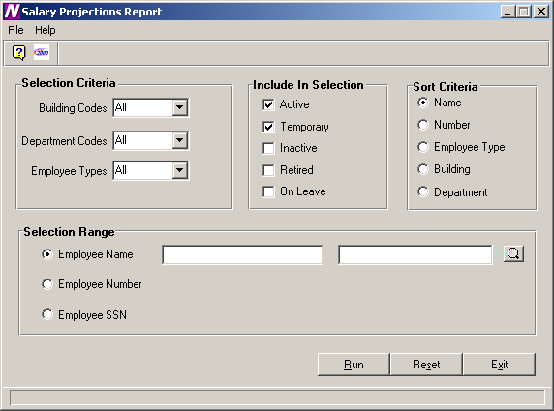

To Print the Earnings Projection Report:
- Define the Selection Criteria.
Select to print a report for employees in All buildings, All departments, and for employee types SCOCH, TCH21, and TCH26. To print a report for employees in selected employee types, use the drop-down menu to change the option to Selection. The system displays the lookup magnifying glass that allows you to select one or more employee types. In the lookup browser, highlight the codes SCOCH, TCH21, and TCH26. Use the Ctrl key to select more than one code. Press the OK button when you have finished selecting all codes in the lookup browser. The system returns you to the criteria selection window where you can specify additional reporting criteria.
- Use the Include in Selection portion of the window to flag the appropriate employee status to be included in the report. The system automatically defaults Active and Temporary employees as the selection. For this exercise, leave the default value.
- Use the Sort Criteria portion of the window to select the manner in which information is to be sorted on the report. Information may be sorted in any one of the following ways:
alphabetical order by Employee Name
numerical ascending order by Employee Number
alphabetical order by Employee Type
numerical/alphabetical order by Building Code
numerical/alphabetical order by Department Code
For this exercise, leave the default sort of Name.
- Use the Selection Range portion of the window to specify those employees who are to be included in the report. You may print a report for a specific range of employee names, employee numbers, or social security numbers.
Move the radio button to the desired selection range. Then use the starting and ending fields to type in the range of employee names, employee numbers, or social security numbers. If desired, use the lookup button to select one or a range of employees.
Leave blank to include all employees.
For this exercise, leave all Selection Range fields blank.
- After all reporting criteria has been specified, press the Run button. From the Report Output window, select the Preview reporting output destination to see the report on-line.
The report displays the employee’s current years salary information labeled as OLD and the new projected earnings information labeled as NEW.

Another report that can be used in the verification process is the Account Code Breakdown Report.

To access the Account Code Breakdown Report, select the Account Code Breakdown option from the Negotiations Manager Reports tree menu. The Account Code Breakdown Report function provides a listing of budgetary account code information that may be printed after salary projections have been made but prior to moving the earnings to Payroll. Use this window to select the bargaining unit and employee type(s).

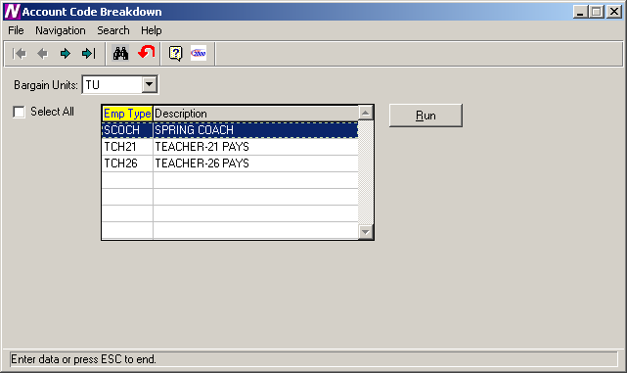

To Print the Account Code Breakdown Report:
- Select the “TU” bargaining unit.
- Select the SCOCH, TCH21, and TCH26 employee types. Use the Ctrl key to select more than one employee type or check the Select All box to include all employee types.
- Click the Run button.
- From the Report Output window, select the Preview reporting output destination to view the report on-line.

The Account Code Breakdown Report prints the costs of the projected salary in account code order. Within each account code, the report includes the employee name, employee number, employee type, earning code, account percentage, and amount expensed to the account code.

The report provides totals for each account and fund. The report concludes with a grand total of earning amounts.

NOTE: Once the salary information has been moved to Payroll, you may run the Contract and Rate Report or the Account Code Breakdown Report from the Payroll Diagnostic Report Menu to see the employee’s earnings information.
In the event that errors have been found, they can be corrected in one of the following two ways:

First, you may make all earnings modifications for the employees with errors through Payroll Manager and then regenerate the projection information. The second way is to modify the projection information through the Earnings Projections screen.

Exercise 8: Modifying Projection Information
The system allows you to update information and will automatically recalculate any earnings information as needed. If you update the FTE%, the system will recalculate the FTE$, Entitlement, and Period Pay amounts. The Override option allows you to change any information that you wish and the system will not recalculate any of the values.

To Update Earnings Information with System Recalculation:
- Click Modify.
- Highlight the appropriate employee record in the browser on the left-hand side of the window.
- Press the Update button .

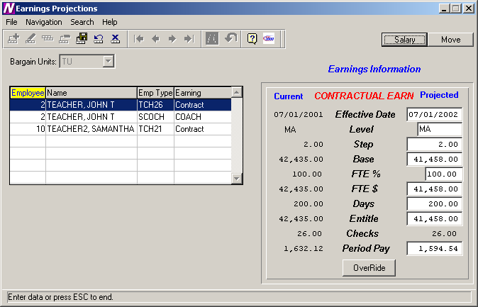

- Update the Projected Effective Date, Level, Step, Base, FTE%, FTE$, Days, Entitlement, #Checks, and/or Period Pay as necessary.
- Press the Save button.

To Update Earnings Information without System Recalculation:
- Highlight the appropriate employee record in the browser on the left-hand side of the window.
- Press the Update button .
- Press the Override button.
- Update any of the open fields as needed. The system will not recalculate any of the earnings information based on the changes you make.
- Press the Save button.

Exercise 9: Using the Projections to Help Prepare Your Budget
The Budgetary Interface function is used to export generated salary projections to Budget Manager.

To Begin the Budgetary Interface Process:

- Use the drop-down menu to select the “TU” bargaining unit for which salary information is to be exported.

The Budgetary Interface window displays a listing of all employee types associated with the selected bargaining unit.

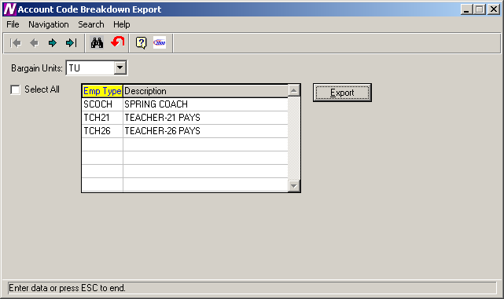

- Use the browser to select the SCOCH, TCH21, and TCH26 employee types for which you wish to export. Press the Control key to select more than one employee type. Check the Select All check box if you wish to include employees in all employee types when projecting earnings.

- Press the EXPORT push button.

After the EXPORT button is clicked the Projected salary information will be exported and be ready for import into the Budget using the Load Salary Notes routine in Budget Manager.

Exercise 10: Earnings Projection Letters
The Earnings Projection Letters function provides the ability to print a salary letter after salaries are projected.

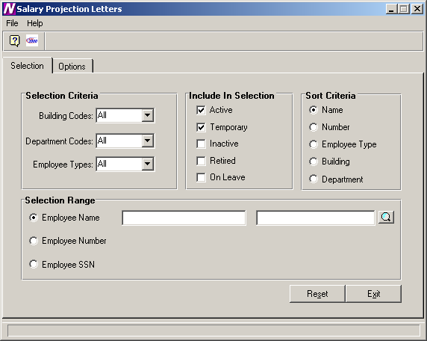

To Select Earnings Projection Letter Criteria:
- Define the Selection Criteria.
Select to print a report for employees in All buildings, All departments, and for employee types SCOCH, TCH21, and TCH26. To print a report for employees in selected employee types, use the drop-down menu to change the option to Selection. The system displays the lookup magnifying glass that allows you to select one or more employee types. In the lookup browser, highlight the codes SCOCH, TCH21, and TCH26 that you wish to include in the report. Use the Ctrl key to select more than one code. Press the OK button when you have finished selecting all codes in the lookup browser. The system returns you to the criteria selection window where you can specify additional reporting criteria.
- Use the Include in Selection portion of the window to flag the appropriate employee status to be included in the report. The system automatically defaults Active and Temporary employees as the selection. For this exercise, leave the default value.
- Use the Sort Criteria portion of the window to select the manner in which information is to be sorted on the report. Information may be sorted in any one of the following ways:
alphabetical order by Employee Name
numerical ascending order by Employee Number
alphabetical order by Employee Type
numerical/alphabetical order by Building Code
numerical/alphabetical order by Department Code
For this exercise, leave the default sort of Name.
- Use the Selection Range portion of the window to specify those employees who are to be included in the report. You may print a report for a specific range of employee names, employee numbers, or social security numbers.
Move the radio button to the desired selection range. Then use the starting and ending fields to type in the range of employee names, employee numbers, or social security numbers. If desired, use the lookup button to select one or a range of employees.
Leave blank to include all employees.
For this exercise, leave all Selection Range fields blank.
- After all reporting criteria has been specified, use the Options window to indicate the additional text and information that is to be displayed on the letter.
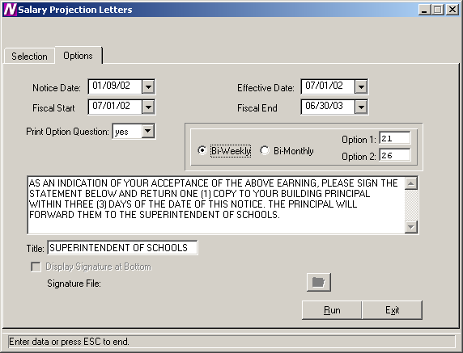

Use this window to indicate the additional text and information that is to be displayed on the letter.

To Enter Projection Letter Options:
- Enter the date (in MM/DD/YY format) that is to be displayed on the letter or notice. This date displays to the left of the school official’s signature line.
- Enter the effective date of the letter as 07/01/02.
NOTE: The Effective Date on this window MUST match the effective date entered on the Generate Projections window.
- Set the Print Option Question field to Yes if you want the letter to include the payment options section (for example, 26 equal payments or 21 equal payments). Then specify the check options.
Set the Print Option Question field to No if the payment options portion is to be excluded from the letter.
- Use the default letter text or change it as needed.
- Enter the title of the individual who is signing the Projection Letter.
- From the Report Output window, select the Preview reporting output destination to see the letter on-line.

Exercise 11: Moving Salary Information to Payroll
After the salary information have been projected and carefully reviewed, you may now move the projected salaries into Payroll. The move should only take place after the final fiscal year payroll has been printed/posted and the Payroll Parameters Screen has been updated for the first payroll check date in the new fiscal year.

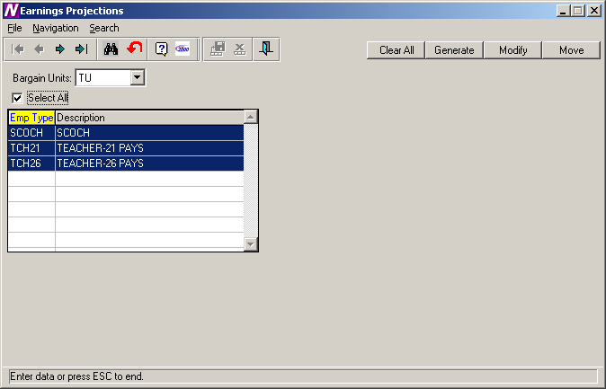

- Choose the TU Bargaining Unit
- Select All Employee Types (You can move each separately if preferred)
- Press the Move button.
- The system displays the question “Has the final Fiscal Year End Payroll been Completed and Posted?”
If it has been completed and posted, choose Yes and continue the Move process.
If you have not yet printed and posted your final payroll, choose No. You should print and post the final payroll before the move can take place.

The new salary information can be seen on the Earnings and Other Earnings windows in Payroll Manager. The effective dates of the earnings and the new step are updated accordingly.

