Name _____________________________
Drawing /Isoline Worksheet

A resident owns this property. As a landscape designer you have been asked to help him place a few items on the property that will have give the best usage.

1.) Draw contour lines for 1.0 – 9.0.
Draw each line so it crosses 2 sides of the outer boundary.
Label each line.

2. The resident want to place a swimming pool on the property. Label on the map where you would advise him to place it and in the space below explain why you chose that location?

3. The resident also wants to put in a satellite dish which will have the best reception. Label the best place on the map. Explain why this is the best location.

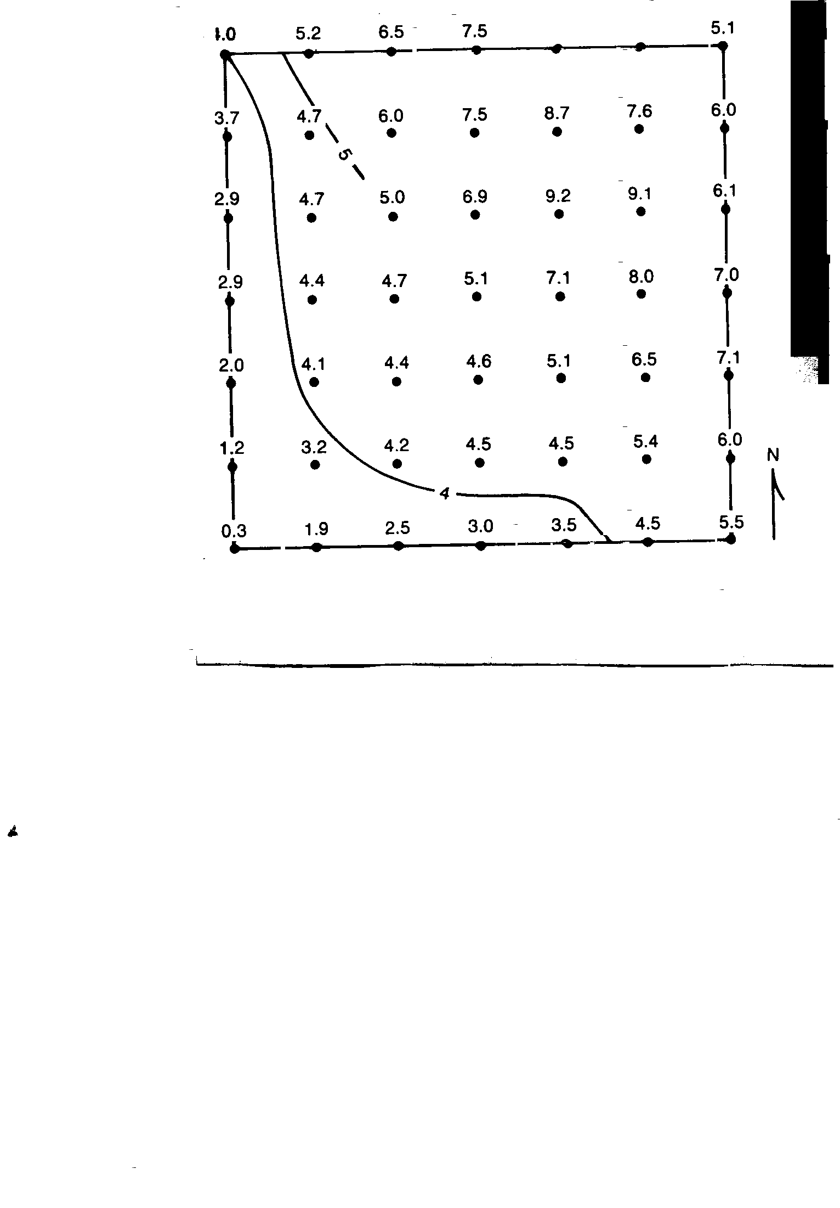

6.8 6..3

