Name ________________________
Date ___________ Block ________

Lab: Studying Rocks in Thin Sections & Optical Crystallography

There are 3 parts of this lab. Some groups will need to begin on part one, the other will need to begin on part two since there are limited supplies.

Part One: Minerals & Optical Crystallography

Visible light rays vibrate in all directions along their path of travel. Using a special type of prism called a polarizer, it is possible to force light to vibrate in only one plane. The identity and optical properties of minerals can be found using a microscope and a polarized light. Rock and mineral samples are mounted and ground to a very thin layer (.03mm) on glass microscope slides. These “thin sections” are then viewed with a polarizing microscope which uses two special polarizers to orient the light.
If two polarizers are placed at right angles to each other (crossed polars), all light is blocked. Under cross polars, all minerals except crystals showing cubic cleavage (because they are isometric) cause a phase shift in the light. This phase shift allows light to refract against atomic bonds and lattices within the crystalline structure causing “interference colors”. Interference colors depend on the thickness of the mineral section, the orientation of the mineral and composition.
Minerals with cubic crystals have uniform atomic structure. Under crossed polarized light these minerals show no phase shifting light is completely blocked and these crystals appear dark. By using interference colors we can determine the identities of various minerals in this section.
In this activity, you will construct a simple polarizing microscope and use it to view a thin section containing samples of four different minerals. This form of mineral study is called optical crystallography and is used by geologists to identify composition and origins of rocks and minerals.

Materials Required
1 flashlight (w/white lens insert)
1 tripod magnifier, 10x
2 sheets of polarizing film
1 composition slide w/ minerals #1-4

Procedure

1. Set up “polarizing microscope” using the materials as shown.
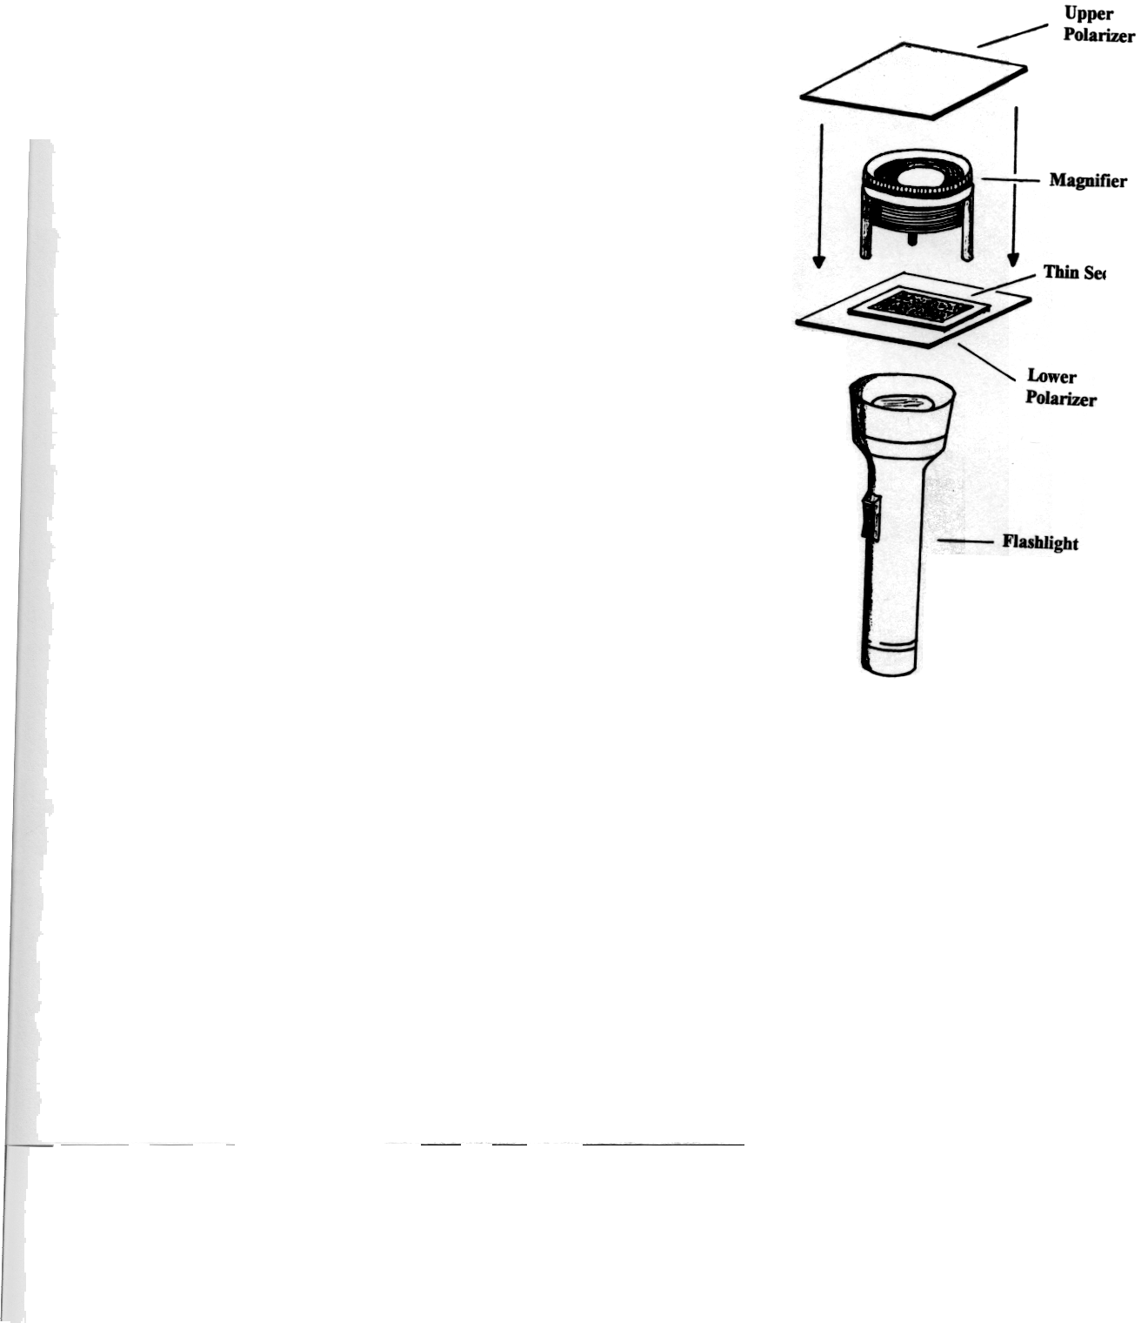
2. With your ”microscope” assembled, switch on the light and check the orientation of your polarizing films. Slowly rotate the top film until you see the background between the two polarizers turn dark.

3. Remove the upper film and place the composite slide thin section (it should have numbers 1-4 on one slide) beneath the magnifier. Carefully slide the thin section between
the legs of the magnifier so it is centered and rests on the bottom film. Look through the magnifier and position the slide so you can see all four mineral grain blocks in your field of view. Record observations of color / brightness in the Data Table for all four fields of the slide. Under “Plain-Polarized Light Observations”.

Data Table

Sample | Plain-Polarized Light Observations | Draw a few crystals
1

2

3

4

4. Place the upper polarizing film on top of the magnifier and orient it in the cross polar position (90 degrees to the bottom polarizer) When properly oriented, the field of view should appear dark with colorful mineral grains showing in the central part of the slide. View and make observation under Cross-Polarized Light Observations.

Sample | Cross-Polarized Light Observations | Draw a few crystals
1

2

3

4

Questions: Minerals and Optical Crystallography

1. In Procedure step #3, you viewed the thin section with only one polarizing film. Describe the light behavior that was being viewed.

2. Compare (and contrast) the four different mineral grain samples displayed in the thin section viewed in Step 3. Consider the following: color differences, some mineral grains appear more “rough” than others?

Difference | Identify 2 slides  you are comparing | Description
1
2
3
4
3. Garnet is a cubic (isometric) mineral. It should appear dark under crossed polarizing film. Which of the numbered samples on the thin section is garnet?

4. Quartz is hexagonal mineral is subdued gray to pale yellow interference color. Which numbered sample is quartz?
___________

5. Olivine is an orthorhombic mineral and displays many bright interference colors. Which sample on your slide is olivine?
______________

6. Hornblende is a mineral that appears light brown to greenish in plane (one) polarizing film. It appears orange, brown. Red. Green and blue under crossed polarized film. Which sample is hornblende?
_______________

7. Review the introduction paragraphs. What is a possible reason that olivine mineral grains display different colors under crossed polarized light?

8. Why is it important that all four mineral grain fields in this section were ground to the same thickness?

Part Two: Studying Rocks in Thin Sections pg 138-139 in text.
Part 2A:
Follow the procedure in the book.

Procedure

#1and 2.
Rock A Mineral Name | Percent in Field
Total 100%

#3.
Rock B Mineral Name | Percent in Field
Total 100%

#4 Rock C diameter of microscope field = ___________________ cm (nearest tenth)

#5 Choose any 5 mineral grains in Rock C (regardless of mineral type). Record grain width in any direction to the nearest tenth of a centimeter. Find the average of the five grains.

grain 1_____________________cm

grain 2_____________________cm

grain 3_____________________cm Find average = ______________cm

grain 4_____________________cm

grain 5_____________________cm

Questions: Studying Rocks in Thin Sections

6. Grain or crystal size can provide clues to rock types. Typically, sedimentary grains are rounded and cemented together. Igneous grains fit together in a jigsaw-puzzle fashion. Metamorphic grains exhibit linear patterns and foliation. Which of Rocks A through E is sedimentary? Igneous? Metamorphic? Explain your answers

7. Determine the actual size of an average grain of Rock C. The actual microscope circular field of each rock sample is .5cm. Use your average grain diameter data from #5 above and the field diameter in #4. Show your work.

8. Using your answer to Question #2, and your reference table, determine the name of the average grain size in Rock C. What kind of rock is Rock C? Identify 2 characteristics of this rock that clearly indicate its classification.

9. Igneous rocks are commonly grouped into mafic rocks and felsic rocks, based on their chemical composition. Mafic rocks are dark in color because they contain many dark minerals such as amphibole, pyroxene, olivine, and biotite. Felsic rocks are light in color and tend to contain minerals such as quartz and orthoclase feldspar. Based on these definitions, is Rock A mafic or felsic? Rock B? Explain your answer.

10. Compare the diagrams for Rock C and Rock D. Look at each rock’s texture in its crystal size, shape, orientation and contact points with other crystals. How do the mineral arrangements (texture) differ?

<<2 samples are required. If 9 slides are completed correctly, bonus points will be received.>>

Part 2B. There are 9 thin rock section slides provided. Identify each rock as igneous, sedimentary or metamorphic (I,S,M) give evidence as to why. Also identify and record any of the 4 individual minerals (garnet, quartz, olivine, hornblende) as seen in Part A if possible.

Slide # | Rock Type | Evidence | Observable minerals  or unique characteristic
#1

#2

#3

#4

#5

#6

#7

#8

#9

