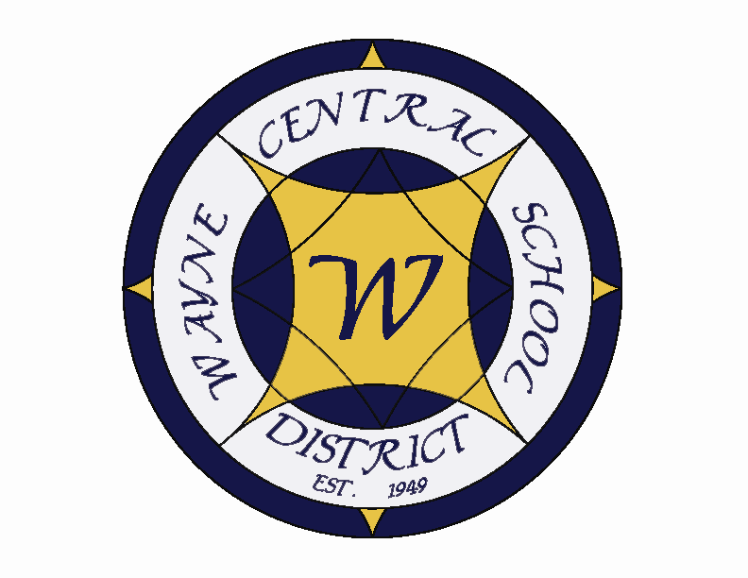
Letter to the Board

Michael Havens
Superintendent of Schools
Phone: 315-524-1001 Fax: 315-524-1049 mhavens@wayne.k12.ny.us

January 27, 2006

“Many would be wise if they did not think themselves wise." --Baltasar Gracian, Spanish writer

Greetings from Wayne Central. Below are a few items of interest.

Board Letter:

- Project Lead the Way – As a continuing part of implementing the high school Model Schools program, RIT has agreed to a partnership with Wayne to bring college level engineering classes to Wayne. These courses will also be available for high school credit and students will be able to choose whether to take them for single or dual credit. At this time those courses will include Introduction to Engineering Design, Principals of Engineering, Civil Engineering/Architecture, Engineering Design and Development and Digital Electronics. Future courses in Aerospace and Biotech are being developed by RIT. The RIT program is called “Project Lead the Way”. In order to provide these courses we are looking at moving a middle school technology teacher to the high school. Declining enrollments in both the elementary and middle school are providing some staffing and program opportunities that otherwise would be available only through additional budget expense. We will be presenting a program on this at a future Board meeting.

- Ontario Historian Meeting: I met with Ontario Town Historian, Liz Albright last Friday to discuss possible student involvement with planning and events surrounding the Town of Ontario’s Bicentennial celebrations and recognitions in 2007. There are several events planned for next year, many of which will occur during our Town of Ontario Days

- Albany Conference: The School Superintendents’ Conference in Albany this week provided some excellent opportunities to dialogue with our state and local legislative representatives. We had the opportunity to spend Monday evening with Senator Nozzolio and Assemblyman Oaks. Tuesday morning we met with Senate Education Chair Saland. All agree that the numbers will change from the governor’s proposal. This has always been the case and is good news for us since our numbers were basically flat. It appears that excess cost aid will be restored as will BOCES aid. No one seems to know if there will be more operating (now called flex aid). That is generally the only aid that helps with salaries, equipment, TRS, etc. There is strong support for an additional STAR rebate for taxpayers. They are also suggesting an on-time budget is possible. :)

Larry and I had the opportunity to attend two workshops with Mike Schmoker. Mike is a well known and respected writer on Educational Reform. His book Results forms the basis for some of our work with teachers. He provided us with additional insight on how we can continue to improve instruction and reminded us why the fourth grade coaching model has been so powerful for us.

- Car Accident Involving Parent & Students: On Wednesday afternoon there was a head on collision involving a parent driving his daughter and two other students after exams. We have been informed that not long before the accident, the parents were on the phone with transportation wondering why busses were not provided for students. The parents were called for a ride by their daughter, after allegedly being told by HS staff that no busses were available. Transportation sends schedules and bus routes to the schools indicating exam bus arrangements, which include a 3:00 run and informed the parents of bus schedules. I believe that one small child involved in the accident received a head trauma.

- 2006-2007 School District Calendar Draft: Attached is a “near” final draft of the school calendar that we have been working on in council for the 06-07 school year. I have also attached a copy of the adopted WFL BOCES calendar which we use as a starting point for our calendar development process. This calendar will go to our union representatives next for their review and comments. This calendar will require the approval of the WTA as we are requesting two teacher days in August. These dates are outside of the negotiated contract which states that the working year for teachers starts September 1. I am not sure what their reaction to this request will be. If they balk at one or both of these dates, we will move the staff start date to September 1 and move the other staff training date to later in the year.

- Marines Boot Camp Visit: After solicitation from recent Wayne graduate and Marine Spencer Schmidt in conjunction with local marine recruiters, I have agreed to send 5 Wayne High School or Middle School staff members to Parris Island, SC to learn about boot camp. The reason the Marines sponsor this program is to promote the Corp and to help us understand the process they use in transforming civilians into Marines.

- Budget: We will be providing the Board with the proposed instructional portion of the budget at our next meeting. This represents 70% of our total spending plan and so generally is the most critical part. My question last night about a tax rate was to getting you thinking where you believe the voting public is. The narrow yes/no margin suggested to me that we have to be careful about spending. Heating costs and gasoline costs are up for everyone. I have a sense through my conversations with our community that they are experiencing some tax fatigue. Based on that and some individual Board conversations, I believe the budget increase should be small. To that end I have asked our administrators to take an honest look at how we are using our current instructional staff. Our student population has declined by more than 200 over the past few years. While the high school population continues to grow, the middle school and elementary is shrinking. Administrative procedures call for primary class sizes of between 16 and 19. Intermediate class should be 20-25 as should middle and high school. I believe we will be able to pay for many of the instructional improvements we are seeking through the relocation of staff. In some cases we may be able to better use funds through hiring different staff. I do not want to lay any staff off and my sense is that the Board would not support such an endeavor, but there are opportunities when people retire. This year we had some elementary and middle school class sizes that dropped as low as 14 while some high school classes swelled to 29-30. I want to avoid that next year. I am extremely interested in the Board’s thoughts about tax rates as the instructional package will be in the mail to you one week from today. Please feel free to email me about what your sense of the community is.

- Auto Break-In’s – Our staff received this information from Trooper Smith this week: In the past 3 weeks vehicles in the Williamson, Marion and Pal-Mac School Parking lots have been the sight of numerous break ins with Audio equipment being removed. The suspect vehicle in all of these break-ins is a metallic blue Chevy Astro Van. The person involved may be a heavy set white male with a beard. He works quickly and has extensive skill in removing these items indicating possible employment in the field of stereo installation. Let me know if you even suspect this vehicle has been here. If you see this or any other suspicious vehicle call me immediately at ext #1033, call your school office to reach me or call 911. If you can get a license plate # that’s great, but never put yourself in the position of possible physical confrontation. We caught a car thief at the middle school 2 years ago because of observant staff.

- Upcoming Events:
1/30 – Four County General Membership Meeting – Club 86
1/30 – FE Parent Group Meeting @ Media Center – 6:45 p.m.
1/30 – 2/3 OP/OE Book Fair
2/2 – 2/7 FE Book Fair
2/3 – Ontario Comedy Club – Dinner @ Ontario Golf Club – 6:00 p.m.
2/4 – Ontario Parks & Recreation Winter Carnival & Chicken BBQ @ Casey Park

Athletics (Home Events Only)
1/27 – Boys’ JV & V Basketball vs. Penn Yan – 6:00 & 7:30 p.m.
1/30 – Varsity Co-Ed Bowling vs. Geneva @ Empire Lanes – 4:00 p.m.
1/31 – Boys’ JV & V Basketball vs. Victor – 6:00 & 7:30 p.m.
2/2 – Varsity Co-Ed Bowling vs. Mynderse – 4:15 p.m.
2/3 – Varsity Wrestling vs. Geneva – 6:30 p.m.
2/3 – Girls’ JV & V Basketball vs. Canandaigua – 6:00 & 7:30 p.m.
2/3 – Boys’ Freshman Basketball vs. Canandaigua – 4:15 p.m.
2/4 – JV Wrestling Tournament @ Wayne – Time TBD

8. Attachments:

  - School Calendar Draft

