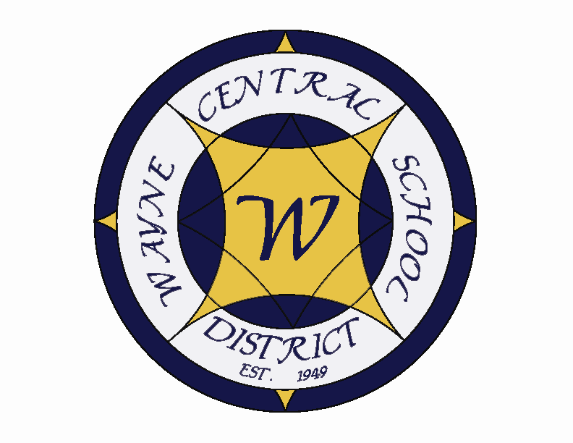
Letter to the Board

Michael Havens
Superintendent of Schools
Phone: 315-524-1001 Fax: 315-524-1049 mhavens@wayne.k12.ny.us

December 9, 2005

“If you can find a path with no obstacles, it probably doesn’t lead anywhere.” ~ Anonymous

Greetings from Wayne Central. Below are a few items of interest.

Board Letter:

- Academic Comparisons: Recently a board member asked about academic achievement comparisons between low economic students (free and reduced lunch status) and other students within the district. I have started to gather some data and have put together the attached charts indicating academic success rate comparisons. This was a sample ELA Assessment. As you can see our low socio-economic students aren’t doing as well as the general population, though special education students struggle the most.

- Bus Driver Resignation: The driver that received a speeding ticket while driving a school bus with students on board tendered her resignation this week. She was driving 12 miles over the speed limit. We gave her the choice of resigning or going to a civil service hearing for the purpose of terminating her employment.

- MS Friends of Music Meeting: I meet with the MS Friends of Music group this week regarding the middle school musical. The meeting went well, though there were some pointed questions. Overall the membership seems to be supportive of the decision and ready to move on.

- Joint Grant Proposal: A new grant has come out offering monies to entities that combines municipal forces. This is the one that Frank Guelli spoke of at our three boards meeting. I would like to discuss it further, but want to wait until the new supervisor takes over in Walworth.

- Eighth Grade Orientation: The orientation to high school went well. We even had two of our board members there in their role as parents. With appx. 170 parents in attendance, one question that was asked was “Why are we trying to obtain a rate of 98% of our students receiving a regents diploma, but only obtain a rate of 90% of our students going to college – why don’t we expect 98% of our students to attend college?”

- HS Fire Alarm: On Tuesday a student pulled the fire alarm after school, causing the building to be evacuated and the fire department to respond. Students were forced to be outside, some in shorts and shirts (after school practices) for appx. 15 minutes. During that time, the after school buses arrived and some students chose to go home, without re-entering the school for their things. We did receive one call from a parent that was told by their child that we had a bomb threat. We have not caught the person who pulled the alarm.

- Cheerleading: It has been more than a month since our decision to restrict cheerleading to home games. With gas prices easing a bit and perhaps with the holiday spirit in mind, I have reversed my decision. We will cheer for away games.

- Upcoming Events:
12/10 – Ontario Village Tree Lighting
12/14 – MS Chorus Concert @ PAC – 7:00 p.m.
12/15 - FE Band & Chorus Concert @ PAC – 7:00 p.m.
12/15 – Wayne Foundation Meeting @ RHouse – 7:00 p.m.
12/18 – HS Band & Chorus Concert @ PAC – 2:30 p.m.
12/20 – OE Band & Chorus Concert @ PAC – 7:00 p.m.
12/21 – MS Band Concert @ PAC – 7:00 p.m.

Athletics (Home Events Only)
12/9 – Boys JV & V Basketball vs. Canandaigua – 6:00 & 7:30 p.m.
12/13 – Boys’ – JV & V Basketball vs. Geneva – 6:00 & 7:30 p.m.
12/14 – Co-Ed V Bowling vs. Marcus Whitman @ Empire Lanes – 4:00 p.m.
12/16 – Boys’ JV & V Basketball vs. Pal-Mac – 7:30 p.m.

10. Attachments:

  - Socio-Economic Academic Report
  - Safety Committee Meeting Minutes – 11/29
  - “In the News” Summary - November
  - WFL BOCES “Board To Board” – November 2005

