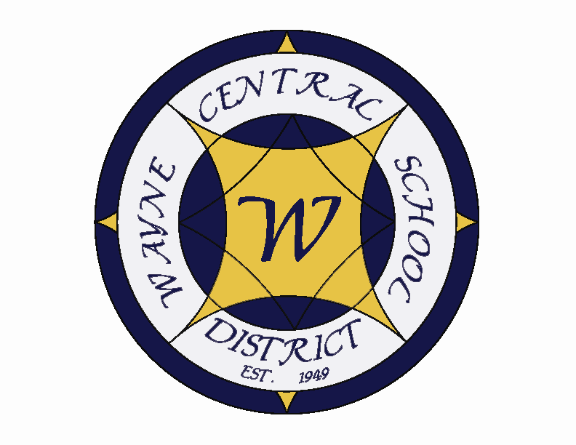
Letter to the Board

Michael Havens
Superintendent of Schools
Phone: 315-524-1001 Fax: 315-524-1049 mhavens@wayne.k12.ny.us

November 10, 2005

“Dost thou love life? Then do not squander time, for that's the stuff life is made of. “
-- Benjamin Franklin

Greetings from Wayne Central. Below are a few items of interest.

Board Letter:

- Local Elections: Congratulations to Jim Switzer on his election to the Ontario Town Board. Joe Molino was re-elected as Ontario Town Supervisor. Frank Guelli was defeated in the Walworth race, which has the potential to bring about some consequences for the Wayne and Gananda School Districts. Frank was a strong supporter of the school districts retaining the sales tax. I am not sure what Bob Plant, the new supervisor’s position will be. In other county towns, there were more upsets. Marv Decker lost in Wolcott to none other than my past nemesis, Kim Park, past Wayne County Administrator. Since the election, Kim has privately indicated that she doesn’t favor taking back the sales tax. She said that she was just following orders before. It will be interesting to see how this shakes out. It appears that Don Colvin won in Savannah by 10 votes (a leader in the campaign to take back the sales tax) however, there may be some question over absentee ballots that could still come into play. Donna Chittenden lost in Sodus and she was a proponent to take back the sales tax. I am unfamiliar with the new supervisor in Huron, John Young.

- Bus Incident: On Wednesday afternoon we had a bus in a dangerous situation. The bus, driven by veteran driver Glen Holberton, pulled over to allow traffic to pass. He pulled over too far in what turned out to be a very soft shoulder area (as you recall, we had significant rains all day) and the bus slide down and tipped precariously to one side. There was one child (from OP) still on the bus. The child used the emergency back exit to escape the bus, just as he had learned in our drills. The bus kiltered enough that the one rear wheel was off the ground. The student was moved away from the scene with the driver. Another bus came along and radioed in the situation. It occurred in the area of 350 and Finley Roads. An ambulance was called as a precaution to ensure that the child was ok. The student’s father was called to the scene as well. The bus was righted and returned to the bus garage. Fred Prince will have the bus thoroughly looked over the be sure it is in good working order before putting it back on the road.

- Wayne County Education Coalition: They are hosting an “emergency” meeting to discuss strategies in light of the recent elections (see attached notice). Joyce and/or Jackie usually attend these meetings. You may wish to consider attending Monday night.

- Post Season Athletics: The Boys’ Soccer team played last Friday evening against #4 seed Pittsford-Mendon in the Class A Championship @ Spencerport HS. They lost a heartbreaker in overtime. As I said last week, this was the first time they have made it to the finals in 31 years (since 1974) and they should be very proud of their accomplishments this year. They had a tremendous season.

Our Girls’ Volleyball team played #1 seed Canandaigua for the Class A Championship for a repeat sectional title on Saturday and lost in the 5th game, 2 games to 3. This too was a heartbreaking loss for the team, but they also have had a tremendous season and should be extremely proud of what they have accomplished and where they have brought the girls’ volleyball program at Wayne.

- National Honor Society Induction: Monday evening I participated in the National Honor Society Induction Ceremony at the HS. I am very proud to say that 43 students were inducted. We now have close to 18% of our juniors and seniors in the National Honor Society.

- Bussing Fleet: I met with Head Mechanic Doug Adriaansen and Fred Prince to discuss the state of our bus fleet. Currently our large buses are on a 10 year replacement cycle. We are looking to see if that is too long and how expensive it would be to the district if we shortened it. We are meeting next week to review costs given the current dollar amount in our bus reserve. If we decide a change is appropriate, we will bring the information to a future board meeting.

- Upcoming Events:
11/11 – Veterans’ Day – Schools Closed
11/12 – HS PTSA Clothing Drive @ HS Parking Lot – 9:00 a.m. – 1:00 p.m.
11/13 – 19 – American Education Week
11/14 – Meet the Winter Coaches Night @ HS – 7:00 p.m.
11/16 – NYS Grade 5 Social Studies Assessment Testing
11/17 – Passport Application processing @ District Office – 5:30 – 7:30 p.m.
11/17 – Wayne Foundation Meeting @ RHouse – 7:00 p.m.
11/17 – Policy Committee Meeting @ District Office – 5:15 p.m.
11/18-20 – NAC – Seussical the Musical” @ PAC evening performances 7:30 p.m.; matinees 2:00 p.m.
11/29 – Passport Application processing @ District Office – 5:30 – 7:30 – p.m.
12/3 – Ontario Chamber of Commerce Holiday Craft Show @ MS – 9:00 – 4:00 p.m.

10. Attachments:
  - WCEC Meeting Notice
  - MS Music Department Pancake Breakfast
  - Four County Meeting – President’s & VP Dinner
  - Times Article – WC HS Principal Search begins
  - NYSSBA Board’s Legal Rights & Responsibilities Workshop
  - American Education Week Letter

Att. A

board letter

From: Laurie Verbridge [mailto:LVerbridge@kmdavies.com]
Sent: Wednesday, November 09, 2005 12:02 PM
To: Laurie Verbridge; Ronald Mendrick; mdurfee800@aol.com; saclark@bluefrog.com; pcrowe@chrisanntha.com; Rdrahms@clydesavannah.org; wgreco@clydesavannah.org; wvotra@clydesavannah.org; sherrie@cseainc.org; 4countysba@edutech.org; ssweeney@edutech.org; crothfuss@gananda.org; woosters@juno.com; lmaddock@lyonscsd.org; bressue@marioncs.org; esterchi@marioncs.org; rboyes@marioncs.org; rchristmann@newark.k12.ny.us; brian_mayou@nexpress.com; DanStarr@nrwcs.org; tgillett@nysutmail.org; dsholes@rccsd.org; npatterson@rccsd.org; paicecar@redcreek.net; jwedman@redsuspenders.com; dfrohlic@rochester.rr.com; edmagin@rochester.rr.com; jlyke@rochester.rr.com; sbvny@rochester.rr.com; spantano@rochester.rr.com; ssalvaggio@soduscsd.org; galens@tds.net; Havens, Michael; kholtz@wflboces.org; skeller@wflboces.org; lverbridge@williamsoncentral.org; mehresman@williamsoncentral.org; mfiegl@williamsoncentral.org; lrsscott@yahoo.com
Subject: WCEC Meeting - November 14 - 7:00 p.m. - KM Davies

In light of the outcome of the elections - which are good for us - the "former board members" may be looking for retaliation....

we need to be prepared as the sale tax is in jeopardy. This is an urgent meeting to discuss what we need to accomplish over the next month to keep the current board from eliminating our portion of the sales tax for our schools!

NOVEMBER 14 - 7:00 p.m. - KM DAVIES

Hello Everyone,

The TCA Middle School Music Department is having a Pancake Breakfast fundraiser on Saturday, November 19th from 7:30am-10:30am at the HS. Please help support our wonderful students and ever growing music department by reserving your breakfast now.
All proceeds from this fundraiser go directly towards the education of students in our performing ensembles and improving the department.
Please Email me ASAP if you would like to join us – you may send the check in the mail or pay at the door.

Breakfast includes: 3 pancakes, 2 sausage links, apple sauce and a beverage
Ticket prices are as follows:
Adults: $6.00
Seniors: $5.00
Children (8 and under): $4.00
CHECKS MADE OUT TO TCA FRIENDS OF MUSIC

Hope to see you there!!!!
Thank you,
Beth Smith

