Lyons Central School District
Technology Tips:

How to make a BIG Poster for your Classroom
- Use Word (2000 or 2003* ) only
- Insert your graphic(s) and text in Word
- Save to a floppy, jump drive, or email to yourself. (This step is only for Staff that logs on to the District server)
- Go to Room 108, log on to the teacher’s workstation. (Note: If you are connected to the District Office server you will not be able to log on). Someone with a MS/HS server account has to log on for you.
- In word, Command bar select ‘Print’ command
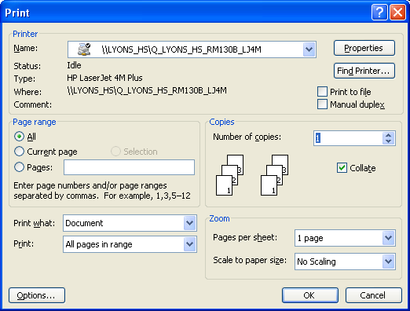

- For Printer Name select ‘DesignN450C’
- Click the Properties button on the dialog box

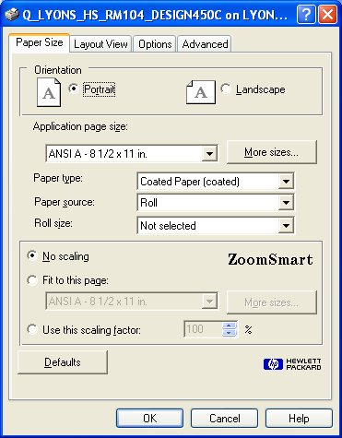
- Check off ‘FIT TO THIS PAGE’
- Select the MORE SIZES button

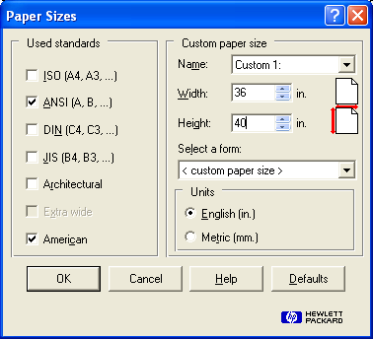
- In the Width box type in ‘36’
- In the Height box type in ‘40’
- Select the ‘OK’ button
- You may get a warning box

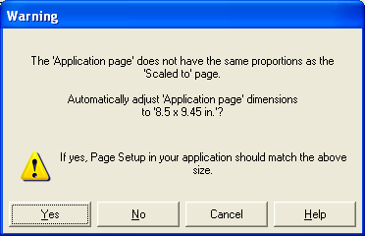
14. Select the no button

- Click okay on the open dialog box – Printing will start

  - For Word 2003 – Use MS. Polyn’s laptop

10/27/05

