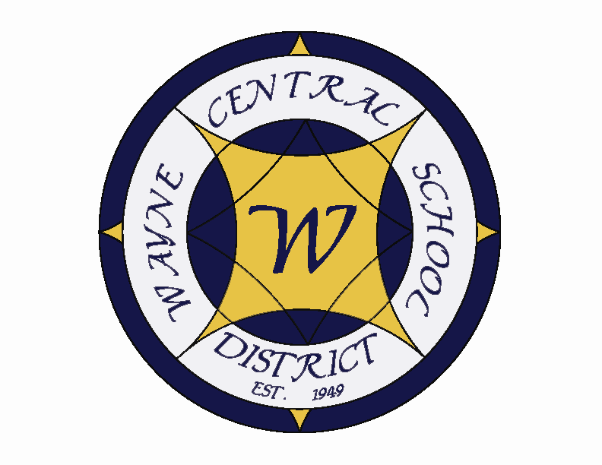
Letter to the Board

Michael Havens
Superintendent of Schools
Phone: 315-524-1001 Fax: 315-524-1049 mhavens@wayne.k12.ny.us

September 23, 2005

“The great use of life is to spend it for something that will outlast it.” - - William James

Greetings from Wayne Central. Below are a few items of interest.

Board Agenda:

- Executive Session: I would like to meet with the Board at 6:30 to present a plan for hiring a new high school principal. We agreed that we would leave Mr. Spring in the high school no longer than Christmas. I have prepared a timeline that would accomplish that goal. There also appears to be some progress on permanently resolving this issue. I will update you at that time.

- Retiree Reception: We will be presenting plaques to our retirees and reading the resolutions for those in attendance followed by refreshments.

- NYSSBA Annual Convention: We will discuss the annual convention and designate the voting delegate. Attached is a schedule of the “ Financial Oversight Fundamentals” workshops that are mandated by that state for board members elected after July 1, 2005. This means that Rick, Jeff and Don are required to take this training within their first year on the board. However, Mr. Hugh Clark of NYSSBA believes that SED will be moving toward requiring all Board members being required to take this training. The entire regulations on this new law have not been finalized yet, but Mr. Clark stated they should be forthcoming shortly. However, the training would be useful information for any board member and I encourage anyone interested to take advantage of this training opportunity at the convention. If you do not get to the training, or decide there are other sessions you would prefer to attend, additional training sessions are coming to Rochester on December 3 and several area school boards are offering training sessions as well. We will keep you posted regarding those sessions as information becomes available.

- Change Orders: Attached are three change orders. Change order #32 is for conduit & wire reinstallation damaged by a site contractor and is being back-charged to Christa Construction, the general contractor. Change order #13 is for installation of ceramic mosaic tile floor in team rooms and change order #9 is for the removal of the existing plaster ceiling and installation of new soffits and acoustical ceiling time in the corridor in front of the old gym as necessary. I recommend approval of these changes as presented.

Board Letter:

- Math Results: We presented our Math results to the Board earlier last year. New York State has now released some comparative data. I have enclosed the data for your review. We will be developing new charts for you shortly.

- Home Schooling: Last month you asked about the number of students being home-schooled. As of today 95 students are home schooled. At some point the district will want to look at how we might work to bring these families back into the school system.

- Katrina Benefit: On October 5 @ 7:00 p.m. in the PAC the middle school is holding a concert to raise money for Katrina victims. It should be a nice event and I encourage you to attend.

- NYS Council of School Supt Conference: I will be attending the NYSCOSS Fall Conference this Sunday – Tuesday in Albany. I will be back in the office on Wednesday. If you need to contact me for any reason, Lori knows where I can reached.

- Upcoming Events:
Sept. 26 – FE Parent Group Mtg @ Media Center – 6:45 p.m.
Sept. 27 – MS PTO mtg @ Media Center – 7:00 p.m.
Sept. 29 – Board Meeting @ PAC – 6:30 p.m.
Oct. 4 – OP/OE PTA Mtg. @ OE – 7:00 p.m.
Oct. 4 – HS Open House – 7:00 p.m.
Oct. 6 – OP Open House – 6:30 p.m.
Oct. 7 – School Closed for Students – Staff Training Day

Athletics: (Home Events)
9/26 – Girls’ JV & V Volleyball vs. Waterloo – 5:00 & 6:00 p.m.
9/26 – Boys’ V Golf vs. Mynderse @ OGC – 4:00 p.m.
9/27 – Boys’ JV Golf vs. Midlakes – 4:15 p.m.
9/27 – Girls’ JV & V Soccer vs. PennYan – 4:15 & 7:00 p.m.

6. Attachments:
  - NYSSBA Financial Oversight Session
  - D&C Math Test Results
  - Newscope - September

NYSSBA CONVENTION
FINANCIAL OVERSIGHT FUNDAMENTALS SESSION

The state requires 6 hours of training for newly seated board members in the financial oversight fundamentals. The New York State School Boards has been sanctioned by the State Education Department to offer the following courses that meet the state requirements for training.

Below is the schedule for the 5 sessions that will be occurring at the NYSSBA Annual Convention. The schedule is as follows:

FRIDAY, OCTOBER 28

11:00 A.M. SCHOOL DISTRICT FINANCES: ROLES AND RESPONSBILITIES

2:30 P.M. REVENUE SOURCES AND THE BUDGET PROCESS

4:00 P.M. BUILDING DISTRICT FISCAL FITNESS

SATURDAY, OCTOBER 29

2:15 P.M. MONITORING SCHOOL DISTRICT FISCAL FITNESS

3:45 P.M. PREVENTING FRAUD, WASTE, AND ABUSE OF
DISTRICT RESOURCES

There is no pre-registration required. Walk-in attendance

