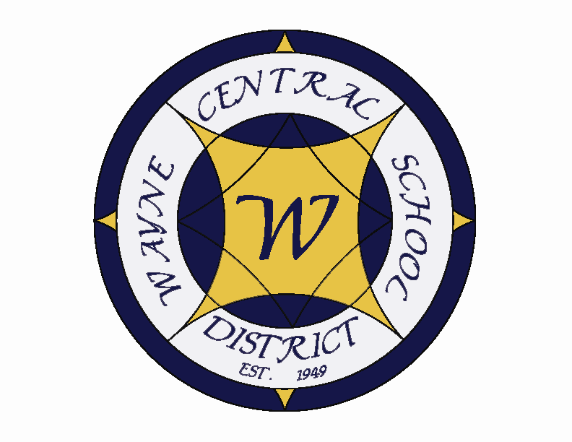
Letter to the Board

Michael Havens
Superintendent of Schools
Phone: 315-524-1001 Fax: 315-524-1049 mhavens@wayne.k12.ny.us

September 9, 2005

“Do you lead your students to the water and make them drink or do you try harder to make them thirsty? “ - - Carter G. Woodson

Greetings from Wayne Central. Below are a few items of interest.

Board Agenda:
- High School Tour: We will meet at the District Office at 6:15 for a tour of the building.

- Music Textbook Presentation: K-12 Music Chair, Sarah Moran will be presenting the music textbook that is being proposed for the elementary level music department.

- Opening Day/Enrollment Figures: I will report on how opening day went and enrollment figures for this year compared to last year’s. I will also see what numbers we can pull together for class sizes. The elementary level will be available, and most of the middle school classes should be set. High school numbers may still be flexing as students continue to rearrange schedules. I have to say what a wonderful operations and maintenance staff Mr. Miller has. They worked very hard to get the buildings in shape.

- School Improvement Plan: The 05-06 School Improvement Plan began at our Board/administration summer retreat is enclosed. The layout and pictures were done by Amy Gebhardt, our new public information person. If you compare it to last year’s you will notice she has a much better eye for I.

- Ribbon Cutting Ceremony: I will review plans for the ribbon cutting ceremony that is taking place on September 23 at 6:00 p.m. We would like our Board of Education members to lead the tours, probably teamed with a member of the high school or district office administration. We will give each member a cheat sheet of information and provide a run through. We are sending out nearly a thousand personal invitations including staff, retirees, town of Ontario and Walworth community leaders and employees, Ontario and Walworth Historical society members, Lions Club , Wayne Booster Clubs, PTA’s, Ontario and Walworth Businesses, our area senators and assemblymen, and past Board of Education members and other organizations.

- WTA Negotiations: Lori Sensenbach, acting president of the WTA in Pat Yates’ absence, has contacted me to talk about opening negotiations for the next contract. We have set up our initial meetingfor September 13th at 2:30. At that time we will be iinterviewing a person to serve as facilitator for the negotiations. We will give you an update at the meeting.

- Business Items: We have the usual business items. Personnel action and CPSE action are attached. The year end, June 30 Treasurer’s Report and the July 31 Treasurer’s Reports as well as budget transfers are submitted for approval.

Board Letter:

- First Week Summary: The first week went well overall. The reports on the kindergarten orientation event were well. This involved bringing in the kindergarten students and their parents on a separate bus run allowing students and parents an opportunity to acclimate to the bus ride, the new school, the full day program, lunches, etc. Parental feedback was pretty positive. Fred reports the internal road seems to have addressed the traffic issues on 350 and at the intersection of Ridge and 350. The high school is getting through a few growing pains with the new Powerschool system for student records management and scheduling, but once this initial process gets settled in, we believe this system will be very beneficial overall. As of today, the district enrollment is up 32 students. This will change next week. I will have more solid figures on Thursday.

- Construction Update: Most construction is completed though we are waiting on some floor tiling. The plumbing at the high school is also slow. I have frozen all payments because of their tardiness, to the General Contractor because of flooring and field issues, and the roof contractor because leaks in the new wing (sorry Jackie). You’ll be able to tour the HS facility yourself on Thursday. They have been putting the urethane topcoat on the track this past week. Weather permitting, it should be completed today. That leaves only the stripping and the track surface will be complete. It requires a curing period before it can actually be utilized by the athletes.

- Freewill Ice Cream Social: Last reminder! So far I have one Board member signed up to assist on September 20 from 6:00 – 8:00 p.m. It would be great for you to be there so, if anyone else can make it, please let Lori know. Thanks.

- NYSSBA Annual Convention: Please let Lori know your requests for attendance at the annual convention so we can send in our registration.

- Grant Writer - Kim Maira, Grant Writer is getting acclimated to the district. We have meet a couple times and have discussed some ideas of where we should be looking for grant opportunities. She shared some thoughts with me regarding after school and even start programs which she will be pursuing. We plan to meet on a weekly basis to keep abreast of progress. I am excited about her skills and the prospects of new grant opportunities.

- NYSSBA Area 2 Ballot – The Area 2 Director seat is the only one in the state (apparently) that is contested and it is a run-off between our own Jeanne Durfee and Thomas Nespeca from Webster. I have the ballot and we have until October 11 to send in the ballot form. I am attaching the letter from Jeanne Durfee requesting your support. I will place this on the agenda for September 29.

- Superintendents: Yesterday I attended the year’s first BOCES Superintendent’s meeting. I was shocked at the number of new faces. Today’s D&C had the following article about the problem state wide. We have feared this was coming. I think it will be a critical issue the state is going to have to solve. Administrators don’t seem to want the superintendency any longer. They are ending their careers at the principal or assistant superintendent level.

- New Teacher Orientation: On August 29, 30 & 31 the district hosted new teacher orientation. At that time we provide new staff with information on the district (the who, what and where). However, the three day orientation focuses mainly on new teacher best practices, networking, curriculum review, and classroom strategies. The session is very useful for our new teachers to get them off to a good start.

- Upcoming Events:
Sept. 12 - OP Grade 1 Parent Information Night @ OP – 6:30 p.m.
Sept. 13 – OP Grade 2 Parent Information Night @ OP – 6:30 p.m.
Sept. 13 – Four Cty School Boards Steering Comm Mtg
Sept. 14 – FE Parent Information Night @ FE – 7:00 p.m.
Sept. 15 – Board of Education Mtg @ DO – 6:15 p.m.
Sept. 16-18 – NYSSBA Academy for Public School Governance in Albany
Sept. 19 – 24 – HOMECOMING WEEK @ HS
Sept. 19 – OE 3rd Grade Open House – 7:00 – 8: 15 p.m.
Sept. 19 – HS PTSA Mtg @ DO – 7 p.m.
Sept. 20 – FE Welcome Back Bash & Ice Cream Social – 6-8 p.m.
Sept. 21 – OE 4th & 5th Grade Open House – 7:00 – 8:15 p.m.
Sept. 23 – Homecoming Parade – Main Street OE – HS – 4:30 p.m -5:30 p.m. (ish)
Sept. 23 – Ribbon Cutting Ceremonies @ HS – 6:00 p.m.
Sept. 25 – 27 – NYSCOSS Fall Conference (Albany) – I will be attending
Sept. 29 – Four Cty School Boards Legislative Comm Mtg

Athletics: (Home Events)
9/9 – Girls’ JV Tennis vs. Newark – 4:15 p.m.
9/9 – Girls JV & V Volleyball vs. Honeoye @ MS Gym – 6:00 & 7:00 p.m.
9/9 – V Football vs. Canandaigua – 7:00 p.m.
9/12 – Boys’ JV & V Soccer vs. Geneva – 4:15 & 7:00 p.m.
9/15 – Boys’ V Golf vs. Victor @ OGC – 4:15
9/15 – Girls’ JV & V Volleyball vs. HF Lima – 5:00 & 6:00 p.m.
9/16 – Girls’ V Tennis vs. Waterloo – 4:15
9/16 – Boys’ JV & V Soccer vs. Newark – 4:15 & 7:00 p.m.
9/16 – Girls’ JV & V Volleyball vs. Victor - 5:00 & 6:00 p.m.
9/17 – JV Football vs. Geneva – 2:00 p.m.
9/17 – Girls’ JV Tennis vs. Newark – 10:00 a.m
9/17 – Girls’ JV & V Volleyball vs. Livonia – 11:00 & noon
9/19 – Boys’ V Volleyball vs. Wilson High – 5:30 p.m.
9/19 – Girls’ JV Tennis vs. Pal-Mac – 4:15 p.m.

- Attachments:
  - Superintendents D & C Article
  - Critical Issues Bulletin
  - Jeanne Durfee Letter
  - MCSBA School Law Conference
  - NYSSBA School Law Seminar
  - NYSSBA Publication “Forecast”
  - Wall Street Article
  - School Law Conference
  - Four County School Boards “News & Notes”
  - Area 2 Proposed Resolutions Discussion Meeting Information

