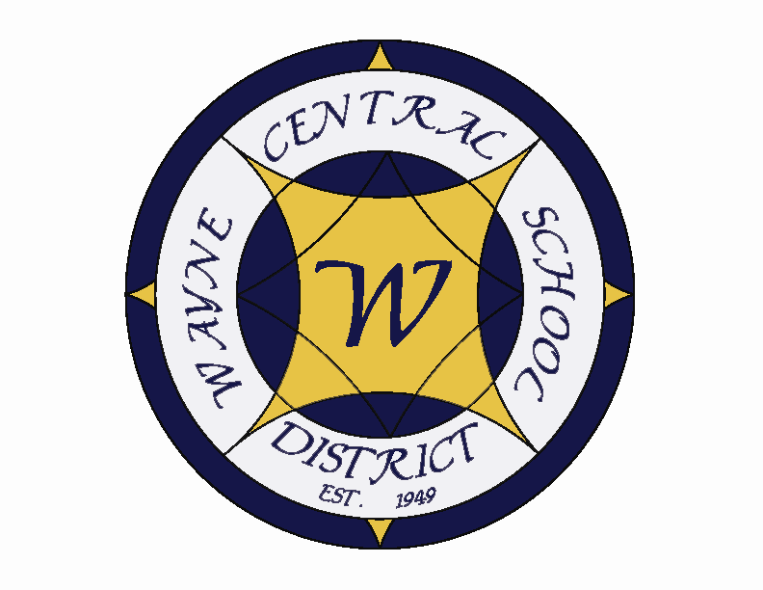
Letter to the Board

Michael Havens
Superintendent of Schools
Phone: 315-524-1001 Fax: 315-524-1049 mhavens@wayne.k12.ny.us

September 2, 2005

“Education is the power to think clearly, the power to act well in the worlds work, and the power to appreciate life. " - Brigham Young

Greetings from Wayne Central. Below are a few items of interest.

Board Letter:

- Opening Activities: On Thursday, I welcomed back the instructional staff and some support staff for a day of settling into their buildings. We began with coffee and refreshments in the high school before we gathered in the PAC for a brief session of new staff introductions, tenure presentations and a welcome speech. Staff badge pictures were also taken in the morning. Then each group went back to their respective buildings to set up classrooms and prepare for Tuesday. Things went well at all the buildings with the exception of the high school. The construction efforts are still underway with the tiling of the remaining corridors, painting of hallways, placing new doors, cafeteria work, etc. Many rooms remain unsettled which made it a difficult day at the high school.

- Construction Update: The remaining hallways are being tiled and the painting is being completed. There are a few final pieces they are finishing up, but in terms of the construction, everything necessary will be completed to allow for opening on Tuesday. That is not to say that everything is done. Work remains to be completed in the gym and equipment is still needed for the production studio. There are things that remain unfinished and work will continue, but despite a little sweat on the eyebrows, we will be able to open as scheduled.

I cannot say enough about the quality and character of our maintenance staff for the effort they have put forth to make it happen. They have worked diligently to put things back together building after building, culminating in a massive effort this week and weekend at the high school. They do it every year, but this year with this capital project, the effort has been exceptional. I would really like to recognize them for all they do to keep our district operating smoothly and efficiently. It takes so many people to make a district outstanding and they are just one more part of the full circle. We have a wonderful custodial staff.

- Freewill Ice Cream Social: Reminder: September 20 from 6-8 p.m. – Please RSVP by Sept. 13 if you are available to assist with ice cream slinging.

- NYSSBA Information on Required Training: Attached is a letter from NYSSBA on a new New York State law that requires trustees elected to a term beginning as of July 1, 2005 to complete at least 6 hours of training in fiscal responsibilities. See the attached letter. The workshops will be offered at the annual convention, which will be a convenient location to take advantage of them, if that works out for our new board members. As with many of the programs NYSSBA offers, I am certain this one would be very informative to any of our board members if anyone is interested in attending.

- Sex Offender Question: John Triou was recently approached by a community member who believes a sex offender has moved into a home on Haley Road and had asked him what he knew about it and/or what the school’s position would be regarding this situation. We have tried to verify this information and have been unable to do so. According to the NYS Sex Offender Registry, there is not a registered offender living at that address. It is alleged that this person has moved into the area from Florida and it is possible that they have simply not registered here in NYS. However, it is not the policy of the district to make notifications to residents of offenders who may be within our district boundaries. We have been advised legally not to assume that responsibility because it implies to parents a sense of district ownership for the tracking of the whereabouts of these persons. This is much too difficult a task. Law enforcement agencies find it difficult and admit they have a hard time verifying whereabouts of these persons at all times. It would be foolhardy to think that we could ever begin to do so. Once we step into this quagmire, even though our intentions are purely in the interest of protecting our children, we open ourselves up for unfortunate liabilities. For this reason, we keep our processes generic – warn children of stranger danger, inform parents of Megan’s Law & the registry, teach children strategies to protect themselves, and be watchful and vigilant ourselves.

- Fire at Ontario Primary - Today a transformer short circuited in the clock cabinet in the main office PA system and started a fire. The smoke detector triggered the sensors and the fire alarm went off. The fire company responded and put out the fire which was contained inside the transformer box. Our maintenance staff on site checked the building and identified the cause of the alarm. Staff were back in the building within the hour. The clock system is damaged and will not be operational on Tuesday. The PA system should still be functional.

- Tax Time – I am sure that you all received your tax bills in the mail. As of September 1st, the tax collection office is now open at the District Office and the lines have formed since before dawn. What an amazing, wonderful community we live in where the people are so enthusiastic about paying their taxes and sending us their money. Some property owners actually pay us extra because they are so pleased with our efforts. Helen Jensen, District Tax Collector gets baked goods, candy, fresh flowers, and sometimes even farm animals in appreciation. ….. well, it’s something like that anyway.

- GVSBI: I plan to participate in the Genesee Valley School Boards Institute again this year as a member district. It costs the school board $145.00 per year and primarily offers our district staff development opportunities for our support staff at very reasonable prices with topics that are very focused on timely, sensitive issues that are highly useful to educational staff. I recommend we continue participating in this organization. (see attached)

- Upcoming Events:
Sept. 4 – Labor Day – Last summer holiday – go out and enjoy!
Sept. 5 – First day of School!
Sept. 5 – Fall modified sports season begins (football began in late August)
Sept. 12 - OP Grade 1 Parent Information Night @ OP – 6:30 p.m.
Sept. 13 – OP Grade 2 Parent Information Night @ OP – 6:30 p.m.
Sept. 13 – Four Cty School Boards Steering Comm Mtg
Sept. 14 – FE Parent Information Night @ FE – 7:00 p.m.
Sept. 16-18 – NYSSBA Academy for Public School Governance in Albany
Sept. 25 – 27 – NYSCOSS Fall Conference (Albany) – I will be attending
Sept. 29 – Four Cty School Boards Legislative Comm Mtg

Athletics: (Home Events)
9/3 – JV Football vs. Brighton – 11:00 a.m.
9/7 - Girls’ V Tennis vs. HAC – 4:15 p.m.
9/7 – Girls’ JV & V Soccer vs. Victor - 4:15 & 7:00 p.m.
9/8 – Boys’ JV Golf vs. Penn Yan – 4:15 p.m.
9/8 – Boys’ V Golf vs. Geneva – 4:15 p.m.
9/9 – Girls’ JV Tennis vs. Newark – 4:15 p.m.
9/9 – Girls JV & V Volleyball vs. Honeoye – 5:00 & 6:00 p.m.
9/9 – V Football vs. Canandaigua – 7:00 p.m.
9/12 – Boys’ JV & V Soccer vs. Geneva – 4:15 & 7:00 p.m.

- Attachments:
  - NYSSBA Information on School Board Training
  - GVSBI Information

