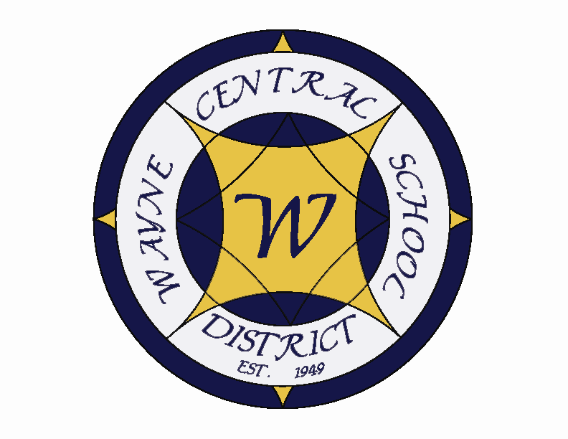
Letter to the Board

Michael Havens
Superintendent of Schools
Phone: 315-524-1001 Fax: 315-524-1049 mhavens@wayne.k12.ny.us

August 5, 2005

“A computer once beat me at chess, but it was no match for me at kick boxing.” - - - Emo Philips

Greetings from Wayne Central. Below are a few items of interest.

Board Letter:

Board Letter items

- Building Project: This week the construction crew is cautiously optimistic. Jeff feels they are a little ahead of schedule. The rooms in D wing are finished, floors waxed and furniture returned. Floor tiles are being laid in the hallway as I write this. A wing is getting ceiling tiles right now. Work needs to be finished in the classrooms. B wing is also getting ceiling tiles right now. Some of the rooms are done. There is still work to do in the main office, guidance and the nurses office. I am pleased with how the guidance area is turning out. There will be much more space for students. C wing is progressing though there appears to me to be much work left. They are leveling floors in the cafeteria and fitness room. The asbestos crew left a hose running in the old gym which damaged an area of the floor. We have put in a claim to the company. In the mean time a section of flooring is being replaced. I am concerned that it will be impossible to exactly match the flooring. E wing is coming fine. The library looks particularly good. The garage door has been replaced as has the “BJs” style ceiling. It looks more like a library now. The flooring has to be done and books returned. If any of you are interested in a tour give me a call and we can do a walk through. It is my daily activity. The other buildings are all coming fine. I don’t see any problems with them finishing on time. The class rooms and hallways in both OP and Freewill are looking great. The cafeteria in OP turned out especially well.

- Grant Writer: At the August Board meeting I will be recommending Kim Maira to you as our new half time grant writer at a salary of $25,000. She has great experience writing grants having secured over a million dollars during the last three years. She is excited about the opportunity to try her skills in a public school setting.

- Public Information Officer: At that Board meeting I will also be recommending Amy Gebhardt as our Public Information officer at a salary of $38,000. Amy currently works in the same position at FLCC and will be taking a slight salary cut to work for our organization. Her work is amazing. I think you are going to be quite pleased with the quality of material that will be produced.

- Personal Note: Those of you with college graduates will appreciate this. My daughter, Jill, is now not only officially graduated but she has obtained a job in her field. I didn’t think that happened anymore. The only bad part is that she is working in Baltimore. I now join Rick, Joyce, Mark and Jackie with children who have left the state for employment.

