Subject Area____Information Literacy K-6_______________Grade Level ___3____

Mission Statement: It is the mission of the Elba Central School District to actualize the phrase “Elba Equals Educational Excellence for Everyone.” We are committed to providing both quality and equity. Every student will have the opportunity to develop to the best of his/her ability.

Elba Standards: In addition to the knowledge and basic skills they need in order to participate in society, graduates of Elba Central School will develop:
- Empowering skills: decision making, goal setting, creative thinking and problem solving abilities;
- Communication and social interaction skills;
- Technological literacy;
- Total wellness (social, physical, emotional health and self-esteem);
- The values necessary to participate in society.
As a result of achieving these outcomes, our students will embrace lifelong learning.

National Standards:
Information Literacy
Standard 1: The student who is information literate accesses information efficiently and effectively.
Standard 2: The student who is information literate evaluates information critically and competently.
Standard 3: The student who is information literate uses information accurately and creatively.
Independent Learning
Standard 4: The student who is an independent learner is information literate and pursues information related to personal interests.
Standard 5: The student who is an independent learner is information literate and appreciates literature and other creative expressions of information.
Standard 6: The student who is an independent learner is information literate and strives for excellence in information seeking and knowledge generation.
Social Responsibility
Standard 7: The student who contributes positively to the learning community and to society is information literate and recognizes the importance of information to a democratic society.
Standard 8: The student who contributes positively to the learning community and to society is information literate and practices ethical behavior in regard to information and information technology.
Standard 9: The student who contributes positively to the learning community and to society is information literate and participates effectively in groups to pursue and generate information.
Performance Indicators:
Students will:
1-Media Center Responsibilities
- understand what a library is
- demonstrate good citizenship in the library by following rules and procedures
- utilize the librarian as a teacher and resource person
- demonstrate proper care of a book and other materials in the library
- follow circulation procedures
2- Collection Organization/Location
- have the ability to locate easy fiction, non-fiction, easy-to-read books and other relevant materials
- select materials for themselves
- understand that each item has a specific place on the library shelves
- understand the arrangement of fiction and non-fiction books including numerical vs. alphabetical order and arrangement of nonfiction by subject.
- have an awareness of the location and use of the catalog (OPAC)
- have the knowledge to search the catalog (OPAC) by subject, author, title and for availability
- develop an understanding of catalog records
3- Literature Appreciation
- recognize the variety of books available in the library
- have the ability to identify a variety of authors and genres (nursery rhymes, fairy tales, concept books, non-fiction, poetry, folktales, myths, legends, biography, autobiography, storytelling)
- develop an appreciation for his/her favorite books and authors
- recognize that books are for enjoyment as well as for information
- have an understanding of the Caldecott Medal
- develop an understanding of story elements (character, setting, plot, visual literacy)
4- Listening and Interactive Skills
- listen and comprehend stories read aloud (sequencing, prediction, retelling)
- recognize that quiet listening is necessary for group attention and enjoyment
- respond appropriately to what is seen and heard
5- Reference Skills
- understand ABC order
- understanding of how to use encyclopedias, dictionary, indexing, Internet
- participate in collaborated classroom/library supported research projects
e. develop an understanding of keyword searching
6- Vocabulary
- use and understand the following terms:
  - borrow, return, renew, overdue
  - author, title, illustrator
  - spine, spine label, cover, barcode, paperback, hardcover, pages, publisher, copyright date

7. Study Skills
- understand the organization of a book (table of contents, index)
- ability to differentiate between factual and non-factual information
- comprehend and restate factual information

Assessment: | Acceptable Performance Level
Conversations, questions, observations | Students will respond and participate in activites to support performance indicators.
Circulation statistics | All students will participate in book exchange. Circulation statistics will increase each year.
Surveys of knowledge and interests | 90% of students will answer questions on survey correctly.
Small group questioning | Students will actively participate in group discussions.
Report card grading | 90% of students will receive a 3 or 4 in all categories.

Scope: Third grade students will begin to develop an understanding of information literacy.

Sequence:

Month | Concept | Supporting Activities | Performance Indicator | Achieved Peformance Level
Ongoing | Listening skills | Use of props at the beginning of each story session; questions and conversations recalling information from stories- retelling of stories through skits and props; Arthur’s Christmas (Reader’s Theater); Clikck Clack Moo Cows That Type (reader’s theater); The Three Billy Goats Gruff (Reader’s Theater); Piggie Pie (Reader’s Theater); Redheaded Robbie’s Christmas Story (Reader’s Theater); Gretchen Groundhog, it’s Your Day! (Reader’s Theater); A Porcupine Named Fluffy (Reader’s Theater) (puppet); | 4 | Reinforced
Ongoing | Literature appreciation-Variety of genres | (Halloween) Hallo-Wiener; Henry and Mudge Under the Yellow Moon; Arthur’s Halloween;  (Christmas) Boxes for Katje; The Best Kind of Gift; Welcome Comfort (Polacco)  (Snow)  (Groundhog Day) Reader’s Theater Gretchen Groundhog;  (President’s Day) So You Want to be President; sing “George Washington Bridge”; movie and activities (attached)  (Snakes) Jimmy’s Boa Ate the Wash; Jimmy’s Boa Bounces Back- books and video-research boa constrictors in non-fiction books-where they live, what they eat, how big, what do they look like- provide adding machine tape to make boas actual size and colors;  Historical Fiction- Mailing May by Michael O. Tunnell; Gifts From the Sea (Kinsey-Warnock); | 3 | Reinforced
Ongoing | Author and illustrator appreciation | Author visit; Author studies: Mary Pope Osborne, Kate DiCamillo; Dr. Seuss; Patricia Polacco; Mrs. Pigglewiggle;. | 3 | Reinforced
Ongoing | Listening and Interactive Skills- comprehend and restate factual information | My Visit to the Zoo by Aliki- have students illustrate postcards; fill out other side with factual info about selected animal; include name of animal, where it lives, and one fact about the animal. (See Aliki author file) | 7 | Introduced
Ongoing | Listening and Interactive Skills- fact | Fact or Fudge? (see library skills file) | 7 | Introduced
Sept | Media Center responsibilities-proper handling of library materials | Read aloud concept books about libraries; | 1 | Reinforced
Sept | Proper handling of books | Poster; practice with books on tables; create bookmarks to mark page | 1 | Reinforced
Sept | Circulation procedures | Book exchange;  Questionnaire | 1,2,6 | Reinforced
Oct/Jan | Vocabulary | Questionaire | 6 | Reinforced
Nov | Reference skills-ABC order | ABC concept books; Alphabet City (Johnson); Sticks and Stones activity from Stretchy Library Lessons; www.littlefingers.com (shelving books); Between the Lions Website: ABCow; www.primarygames.com/ABC%20Zoo/start.htm; | 5 | Reinforced
Dec | Collection organization-OPAC | OPAC worksheet based on Christmas or Holidays-use to find books by title, subject and author and for availability; | 2 | Introduced
Nov/Dec | Collection organization-locate fiction, non-fiction, and easy to read books | Look for 398.2 (Hi ho librario!);Folklore books; Alphabetical Author from Stretchy Library Lessons; | 2 | Reinforced
Jan | Study Skills- organization of a book | Using the index from Stretchy Library Lessons;  Table of Contents-Turtle Time (p. 12) Library Safari;  Classroom Animal reports;  My Visit to the Zoo by Aliki- lead students to understand how to use the index key and color coded symbols in the back of the book; have students answer questions about index (see Aliki file) | 7 | Introduced
Jan | Caldecott Medal | Read various Caldecott titles;  Hold a mock Caldecott award. | 3 | Introduced reinforced
Dec/Feb | Reference skills-keyword | Worlksheet 14 from Discoverer; | 7 | Introduced
Mar/Apr/May | Reference skills-Dictionary, Encyclopedia, index, Internet | The Secret of the Silver Key; Mr. Crumb’s Secret; Lesson books that go along with books- read a chapter and focus on that skill, one at a time; Dictionary Go Fish & Dictionary Dive; The Great Race (Atlas); Almanac Jeopardy from Stretchy Library Lessons; Reference Books- Bat Research (review of resources); The encyclopedia-we can fly from Library Safari; Shaq and safe Internet use: www.microsoft.com/presspass/features/ 2000/nov00/11-27staysafe.asp | 5 | Introduced
Apr | Literature appreciation- Poetry | The Little Red Lighthouse and the Great Gray Bridge by Hildegarde Swift; feelings of inadequacy- write and illustrate poem based on model (lighthouse file) | 1 | Reinforced

3rd grade “mock” Caldecott Award:
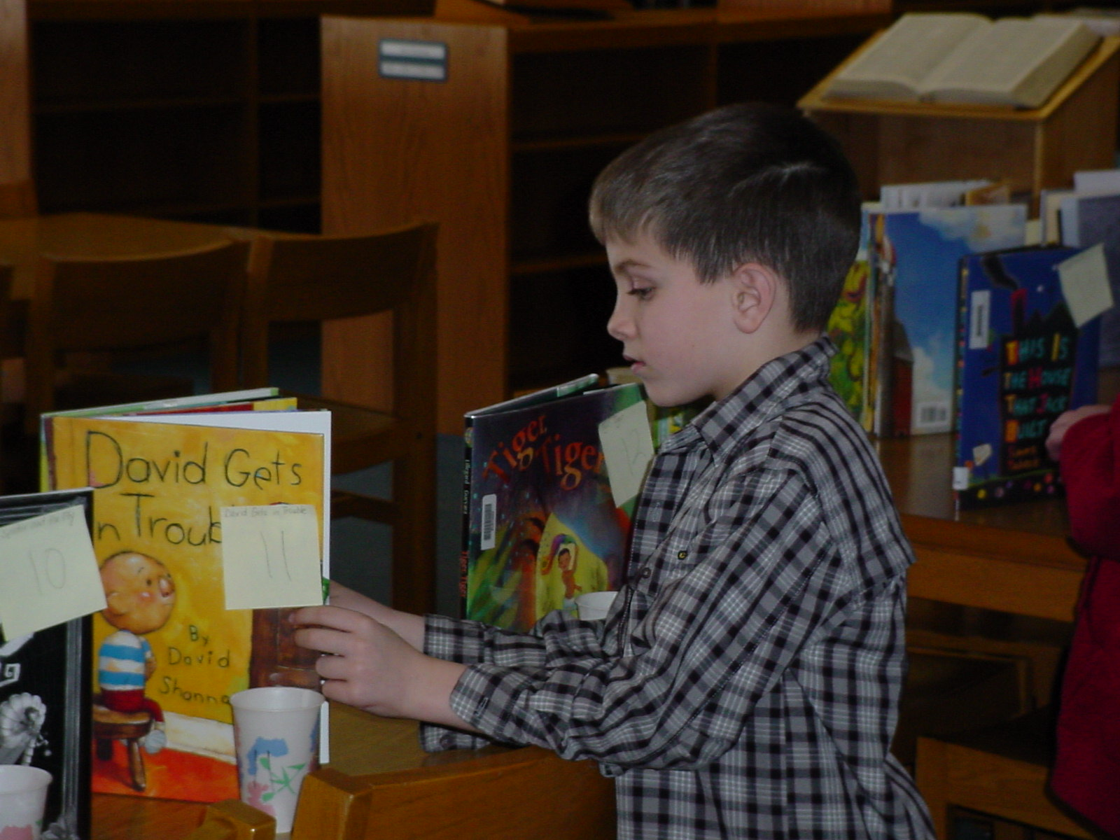
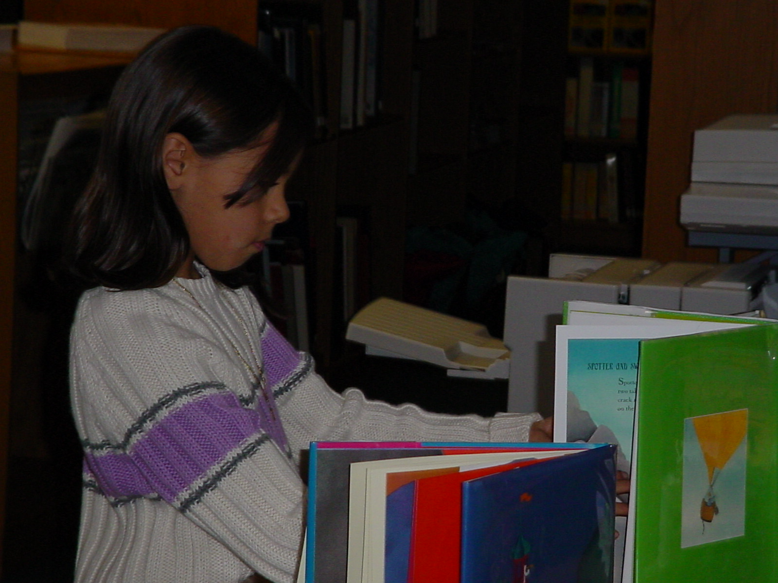

Judging the nominations.

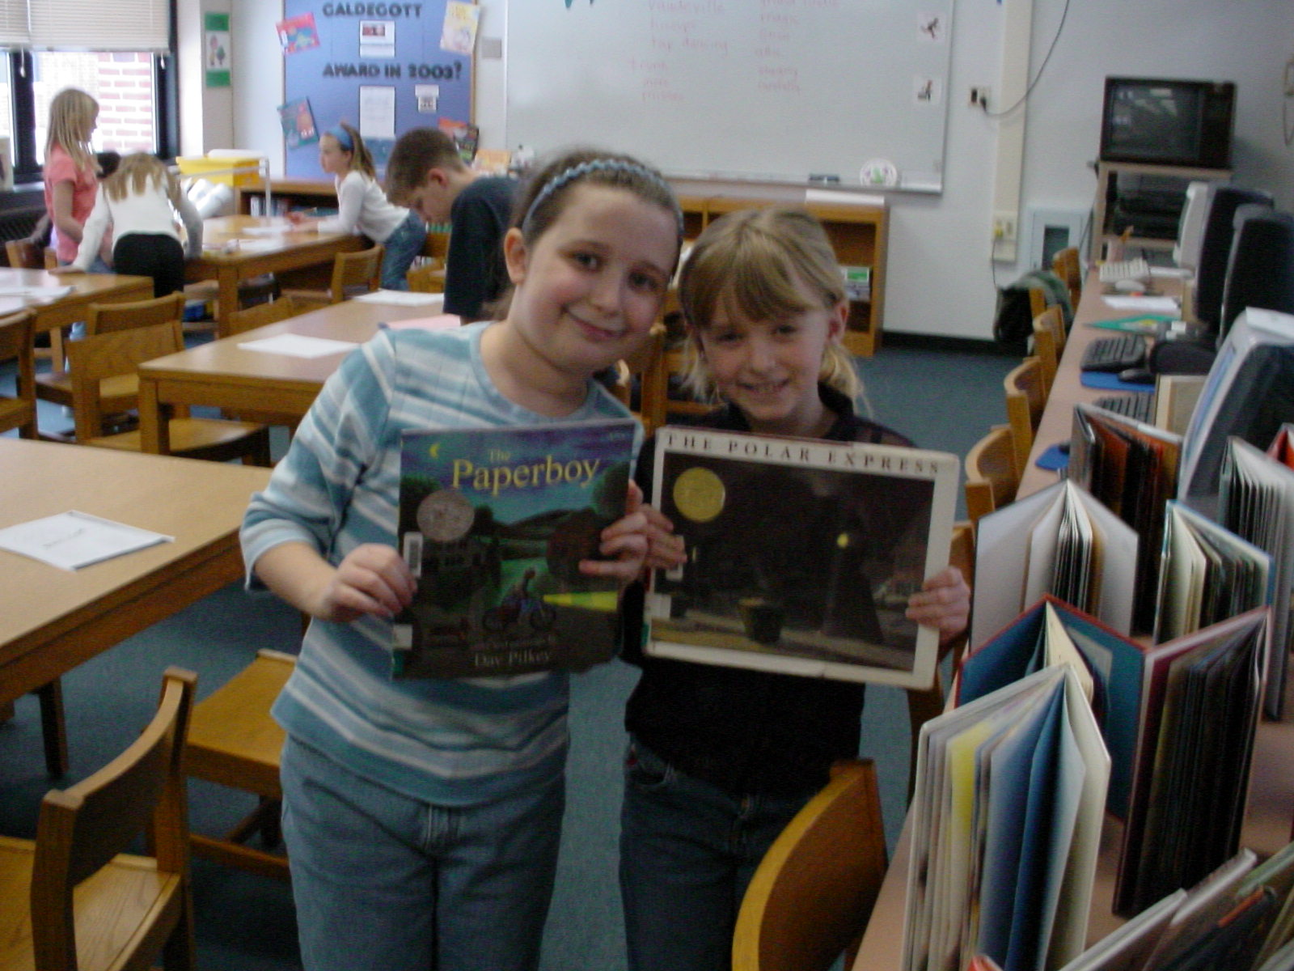

Past winners:

Methodology: Best Practices, 6+1 Writing, Classroom Collaboration, RAC, Information Power, puppetry

Bibliography:

Bannister, Barbara Farley. Elementary School Librarian’s Survival Guide. 1993.

The Best of Mailbox Magazine: Authors: Grades 1-3, 1999.

Carey, Patsy.Activities for any Literature Unit, 1995.

Davis, Robin Works. An Alphabet of Books, 1995.

Davis, Robin Works. An Alphabet of Authors, 1996.

Dingwall, Cindy. Library Celebrations, 1999.

Freeman, Judy. What’s New in Children’s Literature and Strategies for Using It in Your Program, 2003.

Miller, Pat. Reaching Every Reader: Promotional Strategies for the Elementary School Library Media Specialist, 2001.
Preller, James. The Big Book of Picture-Book Authors and Illustrators, 2001.

Rhodes, Immacula A. Teaching With Favorite Kevin Hawkes Books, 2002.

Ritter, Darlene. Literature-Based Art Activities, 1991.

Spencer, Gwynne. What’s Cooking in Children’s Literature, 2001.

SAMPLE

3rd Grade Questionaire

Date: ____________
Class:____________
Names: ___________________________________________

1. What do you like best about coming to library?
Responses:

2. Is there a book that we have read together that is your favorite?
Responses:

3. What letter is this? (Hold up several letters, have individuals answer) Responses:

4. What does the author do? What does the illustrator do?

5.Where in the library can you find easy/picture books?

Nonfiction?

6. Which of the following activities would be your favorite?
Play with playdough, look at a book or watch TV

7. Name something that you like to do for fun or something that you are interested in.

8. Will you tell me five ways to handle books that will keep the books looking nice?

SAMPLE

3rd Grade Vocabulary Survey

Date: ______________
Class:______________

Name of Student | author | title | illustrator | spine | spine label | cover | barcode | paperback | hardcover | pages | publisher | copyright

