
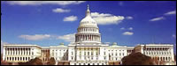
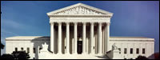
The United States Government

•This branch includes

THE EXECUTIVE BRANCH

President’s jobs include:
•This branch includes – ➢Approving and carrying out laws passed by Legislative Branch
1.) President ➢Appointing and removing cabinet members
(ALSO called Commander in Chief) ➢Negotiating treaties
2.) Vice President ➢Acting as Head of State
3.) 15 Cabinet Members ➢Commander in Chief of the Armed Forces.

•

THE LEGISLATIVE BRANCH

Their duties include:

This branch includes – •MOST important duty to make laws!

Two houses of congress! •Laws are written, discussed and voted on in congress
1.) House of Representatives •Senate must also ratify all treaties.
2.) Senate

HOUSE OF REPRESENTATIVES SENATE

* Number of Congressmen based on State’s population. •Each State elects TWO Senators.
* 435 members of the House •100 total Senators
* Serve two year terms •Serve six year terms
* Helped strengthen the large states power! •Helped strengthen the small states
power!
THE JUDICIAL BRANCH

•Led by the Supreme Court
•This is the highest court in the land
•ALL decisions are final!
•Contains NINE Justices and ONE of them is named the Chief Justice
•NO term limits; serve for life!
•Appointed by President; approved by Congress.

IMPORTANT DATES IN U.S. HISTORY

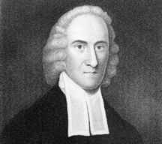
G REAT AWAKENING
1730

This was a period of evangelical zeal during the 1740s that produced numerous conversions and greatly increased church membership. This movement was led by Jonathan Edwards.

.
COLONY OF GEORGIA

1732

•James Oglethorpe (dressed in black at center) and the trustees of the Georgia colony met with members of the Creek people in 1734. They helped the colonists settle in present day Savannah, Georgia.

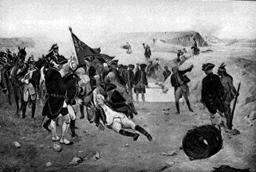
END OF THE FRENCH
AND INDIAN WAR
1763
•The French and Indian War (1754-1763) concluded a series of wars (1689-1763) between Britain and France.
•In the French and Indian War, the two European powers teamed with their respective Native American allies. Both sides were seeking domination of North America. •
•The conflict ended in victory for the British.

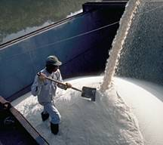
SUGAR ACT PASSED

1764
The Sugar Act imposed duties on a number of goods including molasses and other forms of sugar, textiles and dye, coffee, and wines.

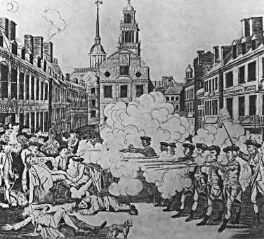
BOSTON MASSACRE
1770
•The Boston Massacre, was not a massacre, but actually a street fight between a mob and a squad of British soldiers.
•The incident ended with the deaths of five colonists.
•
•It used as propaganda to promote anti-British sentiment in the colonies.

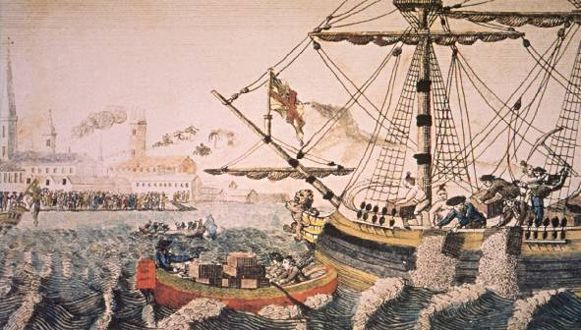
BOSTON TEA PARTY
1773

•On December 16, 1773, the colonists, some dressed as Native Americans, boarded three British ships and tossed the tea cargo into Boston Harbor.

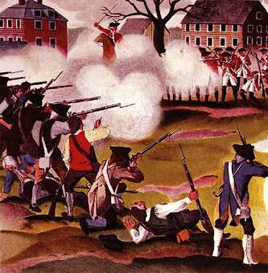
BATTLE OF
LEXINGTON AND CONCORD
1775

•American minutemen, who were far outnumbered by British troops, used a successful strategy that included persistent sniping from hidden areas in the Battle of Lexington and Concord in 1775.
•This strategy forced British troops to retreat from the countryside to strongholds in Boston, Massachusetts.

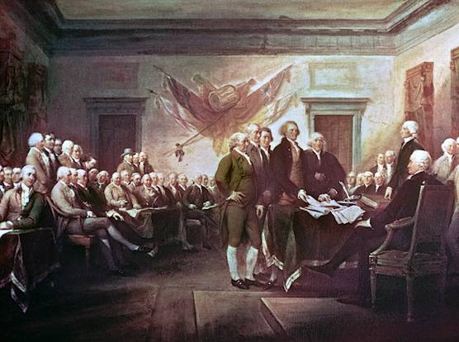
DECLARATION OF
INDEPENDENCE
1776

•The Declaration of Independence is the document in which American colonists proclaimed their freedom from British rule.
•The Second Continental Congress, with representatives of the 13 British colonies in America, adopted the declaration on July 4, 1776.
**The colonists believed that citizens were BORN with the individual rights in the
Declaration of Independence..

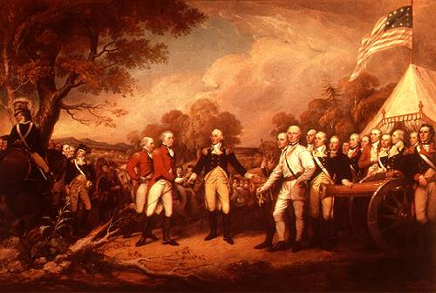
BATTLE OF SARATOGA

1777

•On October 17, 1777, following a defeat at the second Battle of Saratoga, British General John Burgoyne surrendered to American General Horatio Gates at Saratoga, New York.

This was a turning point in the American Revolution

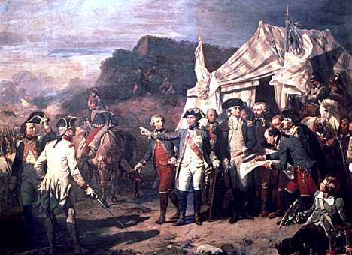
BATTLE OF YORKTOWN

1781
•This is where French and American troops overpowered the British in 1781.

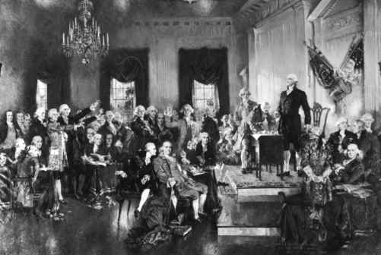
CONSTITUTION WRITTEN!
1787
•After several proposals for reform, the Constitutional Convention met in Philadelphia in 1787.

•Here, a document was written that still forms the basis of the United States government today.
*Here, the GREAT COMPROMISE settled disputes over REPRESENTATION in
Congress!

AMERICA GROWS AND CHANGES!

SENECA FALLS CONVENTION – 1848
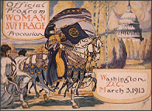
Women like Lucretia Mott and Elizabeth Kady Stanton met to create a list of rights they wished to obtain for WOMEN. This led to the fight for WOMEN’S RIGHTS, including the right to vote.
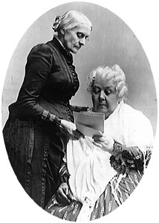

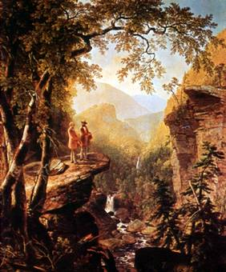
HUDSON RIVER SCHOOL

In ART, the Hudson River School movement started.
•This was the first time American painters,
like Thomas Cole, attempted their own style.
•They focused on landscapes.
•They “broke away” from England’s painters style!
*They painted realistic paintings of landscapes!

CAUSES OF THE CIVIL WAR
There were many causes of the Civil War. Some include:
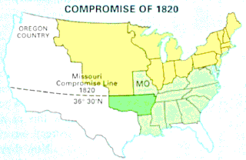
THE MISSOURI COMPROMISE
(1820)

•There was a great debate over where slavery would be
allowed and where it would not. A debate occurred and
finally a compromise was reached.
It stated:
- Missouri entered as a slave state.
- Maine entered as a free state.
3.) The 36’ 30’’ line is drawn.

•This compromise was effective for a number of years – almost thirty! However, after about 1850, problems began to occur and the compromise was less and less effective.

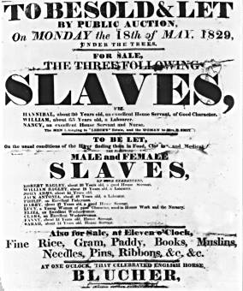
COMPROMISE OF 1850

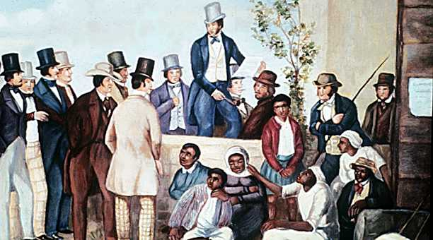
•COMPROMISE AGAIN!

•This time it includes 5 parts!

➢1.) California enters as a FREE state.
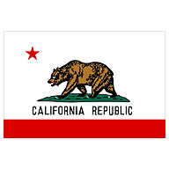
➢2.) Area from Mexican Cession divided into Utah and New Mexico.
Slavery issue to be decided by POPULAR SOVEREIGNTRY.
➢3.) ENDED slave trade in Washington D.C.
➢4.) Made a **STRICT Fugitive Slave Law **
➢5.) Settled boarder problems between New Mexico and Texas.

•Again, problems better for a short period of time and then became worse!

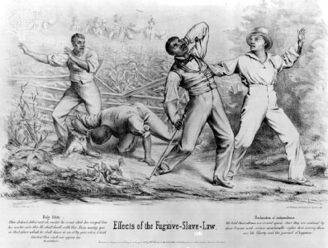
FUGITIVE SLAVE LAW
(1850)

*This law was part of the compromise of 1850.
*It was a law that REQUIRED citizens to catch runaway slaves.
*Northerners HATED this law because it forced them to become a part of the system of slavery.
**Northerners began to support the abolition (to get rid of) of slavery.

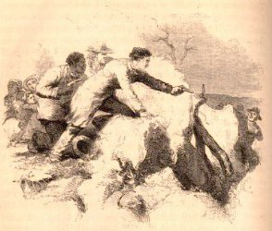
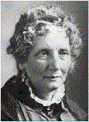
UNCLE TOM’S CABIN
(1852)

*This was a NOVEL written by Harriett Beecher Stowe.
*It was written to show the EVILS of slavery by telling the story of an older slave who was
whipped to death by his owner.
*After reading it, MANY Northerners began to change their view of slavery.
**Many wanted to see the abolition of slavery.

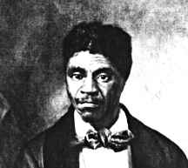
DRED SCOTT DECISION
(1857)

•Dred Scott was a slave.
•He had lived in a free territory with his owner.
•His owner moved back into a slave state.
•While there, the owner died.
•Scott had ABOLITIONIST attorneys file a law suit for him.
•It went to the Supreme Court but he LOST.
•The Court ruled he was NOT a citizen but RATHER property and therefore he could not
file a lawsuit.
•Also, they ruled that Congress could NOT ban slavery in any of the territories.
•This REPEALED the Missouri Compromise.
•Southerners LOVED the ruling while Northerners HATED it!
It meant slavery could spread into all the territories!

THE CIVIL WAR

STRATEGIES OF THE UNION:
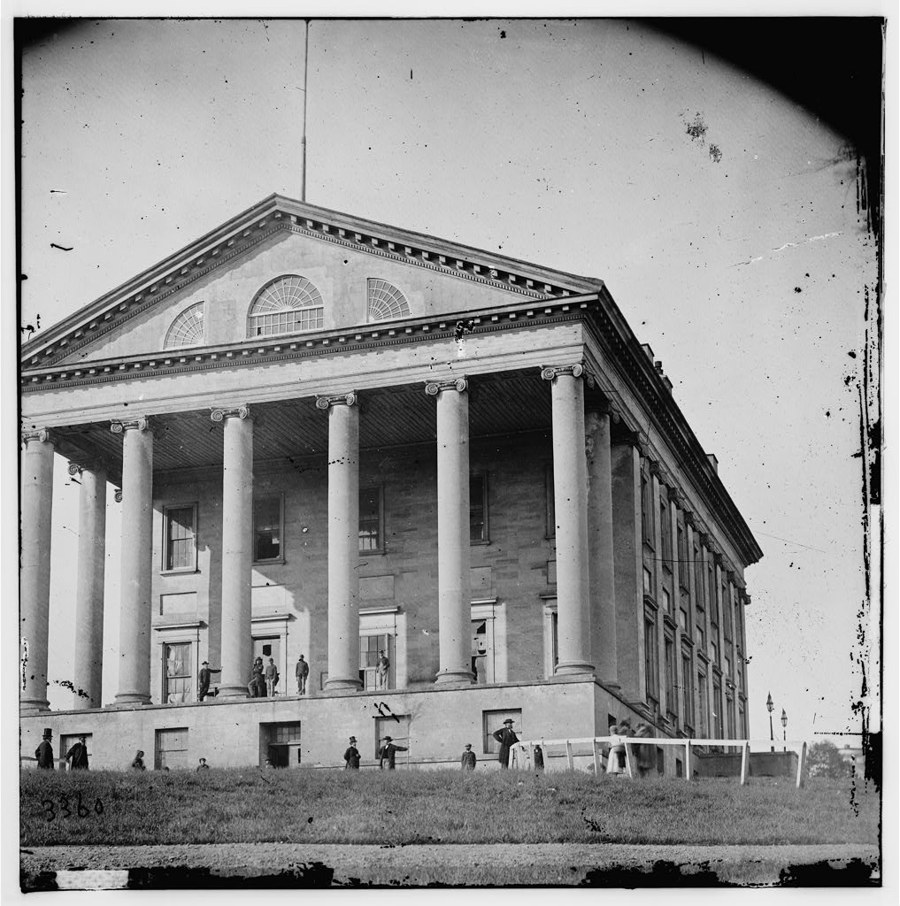
•Use the Navy to blockade Southern ports
•SEIZE Richmond, Va. .

(the Confederate Capitol)
•SEIZE control of the Mississippi River
The rebels capitol in Richmond, Va.

STRATEGIES OF THE CONFERDERATES!
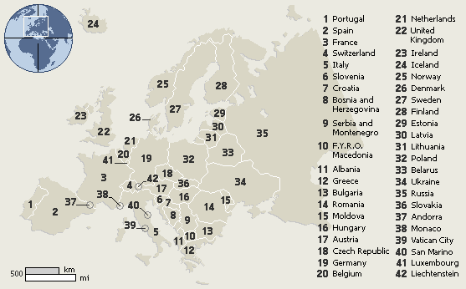
•Fight a defensive war
•Count on European’s money
and supplies to help them win the war.

THE COUNTRIES OF EUROPE!

FORT SUMTER - April 11,1861
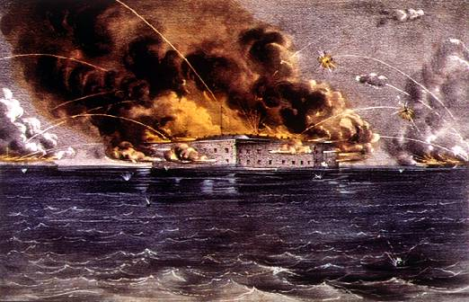
Fort in South Carolina that was controlled by the Union.

This is where THE FIRST SHOTS OF THE CIVIL WAR
WERE FIRED!
WER FIRED!

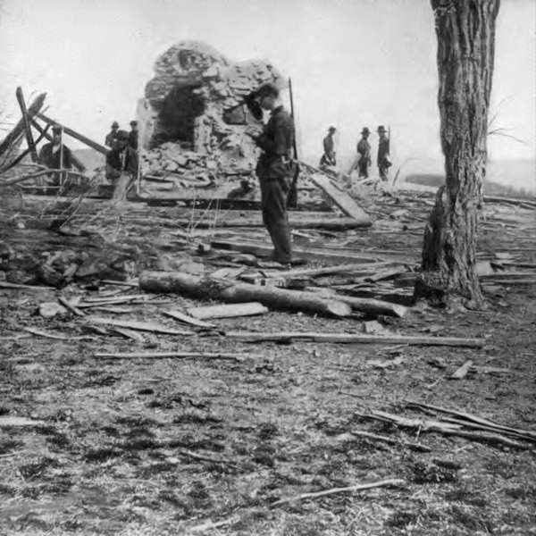
BATTLE OF BULL RUN - July, 1861

•FIRST actual battle fought in Civil War.
•Spectators come out with PICNIC BASKETS to watch the war!

•Jackson stands his ground and the Union retreats.
•Battle shows war will be long and bloody
and that BOTH sides need better training!

ANTIETAM - September 17, 1862

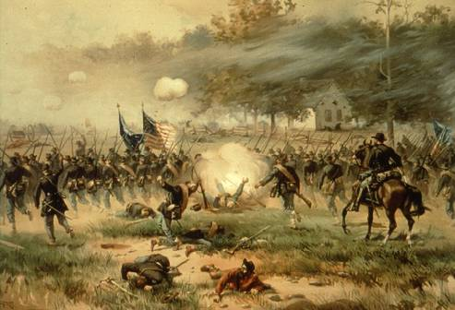
•Lee plans this attack
•Messenger looses his plans
•Union soldiers find them and gave them to
Mc Clellan who was still slow to react
•Confederacy retreats
•Union does not pursue
•Over 23,000 killed
•Union claims victory

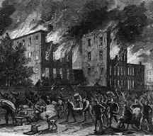
THE ANTI-DRAFT RIOTS - 1863

•These RIOTS occurred in New York City
and lasted for FIVE DAYS!
•People were rebelling against a 1863 draft law.
•This law gave the RICH a way out.
**If people had enough money,
they could avoid being sent off to fight.
•The mostly foreign-born, poor laborers of
New York City could not afford this and
thus were sent off to fight.’
•This SPECIAL TREATMENT of the rich angered many and thus, the RIOTS broke out.

THE EMANCIPATION PROCLAMATION! - January 1, 1863

•This was a document written
and “proclaimed” by Lincoln!

•It stated that ALL slaves in states in
rebellion with the United States would be freed.

•NO SLAVES actually were freed however because the SOUTHERN states paid NO ATTENTION to this document.

•The document did however CHANGE the focus of the Civil War.
Slavery was now an issue. This ALSO kept ENGLAND out of the war!

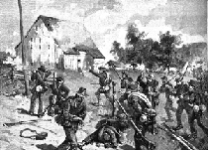
GETTYSBURG - July 1 – 3, 1863

*Lee attempting to advance towards Washington D.C.
*Battle lasts for three days
*Last day, Pickett leads his men in a charge against the
Union, who have the high ground.
*Pickett’s men destroyed
*Confederates (Lee) retreats
*TURNING POINT OF THE WAR!

THE GETTYSBURG ADDRESS - NOVEMBER 19, 1863
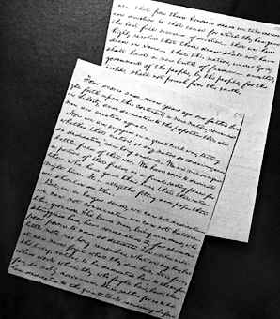
•This was a VERY FAMOUS SPEECH
given by Abraham Lincoln.

•He gave it at a ceremony to dedicate the
National Cemetery in Gettysburg, Pa.

**His speech HONORED those who
died during the Civil War battle at Gettysburg.

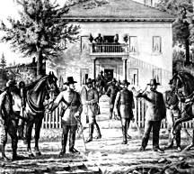
APPOMATTOX - early April, 1865

*PLACE WHERE CONFEDERATES (ROBERT E. LEE)
SURRENDERED TO THE UNION (ULYSSES S. GRANT).

*Grant tried very hard to allow the Confederates to keep their
dignity. He felt they were “his brother” and he worried as
as they became countrymen again.

LINCOLN IS ASSASSINATED - APRIL 14, 1865

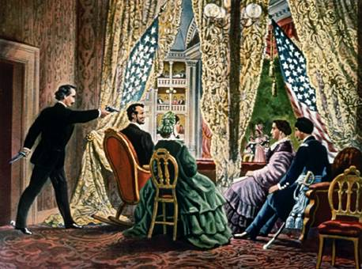
While watching a play with his wife
at Ford’s Theater in Washington D.C.,
Abraham Lincoln is SHOT in the
back of the head by an actor named JOHN WILKES BOOTH.

•He died at 7:20 am, the next morning, at a Washington D.C. hospital.

•The country was in total shock!

**ONE result of the Civil War – SLAVERY ENDED!**

RECONSTRUCTION!

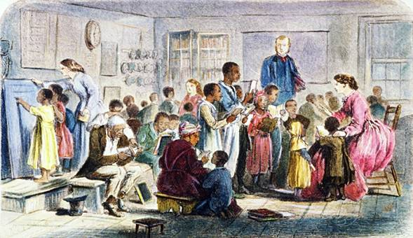
•This was the process where the country tried to “rebuild” the south after the Civil war.

•There were FOUR main plans:

1.) Lincoln’s 10% Plan
2.) Johnson’s Plan
3.) Radical Reconstruction Plan
4.) South REDEEMED! Freedman’s school!
- Southern Conservatives get back into power.

-They accomplish this by limiting African American voting rights!

They use things like: (know what each of these are)
POLL TAXES, THE GRANDFATHER CLAUSE and LITERACY TESTS!

THE FOUR MAIN GROUPS DURING RECONSTRUCTION!

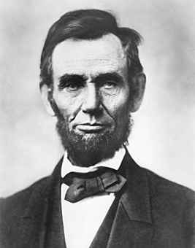
1.) NORTHERN MODERATES – President Lincoln
both Republicans and Democrats
*GOAL – get country back together as quickly as possible.
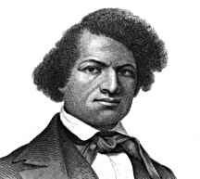

2.) RADICAL REPUBLICANS – Frederick Douglass
Northern Congressman; felt south to blame for war
*GOAL - Wanted south completely “reconstructed”; punished

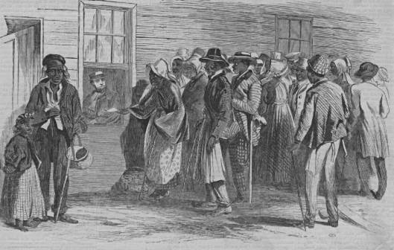

3.) FREEDMAN – Freedman waiting
This group are the NEWLY FREED, former slaves. For help from *GOAL – A BETTER life; look to future with hope and some fear. government!

4.) SOUTHERN CONSERVATIVES –
This group were the former white leaders who had power
*GOAL – think should be just like it was before only without slaves.
SUPREME COURT CASES!

COURT CASE – MARBURY VS. MADISON / 1803

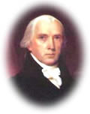  James Madison | 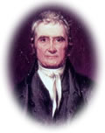  John Marshall | 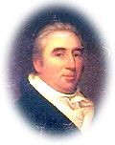  William Marbury
This 1803 decision marked the first time the United States Supreme Court declared a federal law unconstitutional. Chief Justice John Marshall wrote the opinion for the court. He held that it was the duty of the judicial branch to determine what the law is.
LED TO THE RIGHT OF JUDICIAL REVIEW!
His opinion established the power of judicial review—that is, the court's authority to declare laws unconstitutional.

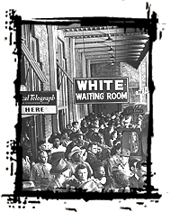
PLESSEY VS. FERGUSON - 1896

•This was a court case that went
all the way to the Supreme Court!

•It involved an African American child
and the right to the SAME QUALITY education as a white child

•The court ruled that SEPARATE BUT EQUAL was o.k.
(said it was CONSTITUTIONAL)

HOWEVER, separate NEVER was equal for the southern blacks!
Because of this ruling, JIM CROW LAWS became the way of the South.

THREE NEW AMENDMENTS PASSED!

•13th. Amendment –
This amendment freed the slaves.

•14th. Amendment –
This amendment gave the former slaves CITIZENSHIP!

•15th. Amendment –
This amendment gave African American men over 21 the right to vote.

Hiram Rivals – first black Senator

WESTERN EXPANSION
(INCLUDES 5 MAIN AREAS!)

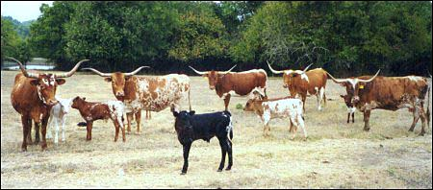
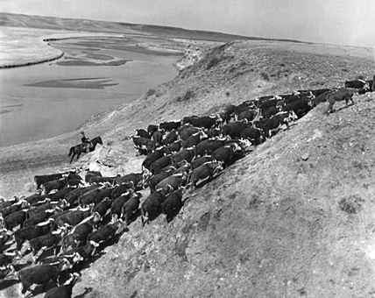
RANCHERS –

Lived on the plains.
Cattle was their “way of life.”
Drove their cattle to COWTOWNS
like ABILENE, KANSAS.
Cow towns “sprang up” near railroads.
These cow towns were often at the end of trails like the CHISHOLM TRAIL.

NATIVE AMERICANS – DAWE’S ACT - 1887

•This ACT or law gave approximately 160 acres
to individual Native Americans for farming or 320 acres for grazing..
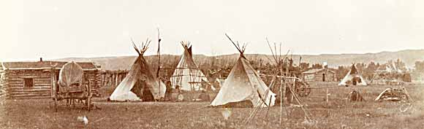
•The ides was to turn the Native Americans into farmers.
It was felt this would “civilize” them. (ASSIMILATION)
•The Native Americans did not believe in owning their own land.
Land belonged to EVERYONE in the tribe equally.
•They often sold off their land for “next to nothing”.
This resulted in much of the “tribal” lands being “white hands” within a few decades.

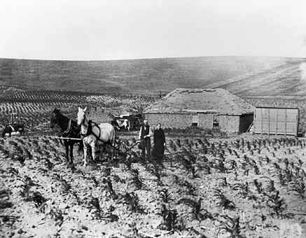
FARMING THE GREAT PLAINS! (THE SODBUSTERS)

Many people moved West due to the HOMESTEAD ACT!
People received 160 acres of land for FREE!
They had to agree to farm it for at least FIVE YEARS!
The steel plow and the wind mill.

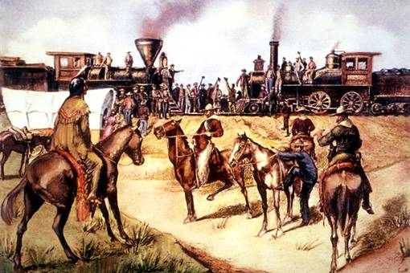
THE RAILROAD – connecting to the West!

Railroads were very important to people moving west.
Goods and people could be shipped easier.
The railroads connected the East and West.
This was called the TRANSCONTINENTAL RAILROAD.

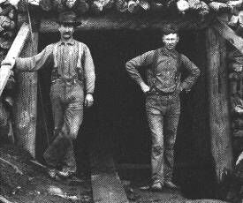
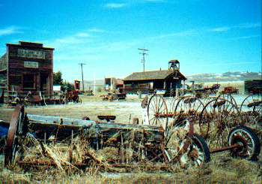
MINERS –

Discoveries of gold and silver brought
MANY to the west because they thought
They could get rich quick.

Wherever mines were built, towns “sprang up”.
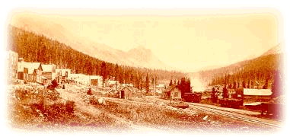
These were called BOOM TOWNS.

When people left them suddenly,
they became GHOST TOWNS.

VOCABULARY TO KNOW!
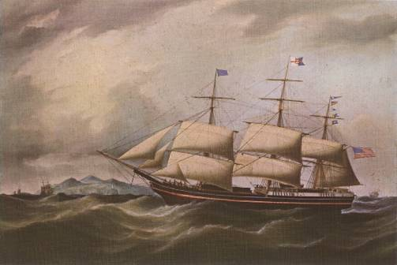
•TARIFFS –
these are taxes on goods brought into the country (IMPORTS).

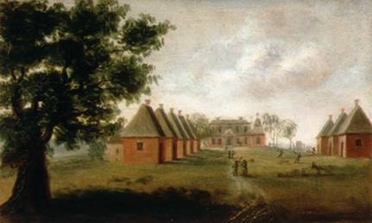

SECTIONALISM - the BELIEF that your part of the
country (North or South) is more important than
the needs of the rest of the country.
This was the REAL cause of the Civil War!

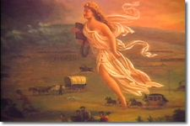
MANIFEST DESTINY - This was the BELIEF that America had the
RIGHT and RESPONSIBILITY to spread from OCEAN to OCEAN
(the ATLANTIC to the PACIFIC)

STUDY GUIDE FOR
MR. COOK’S MIDTERM!
(By: Mrs. Camuto)
JAN. 2004

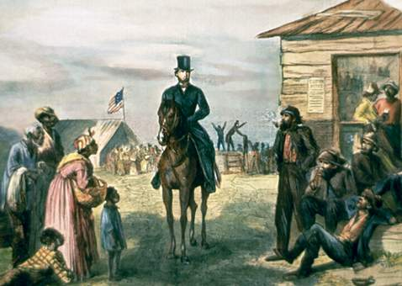

PEOPLE TO KNOW!
(you MUST know FIVE from the following two pages VERY WELL!)

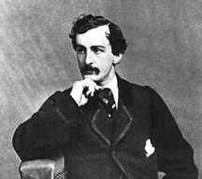
•JOHN WILKES BOOTH –

Southern actor.
Known for shooting Abraham Lincoln.
He was caught and hanged.

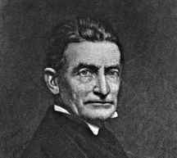
JOHN BROWN –

An abolitionist (someone who doesn’t believe / like slavery)
who went to extreme measures to help free the slaves.
He was involved in murders and the uprising at Harper’s Ferry.

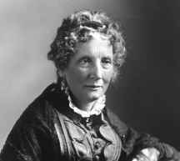
HARRIET BEECHER STOWE –

Author of the novel Uncle Tom’s Cabin.
Known for getting Northerners “stirred up” over the slavery issue.

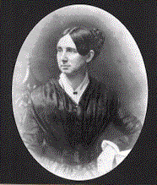
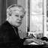
DORTHEA DIX –

A woman who worked to bring supplies
and care to Union soldiers.
She was named Superintendent of Nurses for the Union Army.

DRED SCOTT
-

•Dred Scott was a slave.
•He had lived in a free territory with his owner.
•His owner moved back into a slave state.
•While there, the owner died.
•Scott had ABOLITIONIST attorneys file a lawsuit for him.
•It went to the Supreme Court but he LOST.
•The Court ruled he was NOT a citizen but RATHER property and therefore he could not file a lawsuit.

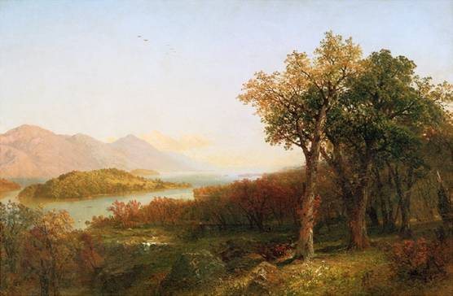
THOMAS COLE –
A painter from the Hudson River School movement.
They painted pictures of American landscapes.

KNOW THE FOLLOWING EVENTS!

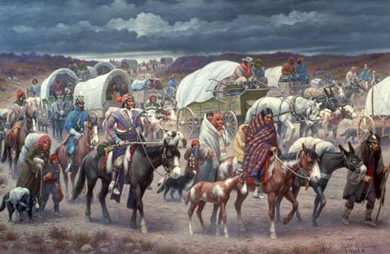
THE TRAIL OF TEARS – 1838
•In 1838, 15,000 Cherokees
were
forced to march hundreds of miles from their homes.
•They were forced off their land
and sent to land west of the Mississippi River.
•The march was called the “Trail of Tears” because thousands died along the way; mostly children and the elderly.

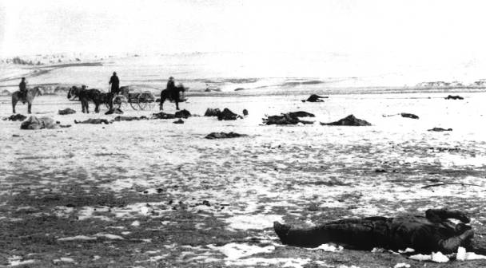
WOUNDED KNEE - December, 1890

•Started when MANY people began heading
towards the Reservation due to Sitting Bull’s death.
•Soldiers became worried and nervous.
•At one point, they surrounded a group of Native Americans.
•The soldiers persuaded them to surrender.
•While they were turning over their guns,
a shot was fired (no one really sure who fired first!)
•Soldiers LOST CONTROL and started firing at everyone.
•In the end, 300 men, women and children were lying died.
•It was a SLAUGHTER that was never forgotten.

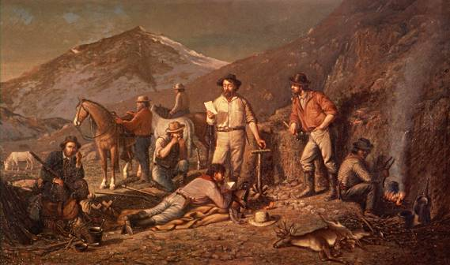
COMSTOCK LODE – June, 1859

This was a GREAT silver deposit
discovered in the state of Nevada.
Led to a boomtown!

THE 36’ 30’’ LINE –
This imaginary line was drawn as a result of
the Missouri Compromise.
The states NORTH of the line are FREE and
those SOUTH of the line are SLAVE states.

.

