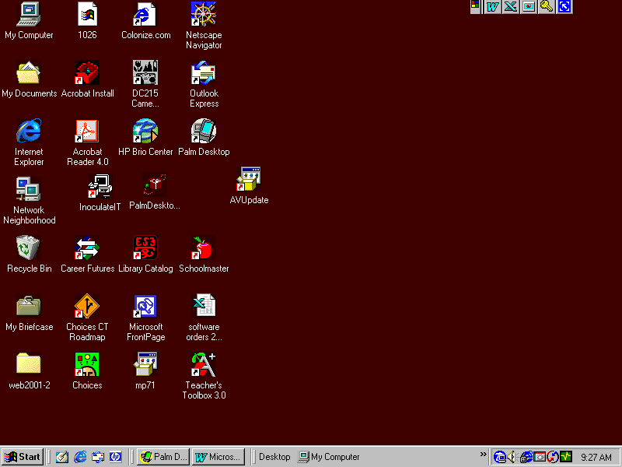
Every 3 weeks:
Click on AV update icon on your desktop

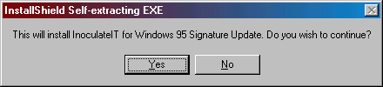
Click Yes button

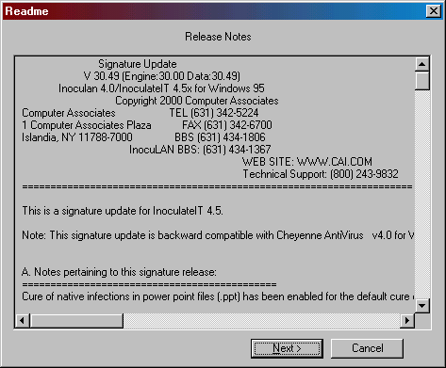
Follow prompts on windows
Keep clicking next

And computer will restart when finished

After Computer has restarted go to Start on Task bar

Click on start
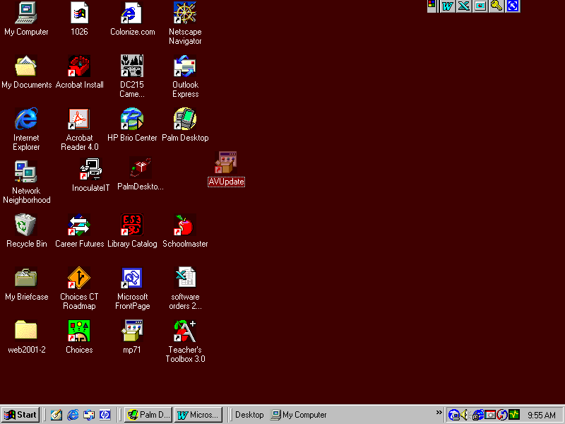

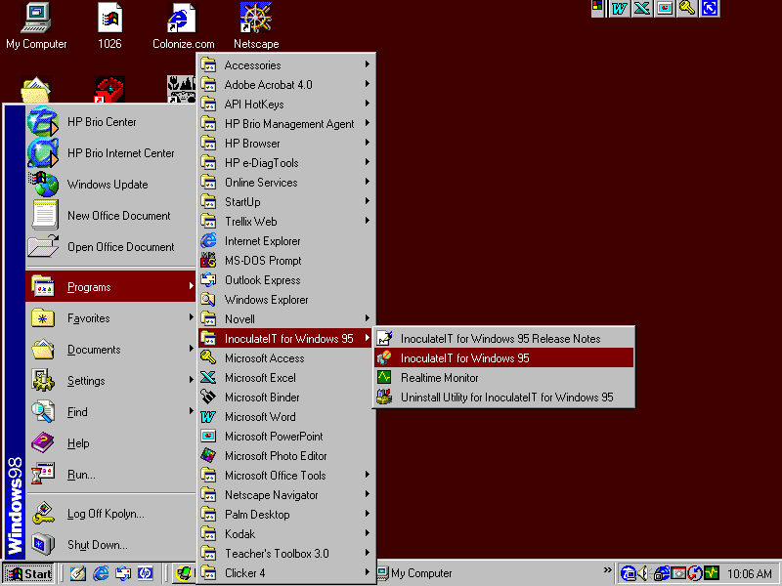
Select this program

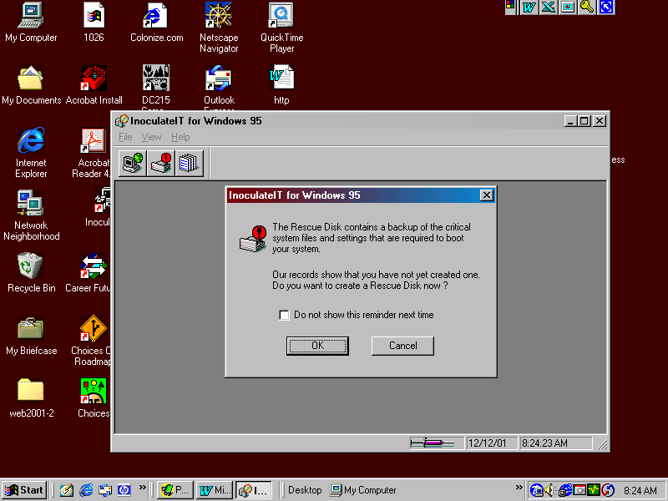
Check do not show this reminder next time and
Select cancel button

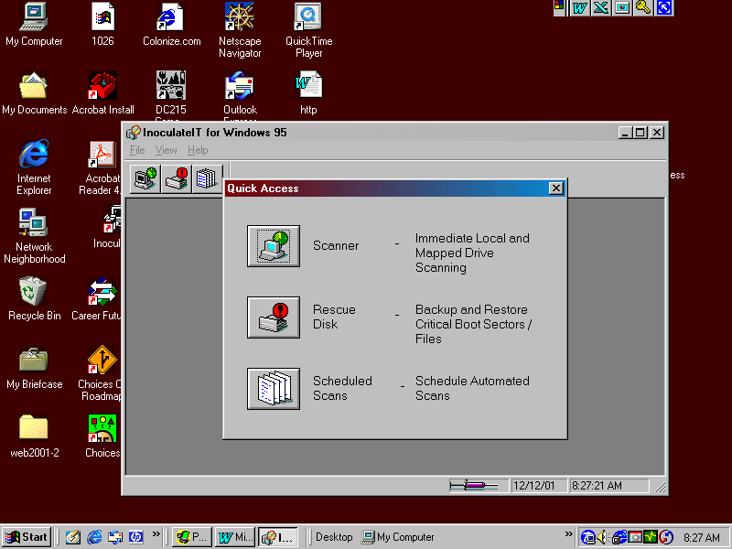
Select Scanner button

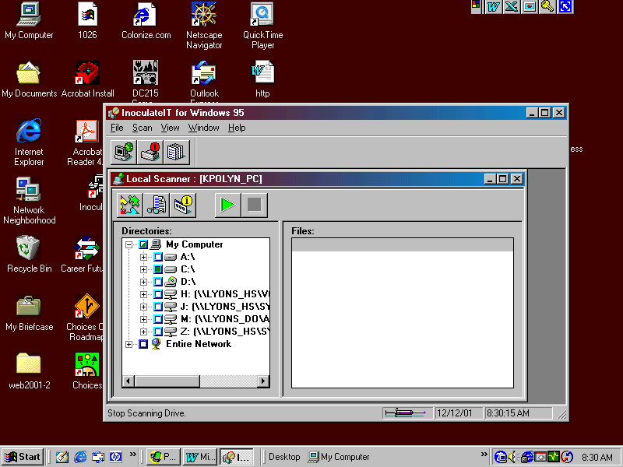
Select green arrow
To run program for scanning viruses

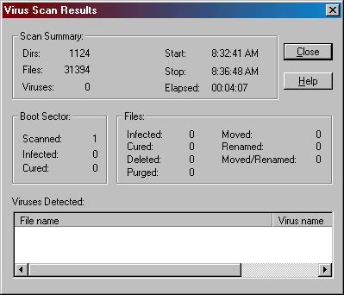
Program will reoprt if you had a virus in infected column 0 means no viruses
Cured indicates program took care of it.
If program indicates you had a virus & was not cured ex.
Infected 1
Cured 0
Your computer is still infected
Email Steve regarding this:
Sleo@wfmail.edutech.org

.org

