Network Log on Procedures for MS/HS

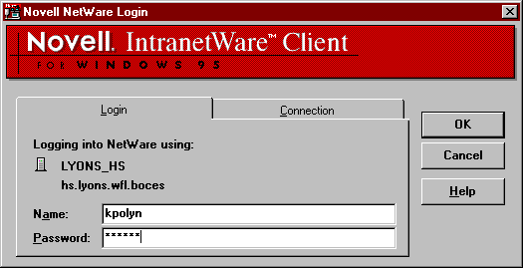
Type first letter of first name last name (no spaces)
Press tab key to get to password box

Type in the password you gave to Network Administrator

Press OK button or Enter key

Next window on computer screen is Network splash screen

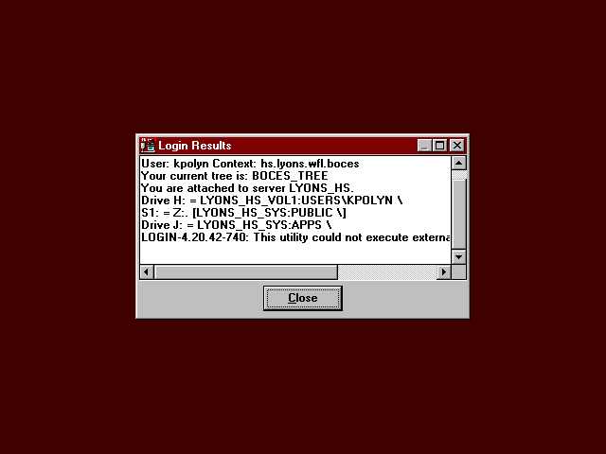
Click close box

The network is connecting you to the printer for that computer workstation.
DO NOT CLICK CANCEL!!!
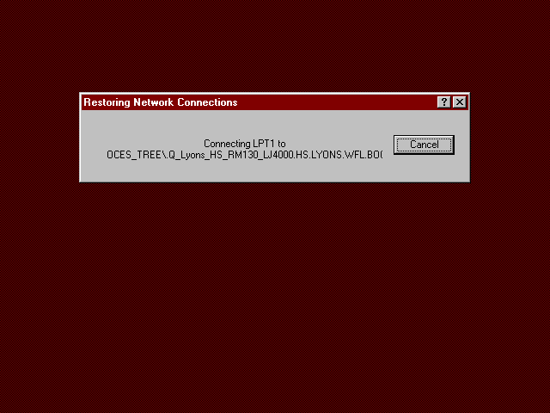
The window will flash quickly on the screen just ignore it. (If you click cancel you will not be able to print.)

A log on window for Windows 95 may appear at the workstation.
This should not be completed.
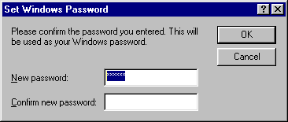

Simply, delete Password (select all of password and press delete key)
Press cancel button. (This will not appear again at this workstation)

The next screen should be the desktop
You are logged on to the network.

