Keshequa Central School
Software License Documentation

Software Title: |  | Tetris v2.00
Vendor: |  | Microsoft
Type: | ❑ District License |  |  |  |  |  | ❑ Site/Licensing
 | ❑ Multiple PC License (#_____) |  |  |  |  |  | ❑ Single PC License
 |  Freeware |  |  | Downloaded From: www.alex-soft.net > Abandon
 | ❑ On-Line Game |  |  |  | URL:

Screen Shot Showing Title, Vendor & Copyright

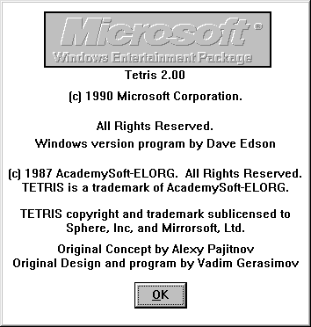

Screen Shot Verifying License Information
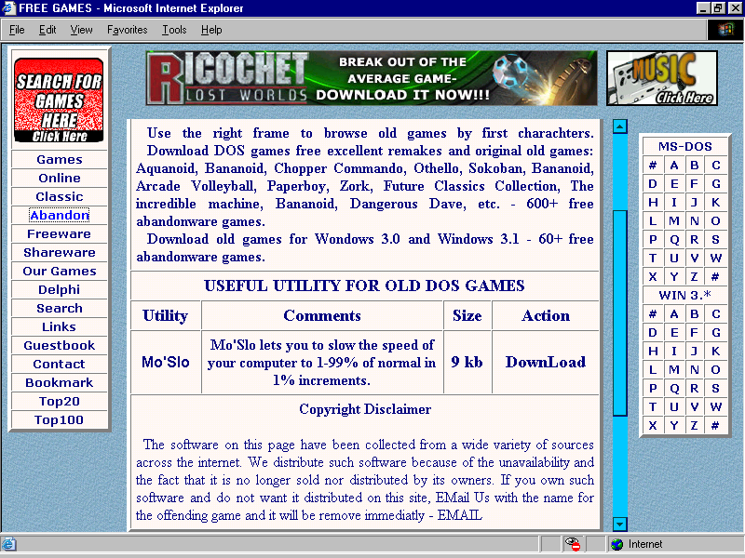

Additional Information: NONE

