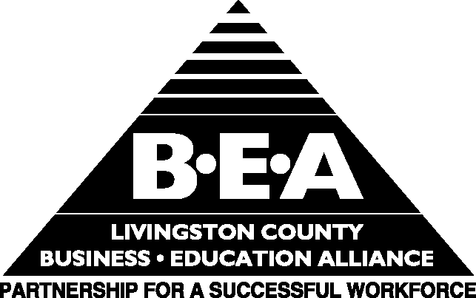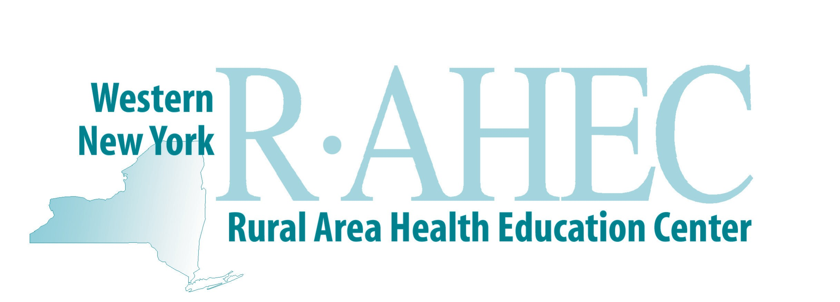

Health Careers Summer Camp Opportunity

The Western New York Rural Area Health Education Center (R-AHEC) and the Livingston County Business Education Alliance (BEA), along with other partnering agencies, will be sponsoring a two-day MASH (Medical Academy of Science and Health) Camp this summer for any interested upcoming 7th and 8th grade students from Livingston County. The first day of camp will be held at the Livingston County Skilled Nursing facility in Mt. Morris on July 19 from 8:30AM- 4:00PM the second day of camp will be held on July 20th at Noyes Memorial Hospital in Dansville from 8:30 AM- 4:00 PM. Students are encouraged to attend both days of camp.

MASH Camp is designed to introduce the students to careers in healthcare. Throughout the two days of camp, each student will get the opportunity to interact with various local health professionals and participate in fun and interactive activities such as shadowing sessions, rescue demonstrations, and a variety of other events. Such areas of healthcare that the students will learn about include nursing, physical therapy, EMT/Rescue, laboratory and radiology. A special guest appearance will be made by Senator Patricia McGee on the second day of camp at Noyes Hospital as part of a “mixer” with students, parents and hospital staff.

Registration fee for this camp is $15 per student. Each child will receive a scrub top and lunch both days. For more information about MASH Camp or to receive a registration form, please call Camp Coordinator, Dave Prete, at (607) 324-9838 or Livingston County BEA Director, Carrie Malone, at 243-4350 or visit the BEA portion of the Livingston County Chamber of Commerce webpage at www.livingstoncountychamber.com under the programs and services section.

