Subject Area____Information Literacy K-6_______________Grade Level ___6___

Mission Statement: It is the mission of the Elba Central School District to actualize the phrase “Elba Equals Educational Excellence for Everyone.” We are committed to providing both quality and equity. Every student will have the opportunity to develop to the best of his/her ability.

Elba Standards: In addition to the knowledge and basic skills they need in order to participate in society, graduates of Elba Central School will develop:
- Empowering skills: decision making, goal setting, creative thinking and problem solving abilities;
- Communication and social interaction skills;
- Technological literacy;
- Total wellness (social, physical, emotional health and self-esteem);
- The values necessary to participate in society.
As a result of achieving these outcomes, our students will embrace lifelong learning.

National Standards:
Information Literacy
Standard 1: The student who is information literate accesses information efficiently and effectively.
Standard 2: The student who is information literate evaluates information critically and competently.
Standard 3: The student who is information literate uses information accurately and creatively.
Independent Learning
Standard 4: The student who is an independent learner is information literate and pursues information related to personal interests.
Standard 5: The student who is an independent learner is information literate and appreciates literature and other creative expressions of information.
Standard 6: The student who is an independent learner is information literate and strives for excellence in information seeking and knowledge generation.
Social Responsibility
Standard 7: The student who contributes positively to the learning community and to society is information literate and recognizes the importance of information to a democratic society.
Standard 8: The student who contributes positively to the learning community and to society is information literate and practices ethical behavior in regard to information and information technology.
Standard 9: The student who contributes positively to the learning community and to society is information literate and participates effectively in groups to pursue and generate information.
Performance Indicators:
Students will:
1-Media Center Responsibilities
- Understand what a library is.
- demonstrate good citizenship in the library by following rules and procedures.
- utilize the librarian as a teacher and resource person.
- Demonstrate proper care of a book and other materials in the library.
- Follow circulation procedures.
2- Collection Organization/Location
- display the ability to locate easy fiction, non-fiction, easy-to-read books and other relevant materials.
- Understand the arrangement of fiction and non-fiction books including numerical vs. alphabetical order and arrangement of non-fiction by subject.
- Select materials for themselves.
- Understand that each item has a specific place on the library shelves.
- Have the knowledge to search the catalog (OPAC) by subject, author, title and for availability.
- Develop an understanding of catalog records.
- Develop searching strategies (electronic and manual).
- Develop an understanding of the Dewey Decimal System.
3- Literature Appreciation
- Recognize the variety of books available in the library.
- Have an understanding of the Caldecott and Newbery Medal.
- Have the ability to identify a variety of authors and genres (storytelling, tall tales, folktales, fairy tales, myths, legends, poetry, biography, autobiography, fiction genres: historical, fantasy, science, realistic, mystery).
- Develop an understanding of story elements (visual literacy, predicting, sequencing, character, setting, and plot).
- Develop an appreciation for his/her favorite books and authors.
- Recognize that books are for enjoyment as well as for information.
4- Listening and Interactive Skills
- recognize that quiet listening is necessary for group attention and enjoyment.
- respond appropriately to what is seen and heard.
- ability to differentiate between factual and non-factual information
- comprehend and restate factual information
5- Reference Skills
- Understand alphabetical and numerical order.
- Develop an understanding of keyword searching.
- Understand that several search terms are needed for complete research.
- Begin to develop an understanding of how to use encyclopedias, atlas, dictionary, indexing, almanac and thesaurus, electronic databases and specialized encyclopedias.
- Participate in collaborated classroom/library supported research projects.
- Begin to understand the process of choosing an appropriate resource .
- Begin to understand how to evaluate resources using reliability, currency and accuracy.
6- Vocabulary
- use and understand the following terms:
  - borrow, return, renew, overdue, plagiarism
  - author, title, illustrator
  - spine, spine label, cover, barcode, paperback, hardcover, pages, publisher, copyright date.
7- Subject headings, see and see also, database, fieldStudy Skills
- a. understand the organization of a book (table of contents, index)
b. develop (in collaboration with classroom teaching) an understanding of
note-taking, outlining, skimming, and organizing.
c. gain knowledge about the format of bibliographies.

Assessment: | Acceptable Performance Level
Conversations, questions, observations | Students will respond and participate in activities to support performance indicators.
Circulation statistics | All students will participate in book exchange. Circulation statistics will increase each year.
Surveys of knowledge and interests | 90% of students will answer questions on survey correctly.
Small group questioning | Students will actively participate in group discussions.
Report card grading | 90% of students will receive a 3 or 4 in all categories.

Scope: Sixth grade students have an understanding of information literacy qualities and skills.

Sequence:

 | Concept | Supporting Activities | Performance Indicator | Achieved Peformance Level
SEPT/  ONGOING | Media Center Responsibilities-  Proper handling of library materials | Ongoing-  Book exchange  Questionnaire  survey | 1 | Master
OCT/  ONGOING | Collection organization-  OPAC | OPAC presentation on monitor-  Students look up books on Ancient Egypt in the OPAC and answer questions on a worksheet about the records. | 2 | Master
ONGOING | Literature appreciation-Variety of Genres | Book displays,  Booktalks,  Book reports assigned by classroom teacher,  Questionnaire  Poetry (APR) | 3 | Reinforced
ONGOING | Author and illustrator appreciation | Author visit,  Questionnaire,  Booktalks; displays | 3 | Reinforced
ONGOING | Listening skills-comprehend and restate factual info. |  | 4 | Reinforced
SEPT | Collection Organization-understand the arrangement of fiction and non-fiction books | Dewey Decimal unit-website and worksheet,  “Around the Media Center” scavenger hunt (Reaching every reader… p.43),  Use of OPAC during book exchange,  Practice putting books in call number order; | 2 | Reinforced
SEPT/  OCT/NOV | Collection organization-Dewey Decimal System | Cut pictures out of magazines that "fit" different Dewey categories (ex: cars, planes, doctors, pets... for 600s.)  Get a BIG piece of paper & divide into 100s, 200s, etc. Give students your handout describing categories & a bunch of pictures to put on appropriate part of mural paper. Discuss when complete, fix mistakes (pets in 600s, wild animals in 500s,  etc.) Post mural in the library for a while.  Book exchange; OPAC; | 2 | Reinforced
OCT/FEB | Reference Skills-Keyword Searching/Subject | Students will highlight or underline keywords and ideas from a copy of a paragraph from newspaper or encyclopedia-answer questions about the article,  5 minute mysteries,  www.cybersmartcurriculum.com  Students will write down 5-6 alternate search terms for a particular subject, (thesaurus)  Use SIRS Discoverer student workbook (middle school); | 5 | Reinforced
DEC | Study Skills-  Organization of a book | Index presentation (overhead) Index practice- copy an index and have students answer questions about the index.  Table of contents practice- | 7 | Reinforced
JAN | Newbery Medal | Booktalk Newbery winners; announce new winners | 3 | Reinforced
JAN | Reference skills- Dictionary/Thesaurus | Dictionary scavenger hunt; Thesaurus triumph crossword puzzle (SLL p. 67) | 5 | Reinforced
JAN/FEB | Reference skills-Almanac/Atlas | Atlas scavenger hunt | 5 | Reinforced
FEB | Study Skills-Bibliographies |  | 7 | Reinforced
MAR | Reference skills- Encyclopedias | Classroom projects; Wonder questions; | 5 | Reinforced
APR | Reference Skills-Electronic Databases/Internet | Classroom projects; SIRS Discoverer worksheets; look for poems in databases to read to class;  Searching the Internet-search engines, Booleon searching, evaluating web sites (see below) | 5 | Reinforced
MAY | Reference Skills-choosing an appropriate resource | Which resource will answer your question most accurately and timely? | 5 | Introduced
APR/ONGOING | Study Skills-notetaking | Students choose a topic (with guidance) and take notes using graphic organizers,  Collaborated classroom projects | 7 | Reinforced
MAY/ONGOING | Study Skills-Outlining | Collaborated classroom projects | 7 | Reinforced
MAY | Reference Skills-  Evaluating resources | Presentation on accuracy, currency and reliability- Compare an outdated book with a current book on the same topic- look at a variety of predetermined web sites on a subject-students will determine which web sites have valid information. | 5 | Introduced

Methodology: Classroom collaboration, Best Practices, 6-Traits writing, RAC, Information Power, booktalking
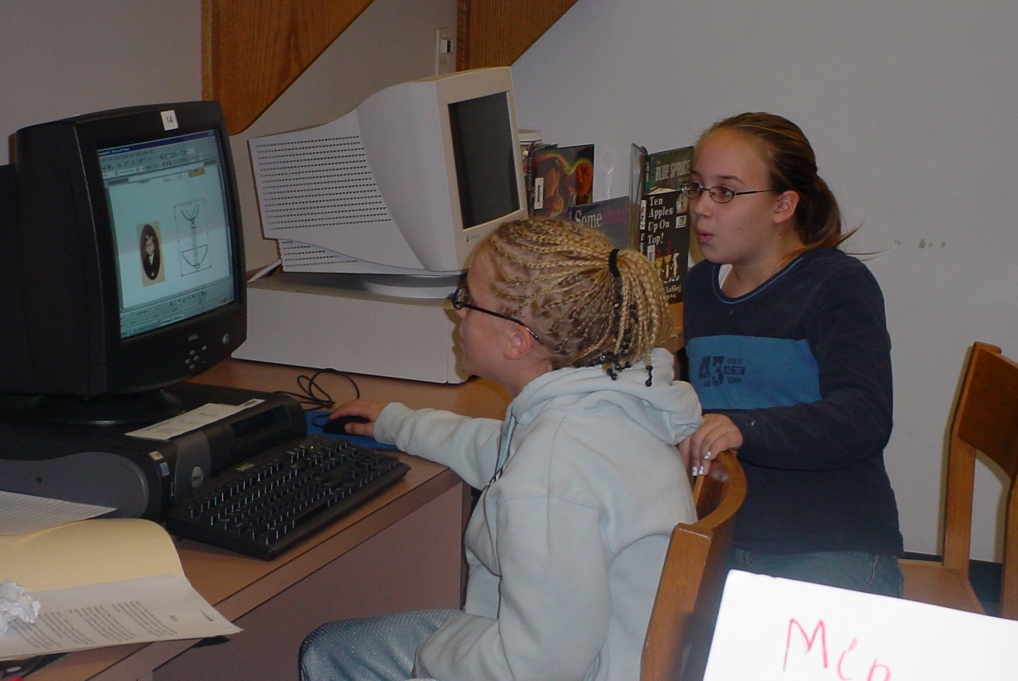
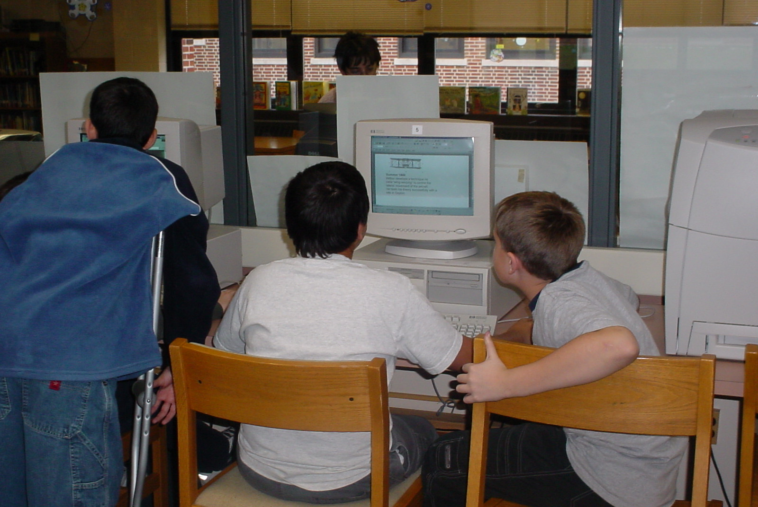

Sixth grade students researching using the Internet.

Bibliography:

Bannister, Barbara Farley. Elementary School Librarian’s Survival Guide. 1993.

The Best of The Mailbox Bookbag Chapter Book & Novel Units Grades 3-6, 1999.

The Best of The Mailbox Magazine Literature Grades 4-6, 1998.

Carey, Patsy.Activities for any Literature Unit, 1995.

Dingwall, Cindy. Library Celebrations, 1999.

Freeman, Judy. What’s New in Children’s Literature and Strategies for Using It in Your Program, 2003.

Miller, Pat. Reaching Every Reader: Promotional Strategies for the Elementary School Library Media Specialist, 2001.
Preller, James. The Big Book of Picture-Book Authors and Illustrators, 2001.

SAMPLE

6th Grade Questionaire

Date: ____________
Class:____________
Names: ___________________________________________

1. What do you like best about coming to library?
Responses:

2. What types of books would you like to see more of in the library?
Responses:

4. What does the author do? What does the illustrator do?

5.Where in the library can you find (J and non-J) fiction books?

Nonfiction?

6. Which of the following activities would be your favorite?
Ride a bike, read a book or watch TV

7. Name something that you like to do for fun or something that you are interested in.

8. Tell me five ways to handle books that will keep the books looking nice?

9. Who is your favorite author?

10. How do you decide where you should look first to find out information about a subject?

11. Can you tell me what makes a web site reliable?

SAMPLE

6th Grade Vocabulary Survey

Date: ______________

Class:______________

Name of Student | author | title | illustrator | spine | spine label | publisher | barcode | copyright

