Subject Area: Art K-6 Grade Level : 6

Mission Statement: It is the mission of the Elba Central School District to actualize the phrase “Elba Equals Educational Excellence for Everyone.” We are committed to providing both quality and equity. Every student will have the opportunity to develop to the best of his/her ability.

Elba Standards: In addition to the knowledge and basic skills they need in order to participate in society, graduates of Elba Central School will develop:
- Empowering skills: decision making, goal setting, creative thinking and problem solving abilities;
- Communication and social interaction skills;
- Technological literacy;
- Total wellness (social, physical, emotional health and self-esteem);
- The values necessary to participate in society.
As a result of achieving these outcomes, our students will embrace lifelong learning.

New York State Standards: 1) Creating, performing and participating in the arts. 2) Knowing and using art materials and resources. 3) Responding to and analyzing works of art. 4) Understanding the cultural dimensions and contributions of the arts.

National Standards:4) Understanding the visual arts in relation to history and culture. 5) Reflecting upon and assessing the characteristics and merits of their work and the work of others. 6) Making connections between visual arts and other disciplines.

Performance Indicators:
1-A produce a collection of art works, in a variety of mediums, based on a range of individual and collective experiences.
1-B know and use as variety of sources for developing and conveying ideas, images, themes, symbols, and events in their creation of art.
1-C use the elements and principles of art to communicate specific meanings to others in their artwork.
1-D during the creative process, reflect on the effectiveness of selected mediums or techniques to convey intended meanings
1-E identify and use in individual and group experience, some of the roles and means for designing, producing and exhibiting art works and discuss ways to improve them.
2-A develop skills in a variety of art materials and competence in at least one medium.
2-B use the computer and other electronic media as designing tools to communicate visual ideas.
2-C take advantage of community opportunities and cultural institutions to learn from professional artists, look at original art and increase their understanding of art.
2-D understand the variety of careers related to the visual arts and the skills necessary to pursue some of them
3-A discuss and write their analyses and interpretations of their own works of art and the art of others using appropriate critical language
3-B identify, analyze and interpret the visual and sensory characteristics that they discover in natural and human-made forms.
3-C compare the ways ideas and concepts are communicated through visual art with the various ways that those ideas and concepts are manifested in other art forms
3-D compare the ways ideas, themes, and concepts are communicated through the visual arts in other disciplines, and various ways that those ideas, themes and concepts are manifested within the discipline.
4-A Demonstrate how art works and artifacts from diverse cultures reflect aspects of those cultures
4-B Demonstrate the ways in which some particular art works and artifacts reflect important aspects of the diverse cultures of the United States
4-C Create art works that reflect a particular historical period of the culture

Assessment: | Acceptable Performance Level
Completed projects | 3-4 on completed work
2 pieces of art work in art show/May  Progress assessment on extended projects | 3-4 on report cards 20/40 weeks

Scope: Sixth Grade art students will explore a wide range of historical periods in the ancient world of art, and will use technology to demonstrate understanding of elements and principles of art and design through created work as well as a vehicle for research

CONTENT SEQUENCE  *Skill appears in bold print | PERFORMANCE INDICATORS (INTERMEDIATE) | INTEGRATED CONTENT STANDARD/P.I. | METHOD OF ASSESSMENT | ACHIEVED PERFORMANCE LEVELS
Ancient Egyptian Artifacts  Large scale grid painting King Tut’s Funerary mask/ Sarcophagus of King Tut w/ Papier Mache’ & paint / pyramid 3-D construction | 1A-E, 2C, 3B,C 4C  3D | SS  2ii.1C  2iii.1A  I | Rubric | Developing  Awareness
Ancient Greece (Grecian Urns) Scratch Art. Amphora with Plaster Paris. | 1D, E, 2C, 3C, D 4B, C | SS  2ii.1C  2iii.1A  I | Rubric | Developing
Middle Ages Coat of Arms  Burnished Tech./ Castles with Clay/ Medallions / Banners | 2C,D, 3A, 4A,C  2B, | SS  2ii.1C  2iii.1A  I | Rubric | Developing Proficient
M.C. Escher Self Portraits Drawing– Hand Holding Ornament | 1A, 1C |  | Rubric | Developing
Holiday Fine Arts Festival | 1E, 2C, 3C |  | Report Card Gr. | Developing
Guiseppe Arcimboldo  Italian Artist  Food Faces “People in Art” Collage | 1B, 1C, 2C  4C | SS  2ii.1C  2iii.1A  I | Rubric | Developing  Proficient
Self Portrait drawing | 1A, 1C |  | Rubric | Developing
Self Portrait Kid Pix Deluxe 3 Realism-Abstraction | 1A, 1C, 2A  2B |  | Rubric | Developing Proficient
Pastel Landscapes or Pastel Wildlife Animals Drawing | 1D  4C |  | Rubric | Developing Proficient
Spring Fine Arts Festival | 1E, 2C, 3C |  | Report Card Gr. | Developing

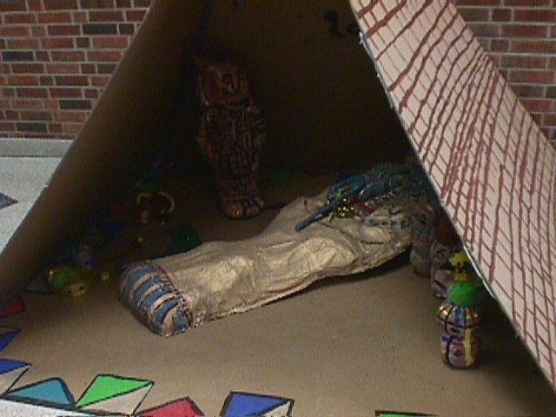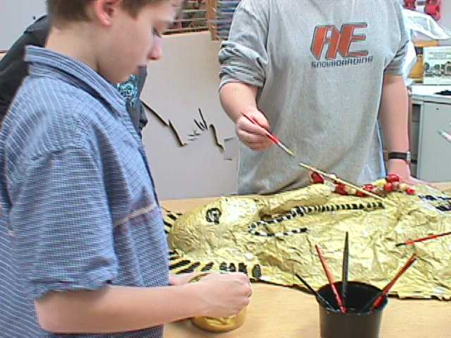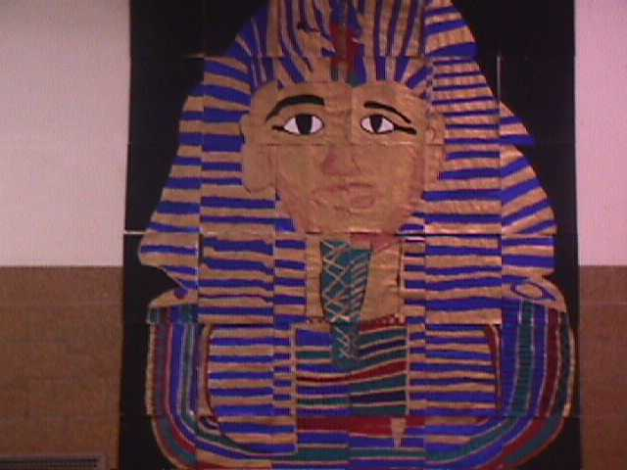
Egyptian Sarcophagus – Papier Mache’ P.I. 1E, 4C King Tut mural grid system
Integrated w/ SS 2ii.1C, 2iii.1A P.I. 1A-E

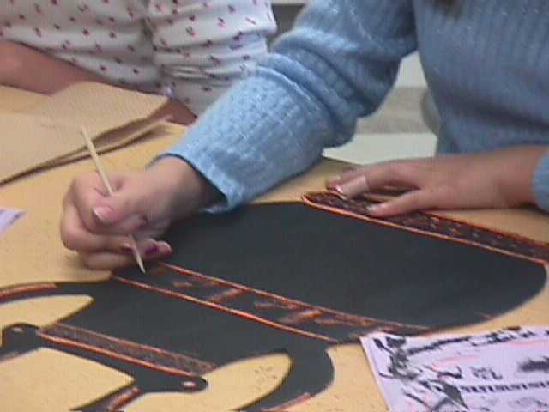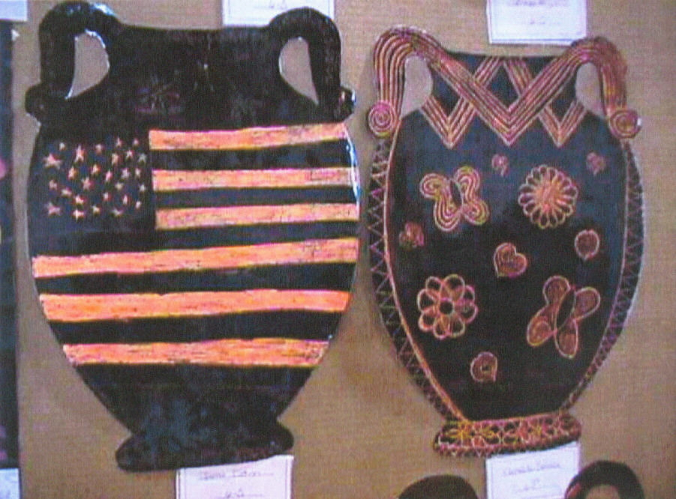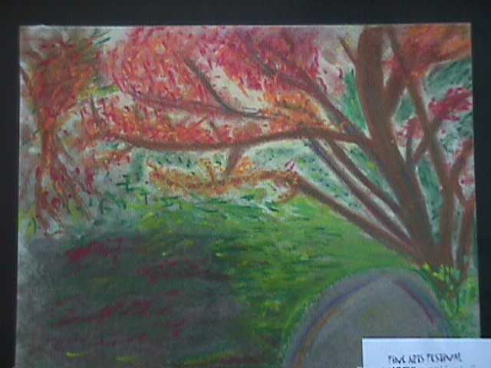
Etched Grecian Urns P.I. 4B,C Pastel Landscapes P.I. 1D, 4C
Integrated w/ SS 2ii.1C, 2iii.1A

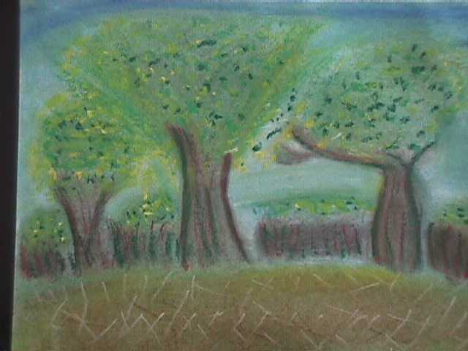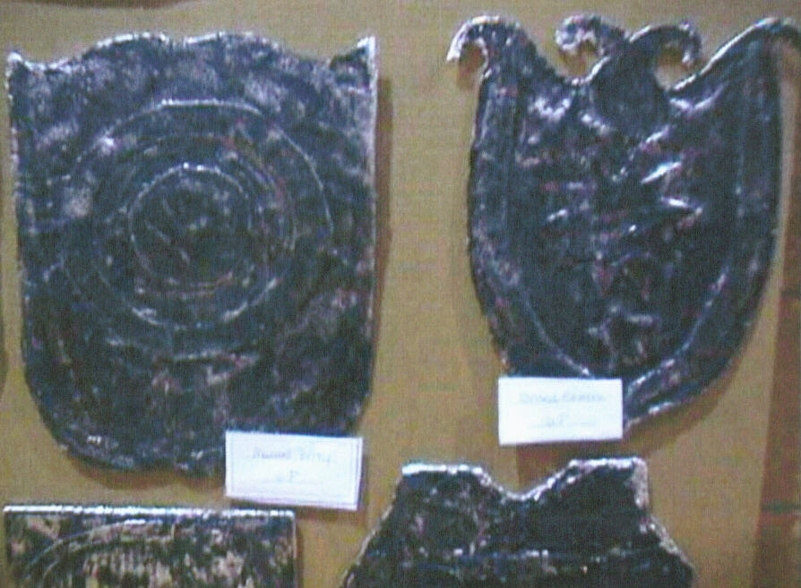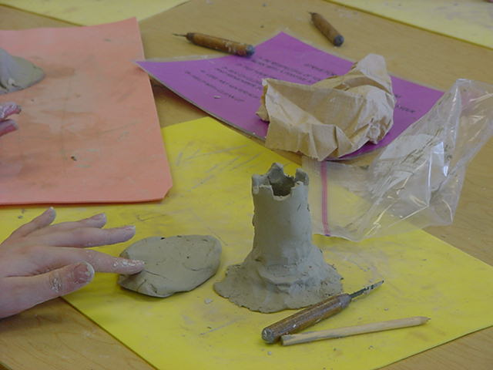
Burnished Shields & Clay Castles (Motte &Bailey) P.I.2B,
3A, 4A,C, Integration w/ SS 2ii.1C, 2iii.1A

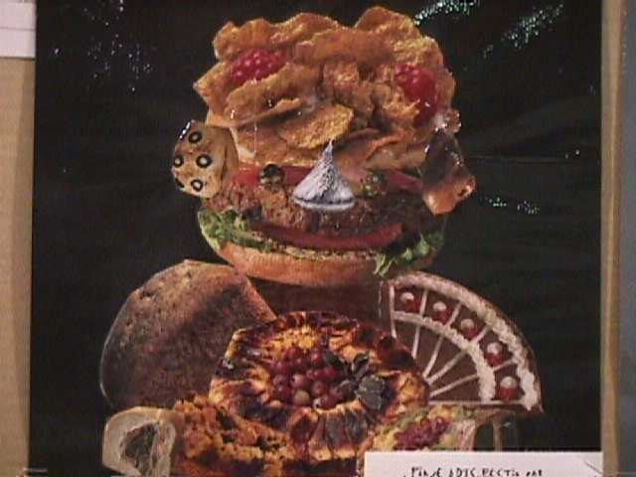 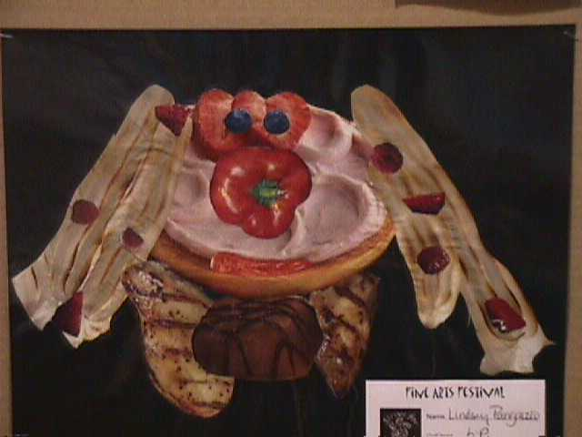 Guiseppe Archimboldo Italian RenaissancePainter Food Face Portrait Collage
P.I.1B,C,2C,4C Integrated w/ / SS 2ii.1C, 2iii.1A

Methodology: Library resources, 6 Traits Writing, Kid Pix Deluxe 3, Integrate with Sixth Grade Social Studies, Science and Math units and themes when possible.
School Arts May/June ‘03

